

Safeguarding and Child Protection Policy (Appendix)
Responsible Board/ Committee | Academy Trust  Foundation Trust
Policy Type | Hybrid Policy
Policy Owner | Designated Safeguarding Lead
Statutory | Yes
Publish Online | Yes
Date Adopted | FDN 6th July 2024  AT 12th July 2024
Last Review Date | December 2025
Review Cycle | Annual
Next Review Date | December 2026
Expiry Date | December 2026
Version | 6

Contents

Contents 2
Parents/carers can access copies of this policy online on our website, or by asking for a paper copy at the academy reception. If parents/carers have any questions about it, they can ask to meet with the DSL. 3
Appendix 1 – Protected Characteristics 4
What are protected characteristics? 4
1.2 Age 4
1.3 Disability 4
1.4 Gender reassignment 4
1.5 Marriage and civil partnership 4
1.6 Pregnancy and maternity 4
1.7 Race 4
1.8 Religion and belief 5
1.9 Sex 5
1.10 Sexual orientation 5
Appendix 2 - indicators of vulnerability to radicalisation 6
Appendix 3 - Safeguarding pupils who are susceptible to radicalisation 9
Appendix 4 - Definitions and indicators of abuse 13
Appendix 5 - Dealing with a disclosure of abuse 19
Responding to concerns about a child 20
Appendix 6 - Mental health support 21
Appendix 7 - Children missing from education 22
Appendix 8 - Children with additional needs 23
Appendix 9 - Allegations and low-level concerns 24
Appendix 10 - General information for staff 27
Appendix 11 - Information for children and families: Charity Contact Details and Helplines 38
Suicide prevention and Self Harm 38
Abuse 40
Eating disorders 42
Mental Health 43
Child marriage 45
Homelessness 46
Sexuality 47
Substance Misuse 48
Female Genital Mutilation (FGM) 51
Young Carers 51
Debt Advice 52
Counselling 52
Bullying 53
Family support 53
Appendix 12 - Website links 56
Appendix 13 – Online safety 58
Appendix 14 – Use of Reasonable Force 60
Appendix 15 – Vetting and due diligence checks 68
Appendix 16 - Individual behaviour for learning plan 70
Appendix 17 – Fabricated and induced illnesses 74
Appendix 17 – Fabricated……………………………………………………………………….

Parents/carers can access copies of this policy online on our website, or by asking for a paper copy at the academy reception. If parents/carers have any questions about it, they can ask to meet with the DSL.

Appendix 1 – Protected Characteristics

What are protected characteristics?
It is against the law to discriminate against someone because of:
- age
- disability
- gender reassignment
- marriage and civil partnership
- pregnancy and maternity
- race
- religion or belief
- sex
- sexual orientation
These are called protected characteristics.
You are protected under the Equality Act 2010 from these types of discrimination.

1.2 Age
A person belonging to a particular age (for example 32 year olds) or range of ages (for example 18 to 30 year olds).

1.3 Disability
A person has a disability if she or he has a physical or mental impairment which has a substantial and long-term adverse effect on that person's ability to carry out normal day-to-day activities.

1.4 Gender reassignment
The process of transitioning from one sex to another.

1.5 Marriage and civil partnership
Marriage is a union between a man and a woman or between a same-sex couple. Same-sex couples can also have their relationships legally recognised as 'civil partnerships'. Civil partners must not be treated less favourably than married couples (except where permitted by the Equality Act).

1.6 Pregnancy and maternity
Pregnancy is the condition of being pregnant or expecting a baby. Maternity refers to the period after the birth, and is linked to maternity leave in the employment context. In the non-work context, protection against maternity discrimination is for 26 weeks after giving birth, and this includes treating a woman unfavourably because she is breastfeeding.

1.7 Race
Refers to the protected characteristic of race. It refers to a group of people defined by their race, colour, and nationality (including citizenship) ethnic or national origins.

1.8 Religion and belief
Religion refers to any religion, including a lack of religion. Belief refers to any religious or philosophical belief and includes a lack of belief. Generally, a belief should affect your life choices or the way you live for it to be included in the definition.

1.9 Sex
A man or a woman.

1.10 Sexual orientation
Whether a person's sexual attraction is towards their own sex, the opposite sex or to both sexes.

Appendix 2 - indicators of vulnerability to radicalisation

Extremism is defined by the government in the Prevent Strategy as: vocal or active opposition to fundamental British values, including democracy, the rule of law, individual liberty and mutual respect and tolerance of different faiths and beliefs. We also include in our definition of extremism calls for the death of members of our armed forces, whether in this country or overseas.
Extremism is defined by the Crown Prosecution Service as: the demonstration of unacceptable behaviour by using any means or medium to express views which:
- Encourage, justify or glorify terrorist violence in furtherance of particular beliefs;
- Seek to provoke others to terrorist acts;
- Encourage other serious criminal activity or seek to provoke others to serious criminal acts; or
- Foster hatred which might lead to inter-community violence in the UK.
Keeping Children Safe in Eduation (KCSiE) describes terrorism as an action that endangers or causes serious violence to a person/people; causes serious damage to property; or seriously interferes or disrupts an electronic system. The use or threat must be designed to influence the government or to intimidate the public and is made for the purpose of advancing a political, religious or ideological cause.
Government and academic research has consistently indicated that there is no single sociodemographic profile of a terrorist in the UK and no one pathway leading to involvement in terrorism. Early intervention at the pre-criminal stage is key to prevent radicalisation. There is no single way to identify an individual who is likely to be susceptible to an extremist ideology. Those who become involved in extremist actions come from a range of backgrounds and experiences, and most individuals, even those who hold radical views, do not become involved in violent extremist activity.
Radicalisation is defined in KCSiE as: the process by which a person comes to support terrorism and extremist ideologies associated with terrorist groups.
Radicalisation is a gradual process. It can sometimes take days, months and even years. Teenagers can be at the greatest risk because they are becoming more independent exploring new things and pushing boundaries as they grow and discover more about their identity, faith or belonging. Extremists tend to target young people via social media online. The process of radicalisation can be done through grooming online, face to face organised groups, exploitation including sexual exploitation, psychological exploitation, exposure to violent material and physical harm. Extremists will use societal or political grievances during times of instability to pull young people into the world of extremism and violent ideologies by influencing, grooming and ultimately radicalising them to support or carry out acts of violent extremism.
Often extremist groups encourage people to support their aims by disguising them as charitable work: fundraising is often a form of recruitment. ‘Us’ and ‘them’ narratives are used which may be in the form of racist memes or videos, as well as the use of emotional blackmail through illicit and emotional language.
Online has a global reach, and mainstream platforms or encrypted messenger apps where young people share ideas and socialise, can be used by extremists to groom young people. Popular open-source messenger platforms include Discord, Rocket Chat, Viber, Discord and Telegram. Conversations promoting racist, misogynist and homophobic ideologies exploited by extremist groups, are known as “dark social” platforms. There are many more communications channels extremist use, so do be aware of what platforms young people use to communicate which may seem like a regular chat for gamers.
Pupils may become susceptible to radicalisation through a range of social, personal and environmental factors - it is known that violent extremists exploit vulnerabilities in individuals to drive a wedge between them and their families and communities. What is often missing for the susceptible individual who is feeling lost or frustrated is a support network to address those feelings – this is where the radicaliser can see an opportunity. It is vital that school staff are able to recognise those vulnerabilities.
Indicators of vulnerability include:
Identity crisis - the pupil is distanced from their cultural/religious heritage and experiences discomfort about their place in society.
Personal crisis - the pupil may be experiencing family tensions; a sense of isolation; and low self-esteem; they may have dissociated from their existing friendship group and become involved with a new and different group of friends; they may be searching for answers to questions about identity, faith and belonging.
Personal circumstances - migration; local community tensions; and events affecting the pupil’s country or region of origin may contribute to a sense of grievance that is triggered by personal experience of racism or discrimination or aspects of Government policy.
Unmet aspirations - the pupil may have perceptions of injustice; a feeling of failure; rejection of civic life.
Experiences of criminality - which may include involvement with criminal groups, imprisonment, and poor resettlement/reintegration.
Special educational needs - pupils may experience difficulties with social interaction, empathy with others, understanding the consequences of their actions and awareness of the motivations of others.
Adverse Childhood Experiences (ACEs) including over exposure to alcohol/drugs and/or abusive home situations.
This list is not exhaustive, nor does it mean that all children experiencing the above are at risk of radicalisation for the purposes of violent extremism.
More critical risk factors could include:
- Being in contact with extremist recruiters
- Family members convicted of a terrorism act or subject to a Channel intervention
- Accessing violent extremist websites, especially those with a social networking element
- Possessing or accessing violent extremist literature
- Using extremist narratives and a global ideology to explain personal disadvantage
- Justifying the use of violence to solve societal issues
- Joining or seeking to join extremist organisations
- Significant changes to appearance and/or behaviour; and
- Experiencing a high level of social isolation resulting in issues of identity crisis and/or personal crisis.
Early examples of radicalisation or extremism may include:
- Closed to new ideas or conversation;
- Uncharacteristic change in behaviour, dress and peer relationships;
- Angry; depressed; withdrawn; short tempered;
- New circle of friends;
- Secretive behaviour;
- Online searches or sharing extremist messages or social profiles;
- Change in language;
- Absence from school or home;
- Asking inappropriate questions;
- Scripted speech;
- Tattoos;
- New found arrogance;
- Change of routine;
- Fixated on a subject;
- Showing sympathy for extremist causes;
- Intolerance of difference, including faith, culture, gender, race or sexuality;
- Graffiti, artwork or writing that displays extremist themes;
- Glorifying violence, especially to other faiths or cultures;
- Making remarks or comments about being at extremist events or rallies outside school;
- Evidence of possessing illegal or extremist literature;
- Advocating messages similar to illegal organisations or other extremist groups;
- Advocating violence towards others.

Radicalisers will make the susceptible feel:
- Special; loved; confident; encouraged; listened to;
- They could do something exciting;
- Understood, like no one else had done before;
- They could talk to them openly;
- Treated like an adult;
- Like they belong for the first time.

Multiple attacks have been carried out over the last 10 years by those either identifying with or driven by ideology similar to ‘incel’ ideology. An ‘incel’ believes there is no hope for them as they are biologically inferior. They blame women for rejecting them and are angry with and jealous of men who are successful with women. Radicalisation is carried out through online communities and an anonymous online subculture. They turn frustrations into blame and violence.
Words to listen out for are: Chad/Tyrone; Stacey; Alpha/Beta; Hit the wall; Femoid/foid; Lookism; Simp; AWALT (all women are like that).
Vulnerabilities and signs are:
- Children with few social relationships outside of the online world;
- Victims of bullying or discrimination;
- Children who spend a lot of time online;
- Children with poor self-esteem - believing themselves to be unattractive for example;
- Young people with Special Education Needs or Disabilities;
- Using terms (which they may have heard in other forums or on other websites);
- Derogatory language against women and Girls’;
- Spending a lot of time on certain websites.

Appendix 3 - Safeguarding pupils who are susceptible to radicalisation

Since 2010, when the Government published the first version of the Prevent Strategy, there has been an awareness of the specific need to safeguard children, young people and families from extremist ideologies.
From 1st July 2015, all schools are subject to the Prevent Duty and must have ‘due regard to the need to prevent people being drawn into terrorism’ (section 26, Counter Terrorism and Security Act 2015).
There have been several occasions both locally and nationally in which extremist groups have attempted to radicalise susceptible children and young people to hold extreme views including views justifying political, religious, sexist or racist violence, or to steer them into a rigid and narrow ideology that is intolerant of diversity and leaves them susceptible to future radicalisation.

The current threat from terrorism in the United Kingdom may include the exploitation of susceptible people, to involve them in terrorism or in activity in support of terrorism. The normalisation of extreme views may also make young people susceptible to future manipulation and exploitation but not necessarily terrorism. We can all have feelings of injustice or not being listened to. King Edward VI Handsworth Wood Girls’ School has a role to play in recognising these issues for our pupils and protecting them from a ‘third party’ who has their own agenda.

King Edward VI Handsworth Wood Girls’ School is clear that this exploitation and radicalisation must be viewed as a safeguarding concern and that protecting children from the risk of radicalisation is part of King Edward VI Handsworth Wood Girls’ School’s safeguarding duty.

King Edward VI Handsworth Wood Girls’ School seeks to protect children and young people against the messages of all violent extremism including, but not restricted to, those linked to Daesh (also known as ISIL, Islamic State, or ISIS) ideology; Far Right/Neo-Nazi/White Supremacist ideology, including Incels; Domestic Terrorism; Irish Nationalist and Loyalist paramilitary groups; and extremist Animal Rights movements. Risks posed by right-wing extremists in the UK are also included in the terror threat level system.

King Edward VI Handsworth Wood Girls’ School values freedom of speech and the expression of beliefs and ideology as fundamental rights underpinning our society’s values. Pupils and teachers have the right to speak freely and voice their opinions. However, freedom comes with responsibility and free speech that is designed to manipulate the susceptible or that leads to violence and harm of others goes against the moral principles in which freedom of speech is valued. Free speech is not an unqualified privilege; it is subject to laws and policies governing equality, human rights, community safety and community cohesion.

Risk Reduction
King Edward VI Handsworth Wood Girls’ School governors, Headteacher, and members of the Senior Leadership Team including the Designated Safeguarding Lead (DSL) will assess the level of risk within King Edward VI Handsworth Wood Girls’ School and put actions in place to reduce that risk. Risk assessment may include consideration of King Edward VI Handsworth Wood Girls’ School’s PSHE curriculum, SEND policy, assembly schedule, the use of school premises by external agencies, integration of pupils by gender identity and SEND, anti-bullying policy and other issues specific to King Edward VI Handsworth Wood Girls’ School’s profile, community and philosophy. To this end, staff will open source due diligence checks on all external speakers invited to King Edward VI Handsworth Wood Girls’ School. Due diligence processes are also undertaken when selecting charities for King Edward VI Handsworth Wood Girls’ School to support through fundraising. Every effort is made to ensure the charity selected does not promote extremist views.
These risk assessments will be reviewed as part of the annual Section175 return that is monitored by the Local Authority and the Local Safeguarding Children Board.

All staff within King Edward VI Handsworth Wood Girls’ School will be alert to changes in a young person’s behaviour or attitude which could indicate that they are in need of help or protection.
We also use specialist online monitoring software (Smoothwall) within school to ensure that inappropriate sites are not accessed by pupils or staff. Smoothwall is also used to block harmful and inappropriate content (without over blocking). Ms Dennis, Ms Jones and Mr Doolan receive alerts and are responsible for managing the filtering and monitoring systems.
King Edward VI Handsworth Wood Girls’ School is required to identify a Prevent Single Point of Contact (SPOC) who will be the lead within the organisation for safeguarding in relation to protecting individuals from radicalisation and involvement in terrorism. The SPOC for King Edward VI Handsworth Wood Girls’ School is: Stacy Dennis. The roles and responsibilities of the SPOC are:
- Ensuring that staff of King Edward VI Handsworth Wood Girls’ School are aware that you are the SPOC in relation to protecting pupils from radicalisation and involvement in terrorism;
- Maintaining and applying a good understanding of the relevant guidance in relation to preventing pupils from becoming involved in terrorism, and protecting them from radicalisation by those who support terrorism or forms of extremism which lead to terrorism;
- Raising awareness about the role and responsibilities of School in relation to protecting pupils from radicalisation and involvement in terrorism;
- Monitoring the effect in practice of King Edward VI Handsworth Wood Girls’ School’s RE curriculum and assembly schedule/form time activities to ensure that they are used to promote community cohesion and tolerance of different faiths and beliefs;
- Raising awareness within King Edward VI Handsworth Wood Girls’ School about the safeguarding processes relating to protecting pupils from radicalisation and involvement in terrorism;
- Acting as the first point of contact within King Edward VI Handsworth Wood Girls’ School for case discussions relating to pupils who may be at risk of radicalisation or involved in terrorism;
- Collating relevant information in relation to referrals of susceptible pupils into the Channel process;
- Attending Channel meetings as necessary and carrying out any actions as agreed;
- Reporting progress on actions to the Channel co-ordinator; and sharing any relevant additional information in a timely manner.

Channel
Channel is a multi-agency approach to provide support to individuals who are at risk of being drawn into terrorist related activity. It is led by the West Midlands Police Counter-Terrorism Unit, and it aims to:
- Establish an effective multi-agency referral and intervention process to identify susceptible individuals;
- Safeguard individuals who might be susceptible to being radicalised, so that they are not at risk of being drawn into terrorist-related activity; and
- Provide early intervention to protect and divert people away from the risks they face and reduce vulnerability.

The Channel programme focuses on providing support at an early stage to people who are identified as being susceptible to being drawn into terrorism. It provides a mechanism for schools to make referrals if they are concerned that an individual might be susceptible to radicalisation. As part of the referral process a risk assessment will be carried out. King Edward VI Handsworth Wood Girls’ School will make referrals to Channel if we are concerned that an individual might be susceptible to radicalisation. An individual’s participation in the programme is entirely voluntary at all stages and consent is sought before they can receive support from Channel. If the individual requiring support is under 18, parental consent is required. Providers of support can include statutory and community partners. The Channel multi-agency panel is responsible for ensuring delivery of the overall package of support for Channel cases.

The types of support are:
- Diversionary activity;
- Sports participation;
- Faith groups;
- Education support;
- Housing;
- Skills training;
- Mentorship;
- Employment support;
- Theological/political.

Schools have a duty to cooperate with the Channel programme in the carrying out of its functions, and with the Police in providing information about an individual who is referred to Channel (Section 38, Counter Terrorism and Security Act 2015).

Further guidance about duties relating to the risk of radicalisation is available in the Advice for Schools on The Prevent Duty (https://assets.publishing.service.gov.uk/government/uploads/system/uploads/attachment_data/file/439598/prevent-duty-departmental-advice-v6.pdf.)

Response

There is no single way to identify an individual who is likely to be susceptible to an extremist ideology. Specific background factors may contribute to vulnerability, and these are often combined with specific needs for which an extremist group may appear to provide answers, and specific influences, such as family, friends and online contacts. The use of social media has become a significant feature in the radicalisation of young people. More information on these factors can be found in Indicators of Vulnerability to Radicalisation (https://www.gov.uk/guidance/get-help-if-youre-worried-about-someone-being-radicalised)
Pupils will be taught about equality, tolerance, healthy relationships and the importance of recognising prejudicial behaviour and reporting it. School will also support pupils to establish friendships and develop their self-esteem. We will respond robustly to any incidents of bullying or discrimination.

When any member of staff has concerns that a student may be at risk of radicalisation or involvement in terrorism, they should speak with the SPOC and to the DSL if this is not the same person.

Numerous factors can contribute to and influence the range of behaviours that are defined as violent extremism, but most young people do not become involved in extremist action. For this reason, the appropriate interventions in any particular case may not have any specific connection to the threat of radicalisation, for example they may address mental health, relationship or drug/alcohol issues.

Whilst support will be found in school there will often be a need to look outside school for additional forms of support, for example mentoring, counselling and involvement in community engagement schemes.

If an adult is worried that someone is being radicalised, they can call the police on 101 to get advice or share a concern to get safeguarding support. Alternatively, contact the local authority safeguarding team for help. (See below.)

Contacting the authorities will not get the individual into trouble if a criminal act hasn’t been committed. The local authority or police will discuss concerns, suggest how they can best help and give access to relevant support and advice. Any response will be proportionate and will be viewed as a safeguarding concern.

If someone is in immediate danger, or if you see or hear something that may be terrorist-related, call 999 or the confidential Anti-Terrorist Hotline on 0800 789 321.

Referral process
- Report online material promoting terrorism or extremism via the Report online material promoting terrorism or extremism - GOV.UK (https://docs.google.com/document/d/17O6ow8pcIG-3iK88uzspVsjdLcpJoGrdBinazXOYpYc/edit) The online tool is for reporting illegal or harmful information, pictures or videos found on the internet. School staff and individuals can make reports anonymously and report material such as: articles, images, speeches or videos that:
• promote terrorism or encourage violence;
• content encouraging people to commit acts of terrorism;
• websites made by terrorist or extremist organisations;
• videos of terrorist attacks.
- To help decide whether to make contact, look at Birmingham’s Multi-Agency threshold document Right Help Right Time (https://www.lscpbirmingham.org.uk/delivering-effective-support). The screening tool (https://www.lscpbirmingham.org.uk/delivering-effective-support) must be completed in order to support the referral. The DSL must have gathered the relevant information and spoken to the relevant people before making the referral. This can be discussed by calling Children's Advice & Support Service (CASS) on 0121 303 1888.
- Next steps could involve a discussion with the Counter Terrorism Unit (CTU) and/or Channel Panel/Community Safeguarding Panel.

Prevent Intervention
Intervention could be:
- Educative – generic in nature. Involves a safe space. Provides the young person the chance to let off steam.
- Diversionary – involves taking groups to allow them to experience ‘other’ cultures.
- Inclusion – appreciation of other communities and cultures through a joint initiative to provide understanding.
- Challenging narratives – KIKIT, ODARA (Women’s Support Network) http://www.odara.org.uk
- Chanel mentor, external agency involvement.

Appendix 4 - Definitions and indicators of abuse

Abuse: a form of maltreatment of a child/young person. Somebody may abuse or neglect a child by inflicting harm or by failing to act to prevent harm. Children may be abused in a family or in an institutional or community setting by those known to them or, more rarely, by others. Abuse can take place wholly online, or technology may be used to facilitate offline abuse. Children may be abused by an adult or adults or by another child.
Neglect is the persistent failure to meet a child's basic physical and/or psychological needs, likely to result in the serious impairment of the child's health or development. Neglect may occur during pregnancy as a result of maternal substance abuse. Once a child is born, neglect may involve a parent or carer failing to:
- Provide adequate food, clothing and shelter (including exclusion from home or abandonment);
- Protect a child from physical and emotional harm or danger;
- Ensure adequate supervision (including the use of inadequate care-givers); or
- Ensure access to appropriate medical care or treatment.

It may also include neglect of, or unresponsiveness to, a child's basic emotional needs.

The following may be indicators of neglect (this is not designed to be used as a checklist):
- Constant hunger;
- Stealing, scavenging and/or hoarding food;
- Frequent tiredness or listlessness;
- Frequently dirty or unkempt;
- Often poorly or inappropriately clad for the weather;
- Poor school attendance or often late for school;
- Poor concentration;
- Affection or attention seeking behaviour;
- Illnesses or injuries that are left untreated;
- Failure to achieve developmental milestones, for example growth, weight;
- Failure to develop intellectually or socially;
- Responsibility for activity that is not age appropriate such as cooking, ironing, caring for siblings;
- The child is regularly not collected or received from school; or
- The child is left at home alone or with inappropriate carers.

Physical abuse may involve hitting, shaking, throwing, poisoning, burning or scalding, drowning, suffocating or otherwise causing physical harm to a child. Physical harm may also be caused when a parent or carer fabricates the symptoms of, or deliberately induces, illness in a child.

The following may be indicators of physical abuse (this is not designed to be used as a checklist):
- Multiple bruises in clusters, or of uniform shape;
- Bruises that carry an imprint, such as a hand or a belt;
- Bite marks;
- Round burn marks;
- Multiple burn marks and burns on unusual areas of the body such as the back, shoulders or buttocks;
- An injury that is not consistent with the account given;
- Changing or different accounts of how an injury occurred;
- Bald patches;
- Symptoms of drug or alcohol intoxication or poisoning;
- Unaccountable covering of limbs, even in hot weather;
- Fear of going home or parents being contacted;
- Fear of medical help;
- Fear of changing for PE;
- Inexplicable fear of adults or over-compliance;
- Violence or aggression towards others including bullying; or
- Isolation from peers.

Sexual abuse involves forcing or enticing a child or young person to take part in sexual activities, not necessarily involving a high level of violence, whether or not the child is aware of what is happening. The activities may involve physical contact, including assault by rape and/or penetration or non-penetrative acts such as masturbation, kissing, rubbing and touching outside of clothing. They may also include non-contact activities, such as involving children in looking at, or in the production of, sexual images, watching sexual activities, encouraging children to behave in sexually inappropriate ways, or grooming a child in preparation for abuse (including via the internet). Sexual abuse is not solely perpetrated by adult males. Women can also commit acts of sexual abuse, as can other children.
The following may be indicators of sexual abuse (this is not designed to be used as a checklist):
- Sexually explicit play or behaviour or age-inappropriate knowledge;
- Anal or vaginal discharge, soreness or scratching;
- Reluctance to go home;
- Inability to concentrate, tiredness;
- Refusal to communicate;
- Thrush, persistent complaints of stomach disorders or pains;
- Eating disorders, for example anorexia nervosa and bulimia;
- Attention seeking behaviour, self-mutilation, substance abuse;
- Aggressive behaviour including sexual harassment or molestation;
- Unusual compliance;
- Regressive behaviour, enuresis, soiling;
- Frequent or open masturbation, touching others inappropriately;
- Depression, withdrawal, isolation from peer group;
- Reluctance to undress for PE or swimming; or
- Bruises or scratches in the genital area.

Emotional abuse is the persistent emotional maltreatment of a child/young person such as to cause severe and persistent adverse effects on the child/young person’s emotional development. It may involve conveying to children/young people that they are worthless or unloved, inadequate, or valued only insofar as they meet the needs of another person. It may include not giving the child/young person opportunities to express their views, deliberately silencing them or 'making fun' of what they say or how they communicate. It may feature age or developmentally inappropriate expectations being imposed on children/young people. These may include interactions that are beyond the child/young person's developmental capability, as well as overprotection and limitation of exploration and learning, or preventing the child/young person participating in normal social interaction. It may also involve seeing or hearing the ill-treatment of another person. It may involve serious bullying (including cyber bullying), causing children/young people frequently to feel frightened or in danger, or the exploitation or corruption of children/young people. Some level of emotional abuse is involved in all types of maltreatment.

The following may be indicators of emotional abuse (this is not designed to be used as a checklist):
- The child consistently describes themself in very negative ways – as stupid, naughty, hopeless, ugly;
- Over-reaction to mistakes;
- Delayed physical, mental or emotional development;
- Sudden speech or sensory disorders;
- Inappropriate emotional responses, fantasies;
- Neurotic behaviour: rocking, banging head, regression, tics and twitches;
- Self-harming, drug or solvent abuse;
- Fear of parents being contacted;
- Running away;
- Compulsive stealing;
- Appetite disorders - anorexia nervosa, bulimia; or
- Soiling, smearing faeces, enuresis (involuntary urination, especially by children at night).

N.B.: Some situations where children stop communicating suddenly (known as “traumatic mutism”) can indicate maltreatment.

Responses from parents/carers

Research and experience indicates that the following responses from parents may suggest a cause for concern across all five categories:
- Delay in seeking treatment that is obviously needed;
- Unawareness or denial of any injury, pain or loss of function (for example, a fractured limb);
- Incompatible explanations offered, several different explanations or the child is said to have acted in a way that is inappropriate to their age and development;
- Reluctance to give information or failure to mention other known relevant injuries;
- Frequent presentation of minor injuries;
- A persistently negative attitude towards the child;
- Unrealistic expectations or constant complaints about the child;
- Alcohol misuse or other drug/substance misuse;
- Parents request removal of the child from home; or
- Violence between adults in the household;
- Evidence of coercion and control.

Disabled children

When working with children with disabilities, practitioners need to be aware that additional possible indicators of abuse and/or neglect may also include:
- A bruise in a site that may not be of concern on an ambulant child such as the shin, maybe of concern on a non-mobile child;
- Not getting enough help with feeding leading to malnourishment;
- Poor toileting arrangements;
- Lack of stimulation;
- Unjustified and/or excessive use of restraint ;
- Rough handling, extreme behaviour modification such as deprivation of medication, food or clothing, disabling wheelchair batteries;
- Unwillingness to try to learn a child’s means of communication;
- Ill-fitting equipment, for example, callipers, sleep boards, inappropriate splinting;
- Misappropriation of a child’s finances; or
- Inappropriate invasive procedures.

Child-on-child abuse

All staff should be aware that children can abuse other children (often referred to as child-on-child abuse), and that it can happen both inside and outside of school and online. All staff should be clear as to King Edward VI Handsworth Wood Girls’ School’s policy and procedures with regard to child-on-child abuse and the important role they have to play in preventing it and responding where they believe a child may be at risk from it.

Staff must challenge inappropriate behaviour between children that are abusive in nature; an unsafe environment for children and in worst case scenarios a culture that normalises abuse leading to children accepting it as normal and not coming forward to report it.

Child-on-child abuse is most likely to include, but may not be limited to:
• bullying (including cyberbullying, prejudice-based and discriminatory bullying);
• abuse in intimate personal relationships between children (sometimes known as ‘teenage relationship abuse’);
• physical abuse such as hitting, kicking, shaking, biting, hair pulling, or otherwise causing physical harm (this may include an online element which facilitates, threatens and/or encourages physical abuse);
• sexual violence, such as rape, assault by penetration and sexual assault; (this may include an online element which facilitates, threatens and/or encourages sexual violence);
• sexual harassment, such as sexual comments, remarks, jokes and online sexual harassment, which may be standalone or part of a broader pattern of abuse;
• causing someone to engage in sexual activity without consent, such as forcing someone to strip, touch themselves sexually, or to engage in sexual activity with a third party;
• consensual and non-consensual sharing of nude and semi-nude images and/or videos(also known as sexting or youth produced sexual imagery);
• upskirting, which typically involves taking a picture under a person’s clothing without their permission, with the intention of viewing their genitals or buttocks to obtain sexual gratification, or cause the victim humiliation, distress, or alarm; and
• initiation/hazing type violence and rituals (this could include activities involving harassment, abuse or humiliation used as a way of initiating a person into a group and may also include an online element).

NB: Consensual image sharing, especially between older children of the same age, may require a different response. It might not be abusive – but children still need to know it is illegal - whilst non-consensual is illegal and abusive. UKCIS provides detailed advice about sharing of nudes and semi-nude images and videos. For further details see Sexual Violence and Harassment Policy.
Child sexual exploitation (CSE) and Child Criminal Exploitation (CCE)
Both CSE and CCE are forms of abuse that occur where an individual or group takes advantage of an imbalance in power to coerce, manipulate or deceive a child into taking part in sexual or criminal activity, in exchange for something the victim needs or wants, and/or for the financial advantage or increased status of the perpetrator or facilitator and/or through violence or the threat of violence. Children can be exploited by adult males or females. They may also be exploited by other children, who themselves may be experiencing exploitation. CSE and CCE can affect children, both males and females and can include children who have been moved (commonly referred to as trafficking) for the purpose of exploitation.
Child Criminal Exploitation (CCE)
Some specific forms of CCE can include children being forced or manipulated into transporting drugs or money through county lines, working in cannabis factories, shoplifting or pickpocketing. They can also be forced or manipulated into committing vehicle crime or threatening/committing serious violence to others.
Children can become trapped by this type of exploitation as perpetrators can threaten victims (and their families) with violence, or entrap and coerce them into debt. They may be coerced into carrying weapons such as knives or begin to carry a knife for a sense of protection from harm from others. As children involved in criminal exploitation often commit crimes themselves, their vulnerability as victims needs to be recognised. They may still have been criminally exploited even if the activity appears to be something they have agreed or consented to.
It is important to note that the experience of Girls’ who are criminally exploited can be very different to that of boys. The indicators may not be the same, however Girls’ are at risk of criminal exploitation too. It is also important to note that both boys and Girls’ being criminally exploited may be at higher risk of sexual exploitation.
Child Sexual Exploitation (CSE) DfE Child sexual exploitation ( https://www.gov.uk/government/publications/child-sexual-exploitation-definition-and-guide-for-practitioners)
CSE is a form of child sexual abuse. Sexual abuse may involve physical contact, including assault by penetration (for example, rape or oral sex) or nonpenetrative acts such as masturbation, kissing, rubbing, and touching outside clothing. It may include non-contact activities, such as involving children in the production of sexual images, forcing children to look at sexual images or watch sexual activities, encouraging children to behave in sexually inappropriate ways or grooming a child in preparation for abuse including via the internet.
CSE can occur over time or be a one-off occurrence, and may happen without the child’s immediate knowledge e.g. through others sharing videos or images of them on social media.
CSE can affect any child, who has been coerced into engaging in sexual activities. This includes 16 and 17 year olds who can legally consent to have sex. Some children may not realise they are being exploited e.g. they believe they are in a genuine romantic relationship.
The presence of any significant indicator for sexual exploitation should trigger a referral to Birmingham Children’s Trust. The significant indicators are:
- Having a relationship of concern with a controlling adult or young person (this may involve physical and/or emotional abuse and/or gang activity);
- Entering and/or leaving vehicles driven by unknown adults;
- Possessing unexplained amounts of money, expensive clothes or other items;
- Frequenting areas known for risky activities;
- Being groomed or abused via the Internet and mobile technology;
- Having unexplained contact with hotels, taxi companies or fast food outlets;
- Missing for periods of time (CSE and county lines).
Domestic Abuse
Domestic abuse can encompass a wide range of behaviours and may be a single incident or a pattern of incidents. That abuse can be, but is not limited to, psychological, physical, sexual, financial or emotional. Children can be victims of domestic abuse. They may see, hear, or experience the effects of abuse at home and/or suffer domestic abuse in their own intimate relationships (teenage relationship abuse). All of which can have a detrimental and long-term impact on their health, well-being, development, and ability to learn.
Serious violence
Staff should be aware of the indicators, which may signal children are at risk from, or are involved with, serious violent crime. These may include:
- increased absence from school;
- a change in friendships or relationships with older individuals or groups;
- a significant decline in academic performance;
- signs of self-harm or a significant change in wellbeing;
- or signs of assault or unexplained injuries;
- unexplained gifts or new possessions (which could indicate that children have been approached by, or are involved with, individuals associated with criminal networks or gangs and may be at risk of criminal exploitation).

FGM
Students who are susceptible to exploitation, trafficking, or so-called ‘honour-based’ abuse (including female genital mutilation and child marriage)
With effect from October 2015, all schools are subject to a mandatory reporting requirement in respect of female genital mutilation (FGM). When a teacher suspects or discovers that an act of FGM is going to be or has been carried out on a girl aged 18 or under, that teacher has a statutory duty to report it to the Police. Failure to report such cases will result in disciplinary action.
The teacher must discuss the situation with the DSL who will consult Birmingham Children’s Trust before a decision is made as to whether the mandatory reporting duty applies.
Staff will be supported to talk to families and local communities about sensitive concerns in relation to their children and to find ways to address them together wherever possible.
All staff must be aware of the latest advice and guidance provided to assist in addressing specific vulnerabilities and forms of exploitation around:
• Child marriage;
• FGM;
• Honour based abuse;
• Trafficking;
• Criminal exploitation and gang affiliation.
Staff will be supported to recognise warning signs and symptoms in relation to each specific issue, and include such issues, in an age appropriate way, in their lesson plans when necessary. (For further information staff should read Annex B of Keeping Children Safe in Education 2023)

Appendix 5 - Dealing with a disclosure of abuse

When a pupil tells me about abuse they have suffered, what should I remember?

- Stay calm.
- Do not communicate shock, anger or embarrassment.
- Reassure the young person. Tell them you are pleased that they are speaking to you.
- Never enter into a pact of secrecy with the young person. Assure them that you will try to help but let the young person know that you will have to tell other people in order to do this. State who this will be and why.
- Tell them that you believe them. Children very rarely lie about abuse; but they may have tried to tell others and not been heard or believed.
- Tell the young person that it is not their fault.
- Encourage the young person to talk but do not ask "leading questions" or press for information, as this could impact any potential future court proceedings.
- Listen and remember.
- Check that you have understood correctly what the young person is trying to tell you.
- Praise the young person for telling you. Communicate that they have a right to be safe and protected.
- Do not tell the young person that what they experienced is dirty, naughty or bad.
- It is inappropriate to make any comments about the alleged offender.
- Be aware that the young person may retract what they have told you. It is essential to record in writing, all you have heard, though not necessarily at the time of disclosure.
- At the end of the conversation, tell the young person again who you are going to tell and why that person or those people need to know.
- As soon as you can afterwards, make a detailed record on CPOMS of the conversation using the young person’s own language. Include any questions you may have asked. Do not add any opinions or interpretations.
- If the disclosure relates to a physical injury, do not photograph the injury, but record in writing (using the body diagram on CPOMS) as much detail as possible.

NB, it is not the education staff’s role to seek disclosures. Their role is to observe that something may be wrong, ask about it, listen, be available and try to make time to talk.

Immediately afterwards

You should not deal with this yourself. Clear indications or disclosure of abuse must be reported to Birmingham Children’s Trust without delay, by the Headteacher, DSL or in exceptional circumstances by the staff member who has raised the concern.

Children making a disclosure may do so with difficulty, having chosen carefully to whom they will speak. Listening to and supporting a child who has been abused can be traumatic for the adults involved. Support for you will be available from members of the Leadership Team and Employee Assistance.

Responding to concerns about a child
In our school King Edward VI Handsworth Wood Girls’’ Academy
Our DSL is Stacy Dennis (Lead DSL)
Our DDSLs are Emma Jones, Amy Dingwall, and Aroosa Liaqat
Our Safeguarding Governor is Mike Ewins

CONCERN ABOUT A CHILD:
Speak to Designated Safeguarding Lead (DSL) if urgent.
Record on CPOMS

DSL(s) review concerns and decide next steps
referring to Right Help Right Time (RHRT)
- Consider discussing concerns with parent / carers and seek consent where appropriate.
- Consider completing Early Help Assessment (EHA).

Record on Electronic recording system or in writing on. Notice of Concern Form. Speak to designated safeguarding lead if urgent.

At any point consider seeking advice:

Children’s Advice Support Service (CASS)
0121 303 1888
In case of emergency phone police on 999

Record on Electronic recording system or in writing on. Notice of Concern Form. Speak to designated safeguarding lead if urgent. Diagra

Complex &
Significant
Request for Support submitted to CASS for a multi-agency strategy discussion

Record on Electronic recording system or in writing on. Notice of Concern Form. Speak to designated safeguarding lead if urgent.
Universal+/Additional
Continue with early help process using the EHA as appropriate. Consider request for support from Think Family (TF) service

Record on Electronic recording system or in writing on. Notice of Concern Form. Speak to designated safeguarding lead if urgent.
Universal /
Universal+
Continue with early help process using the EHA as appropriate

Record on Electronic recording system or in writing on. Notice of Concern Form. Speak to designated safeguarding lead if urgent.

Appendix 6 - Mental health support

KCSiE requires all staff to be aware that mental health problems can, in some cases, be an indicator that a child has suffered or is at risk of suffering abuse, neglect or exploitation. Additional information has been added to help schools prevent and tackle bullying and support pupils whose mental health problems manifest themselves in behaviour.

Department for Education (DfE) (2017) Preventing bullying:
https://www.gov.uk/government/publications/preventing-and-tackling-bullying

Department for Education (DfE) (2018) Mental health and behaviour in schools:
https://www.gov.uk/government/publications/mental-health-and-behaviour-in-schools--2

Our Senior Mental Health Lead is Emma Jones. The senior mental health lead should be supported by the senior leadership team and could be the pastoral lead, special educational needs coordinator (SENCO) or DSL.
In our school this means that:
- All staff will be alert to signs of mental ill-health and be aware that mental health problems can, in some cases, be an indicator that a child has suffered or is at risk of suffering abuse, neglect or exploitation
- All staff will take immediate action and speak to a DSL if they have a mental health concern about a child that is also a safeguarding concern
- We take seriously our organisational and professional role in supporting and promoting mental health and wellbeing of children/young people through:
- Prevention: creating a safe and calm environment where mental health problems are less likely, improving the mental health and wellbeing of the whole school population, and equipping pupils to be resilient so that they can manage the normal stress of life effectively. This will include teaching pupils about mental wellbeing through the curriculum and reinforcing this teaching through school activities and ethos;
- Identification: recognising emerging issues as early and accurately as possible;
- Early support: helping pupils to access evidence based early support and interventions; and
- Access to specialist support: working effectively with external agencies to provide swift access or referrals to specialist support and treatment

Appendix 7 - Children missing from education

A child going missing and/or having patterns of unauthorised absence, particularly repeatedly, can act as a vital warning sign of a range of safeguarding risks, including abuse and neglect, which may include sexual abuse or exploitation; child criminal exploitation; mental health problems; substance abuse and other issues. Early intervention is necessary to identify the existence of any underlying safeguarding risks and to help prevent the risk of them going missing in future.
Work around attendance and children missing from education will be coordinated with safeguarding interventions and close liaison with the DSL/Deputies. This will involve working closely with the CME Team, School Admissions Service, Education Legal Intervention Team, Elective Home Education Team and Birmingham Children’s Trust.
The Attendance Manager will notify the local authority of any student who has been absent without King Edward VI Handsworth Wood Girls’ School’s permission for a continuous period of 5 days or more after demonstrating that we have made reasonable enquiries to ascertain the whereabouts of students that would be considered ‘missing’.
King Edward VI Handsworth Wood Girls’ School will also notify the local authority of any pupil who is to be deleted from the admission register under any of the prescribed regulations outlined in the Education (Pupil Registration) (England) Regulations.
We also recognise the increased vulnerabilities of children being educated within Alternative Provision including that of going missing within education. To safeguard children from this and other risks, we take the following action (in line with Keeping Children safe in Education 2025):
- Review AP placements at least half termly.
- Be notified of any arrangements that may put the pupil at risk.
- Obtain written confirmation that appropriate safeguarding checks have been carried out on individuals working within the AP.
- Remain fully aware of where a pupil is based during school/college hours (e.g. if the AP is using a satellite site or going on an educational trip).
- Review and potentially terminate any placements where safeguarding concerns arise.

Appendix 8 - Children with additional needs

Children with special educational needs and disabilities or health issues

Children with special educational needs or disabilities (SEND) or certain medical or physical health conditions can face additional safeguarding challenges both online and offline. Staff and the Governing body should be aware that additional barriers can exist when recognising abuse and neglect in this group of children.

These can include:

• assumptions that indicators of possible abuse such as behaviour, mood and injury relate to the child’s condition without further exploration;
• these children being more prone to peer group isolation or bullying (including prejudice-based bullying) than other children;
• the potential for children with SEND or certain medical conditions being disproportionately impacted by behaviours such as bullying, without outwardly showing any signs, and
• communication barriers and difficulties in managing or reporting these challenges.
• cognitive understanding – being unable to understand the difference between fact and fiction in online content and then repeating the content/behaviours in school or the consequences of doing so.

Any reports of abuse involving children with SEND will therefore require close liaison with the DSL (or deputy) and the SENCO. The Assistant Headteacher is the SENCo and Lead DSL.

King Edward VI Handsworth Wood Girls’ School will consider extra pastoral support and attention for these children, along with ensuring any appropriate support for communication is in place.

Further information can be found in the Department for Education’s SEND Code of Practice 0 to 25(Appendix 12r), and Supporting Pupils at School with Medical Conditions (Appendix 12hh).

When King Edward VI Handsworth Wood Girls’ School is considering excluding, either for a fixed term or permanently, a susceptible pupil or one who is the subject of a Child Protection Plan, or where there is an existing child protection file, we will conduct an holistic multi-agency risk-assessment prior to making the decision to exclude. In the event of a one-off serious incident resulting in an immediate decision to exclude, the risk assessment should be completed prior to convening a meeting of the governing body.

In line with changes made within Keeping Children safe in Education 2025, we also recognise the potential increased vulnerabilities and need for support for children within kinship care arrangements.

Appendix 9 - Allegations and low-level concerns

Low-Level Concerns Process for KEVI HWGA

(Aligned with Keeping Children Safe in Education, 2025)

1. Purpose and Principles

This process ensures that all concerns about the behaviour of adults working
in or on behalf of the school are identified, reported, recorded and addressed,
even when they do not meet the statutory “harm threshold” for referral to the
Local Authority Designated Officer (LADO).
KCSIE states that schools must have procedures enabling staff to share
low-level concerns responsibly, build a culture of openness, and identify early
signs of inappropriate behaviour.

2. Definition of a Low-Level Concern

A low-level concern is any concern that an adult may have acted in a way
that:

• Is inconsistent with the school’s Code of Conduct;
• Does not meet the “harm threshold” for LADO referral;
• May be inappropriate, unprofessional, or a breach of expected
boundaries, even if inadvertent.

Examples (non-exhaustive):

• Being over-friendly with pupils;
• Having favourites;
• Taking photos of pupils on a personal mobile phone;
• One-to-one engagement in secluded or unobservable areas;
• Humiliating or demeaning pupils;
• Inadvertent or thoughtless behaviour that creates discomfort or crosses
professional boundaries.

3. Why Low-Level Concerns Matter

Responding to low-level concerns:
• Supports a strong safeguarding culture;
• Allows early identification of patterns;
• Prevents escalation into more serious breaches;
• Protects staff from false allegations through openness and transparency.

4. Reporting Low-Level Concerns

4.1 Who can report?

Concerns can be raised by anyone: staff, volunteers, pupils, parents,
contractors, or visitors.

4.2 How to report

Staff should use one of the following channels:

1. Direct verbal and written report to the Headteacher, Ms Kiran Takhar -
ktakhar@hwga.org.uk

2. In the absence of the Headteacher a direct verbal and written report to
the Deputy Headteacher: Pastoral, Mrs Laura Bindley -
lbindley@hwga.org.uk

4.3 If the concern relates to the Headteacher

It must be reported to the Chair of Governors
fazle.kinkhabwala@kevibham.org

5. How Concerns Will Be Managed

5.1 Immediate Review

The Headteacher (or alternative route above):

• Reviews the information;
• Decides whether it remains low-level or meets the harm threshold
for LADO referral;
• May speak confidentially with the concerned staff member and the
individual involved.
• May seek advice from HR or other senior colleagues as necessary.

5.2 Professional Conversations

A confidential, supportive discussion is held to:

• Clarify facts;
• Reinforce the Code of Conduct;
• Offer advice or additional training if appropriate.

5.3 Determining Escalation

If, on review, concerns indicate:

• A pattern of behaviour;
• Increasing seriousness;
• Potential safeguarding risk;
…the Headteacher must reconsider whether a LADO referral is required.

6. Recording Low-Level Concerns

The school will maintain a confidential Low-Level Concerns Log, held
securely by the Headteacher.

Records must include:

• Date of concern;
• Person reporting;
• Details of incident/behaviour;
• Actions taken;
• Outcome and rationale;
• Any follow-up monitoring arrangements.

7. Review of Low-Level Concern Log

The Headteacher will review the log regularly (at least half-termly) to identify
trends or cumulative issues.

8. Staff Expectations & Preventive Culture

The school will:

• Reinforce the staff Code of Conduct annually;
• Provide training on professional boundaries and safer working practice;
• Ensure learning from any breaches is incorporated into policy updates;
• Promote transparent practice (e.g., open-door teaching, not using
personal devices).

9. Confidentiality and Data Protection

• Information will be handled in line with GDPR and safeguarding principles.
• Records will be proportionate, factual, and stored securely.
• Only relevant senior staff will have access.

10. Communication with Staff and Stakeholders

This process will be:

• Included in the Safeguarding and Child Protection Policy;
• Explained during new staff induction;
• Reinforced through annual safeguarding training;
• Visible in staff handbooks and intranet portals.

11. Annual Process Review

The Governing Body will review:

• The effectiveness of the low-level concerns process;
• Emerging data trends;
• Whether safer working practice guidance requires revision;
• Compliance with the most recent KCSIE version.

Appendix 10 - General information for staff

A SAFER SCHOOL CULTURE
All staff have a responsibility to provide a safe environment in which children can learn. All staff should be aware of the indicators of abuse and neglect, know what to do if a child is being abused or neglected and know to maintain an appropriate level of confidentiality always acting in the best interests of the child. Staff will receive appropriate safeguarding and child protection training from the Designated Safeguarding Lead (DSL). A central record will be kept by the DSL to record who has completed training.
Staff should not assume a colleague or another professional will take action and share information that might be critical in keeping children safe. They should be mindful that early information sharing is vital for effective identification, assessment and allocation of appropriate service provision. Information Sharing: Advice for Practitioners Providing Safeguarding Services to Children, Young People, Parents and Carers (https://www.gov.uk/government/publications/safeguarding-practitioners-information-sharing-advice) supports staff who have to make decisions about sharing information. This advice includes the seven golden rules for sharing information and considerations with regard to the Data Protection Act 2018 and General Data Protection Regulation (GDPR).

Contextual safeguarding
Safeguarding incidents and/or behaviour can be associated with factors outside school and/or can occur between children outside school. All staff, but especially the DSL and Deputy DSLs should consider the context within which such incidents and/or behaviour occur. This is known as contextual safeguarding, which simply means that assessments of our pupils should consider whether wider environmental factors are present in their life that are a threat to their safety and/or welfare. Staff should consider whether children are at risk of abuse or exploitation in situations outside their families. Extra-familial harms take a variety of different forms and children can be susceptible to multiple harms including (but not limited to) sexual exploitation, criminal exploitation, and serious youth violence. Children’s social care assessments should consider such factors so it is important that school provides as much information as possible as part of the referral process. This will allow any assessment to consider all the available evidence and the full context of any abuse.
Pastoral staff will use the Right Help, Right Time Think Family (https://www.lscpbirmingham.org.uk/delivering-effective-support) approach to support pupils and will consider the cause, such as Adverse Childhood Experiences when working with children. Our response will be solution, rather than problem, focused.

Additional information regarding contextual safeguarding is available: Contextual Safeguarding Network (https://contextualsafeguarding.org.uk/about/what-is-contextual-safeguarding)
Staff are advised to maintain an attitude of “it does happen here” where safeguarding is concerned and that all pupils can be impacted upon by external factors in their life.

ROLES AND RESPONSIBILITIES

All staff must:
- Be familiar with this Safeguarding and Child Protection Policy.
- Understand their role in relation to safeguarding.
- Be able to identify concerns early, provide help for pupils, follow the referral processes through CPOM’s and prevent concerns from escalating.
- Be aware of indicators of abuse and neglect so that they are able to identify cases of children who may be in need of help or protection, early. Be alert to signs and indicators of possible abuse (see appendix 4).
- Be aware that abuse, neglect and safeguarding issues are rarely stand-alone events that can be covered by one definition or label. In most cases, multiple issues will overlap with one another.
- Deal with a disclosure of abuse from a child in line with the guidance in Dealing with disclosures of abuse (see appendix 5) DSLs must be informed immediately, and details added to CPOMS as soon as possible.
- Be familiar with the guidance issued by Birmingham Safeguarding Children Partnership in Right Help Right Time (https://lscpbirmingham.org.uk/working-with-children/right-help-right-time) and procedures for Early Help (https://lscpbirmingham.org.uk/working-with-children/early-help).
- Be involved, where appropriate, in the implementation of individual School-focused interventions, Early Help Assessments and Our Family Plans, Child In Need Plans and inter-agency Child Protection Plans.
- Not disclose to a parent any information held on a child if this would put the child at risk of significant harm.
- Speak to a DSL/deputy if they are unsure about policies, procedures, terminology, their role, sharing information. Fears about sharing information must not be allowed to stand in the way of the need to promote the welfare, and protect the safety of children.
- Report any steps taken to support a child who has a safeguarding vulnerability to a DSL.
- Follow the Trust guidance on dealing with allegations against staff (whistleblowing), including the information on low level concerns as set out in Keeping Children Safe in Education, Part 4 and in appendix 9.

STUDENTS AT RISK

Children with a social worker
King Edward VI Handsworth Wood Girls’’ School will work with partners to effectively identify the needs of children with a social worker and ensure they can access interventions that make a difference to their education:
• Children with a social worker may face barriers to education because of complex circumstances.
• Effective support for children with a social worker needs education settings and local authorities to work together. All agencies play a crucial role in establishing a culture where every child is able to make progress.
• Education settings and local authorities will have different responsibilities but establishing shared priorities can help to drive change for children.

Mental Ill-Health
KCSiE requires all staff to be alert to signs of mental ill-health and aware that mental health problems can, in some cases, be an indicator that a child has suffered or is at risk of suffering abuse, neglect or exploitation.
Staff will demonstrate professional curiosity if they notice a child may be developing a mental health problem. If staff have a mental health concern about a child that is also a safeguarding concern, immediate action should be taken, following this policy by informing the DSL/Deputy DSL and logging information onto CPOMS.
Staff must take seriously their organisational and professional role in supporting and promoting mental health and wellbeing of children through
- Prevention: creating a safe and calm environment where mental health problems are less likely, improving the mental health and wellbeing of the whole school population, and equipping pupils to be resilient so that they can manage the normal stress of life effectively. This will include teaching pupils about mental wellbeing through the curriculum and reinforcing this teaching through school activities and ethos.
- Identification: recognising emerging issues as early and accurately as possible.
- Early support: helping pupils to access evidence based early support and interventions; and
- Access to specialist support: working effectively with external agencies to provide swift access or referrals to specialist support and treatment. Additional information is available at the end of this document to help prevent and tackle bullying and support pupils whose mental health problems manifest themselves in behaviour.
Children Who Are Lesbian, Gay, Bi, Or Trans (LGBT)
The fact that a child may be LGBT is not in itself an inherent risk factor for harm. However, children who are LGBT can be targeted by other children. In some cases, a child who is perceived by other children to be LGBT (whether they are or not) can be just as susceptible as children who identify as LGBT.

Risks can be compounded where children who are LGBT lack a trusted adult with whom they can be open. It is therefore vital that staff endeavour to reduce the additional barriers faced, and provide a safe space for them to speak out or share their concerns with members of staff.
Self-Harm

The following flowchart will be followed in the event of a self-harm disclosure:
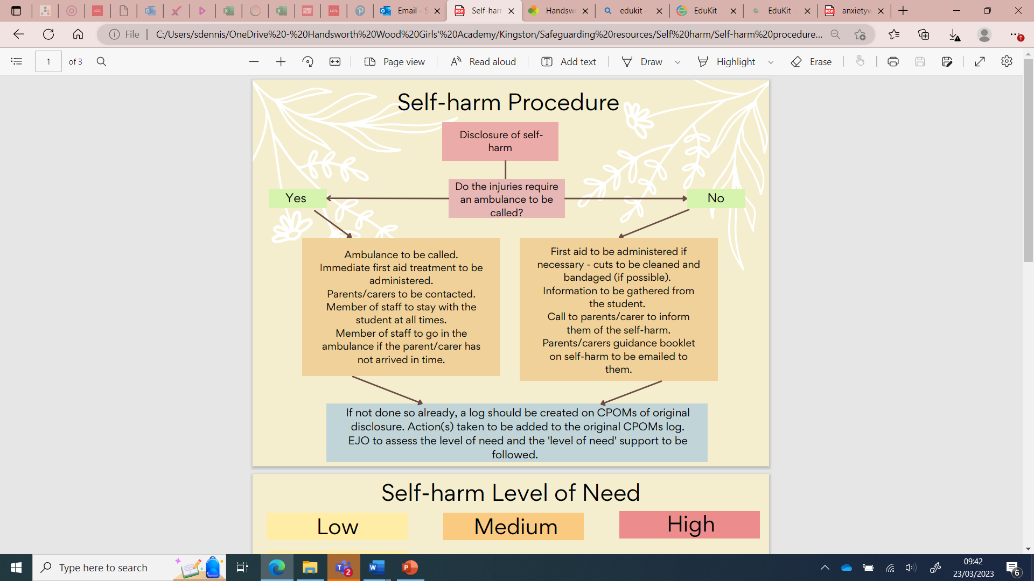
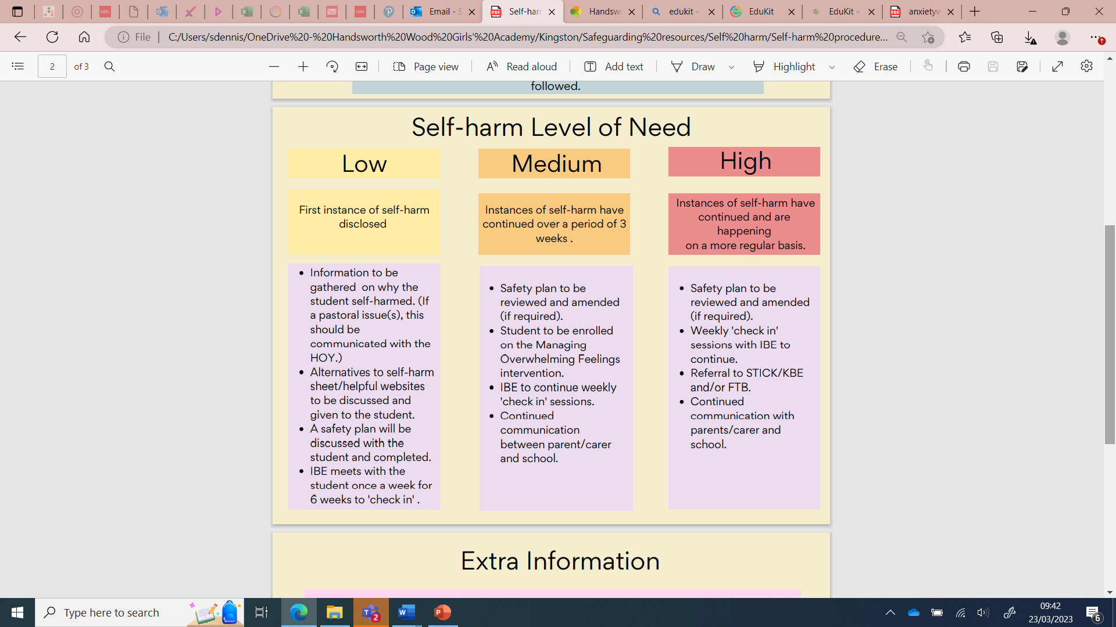

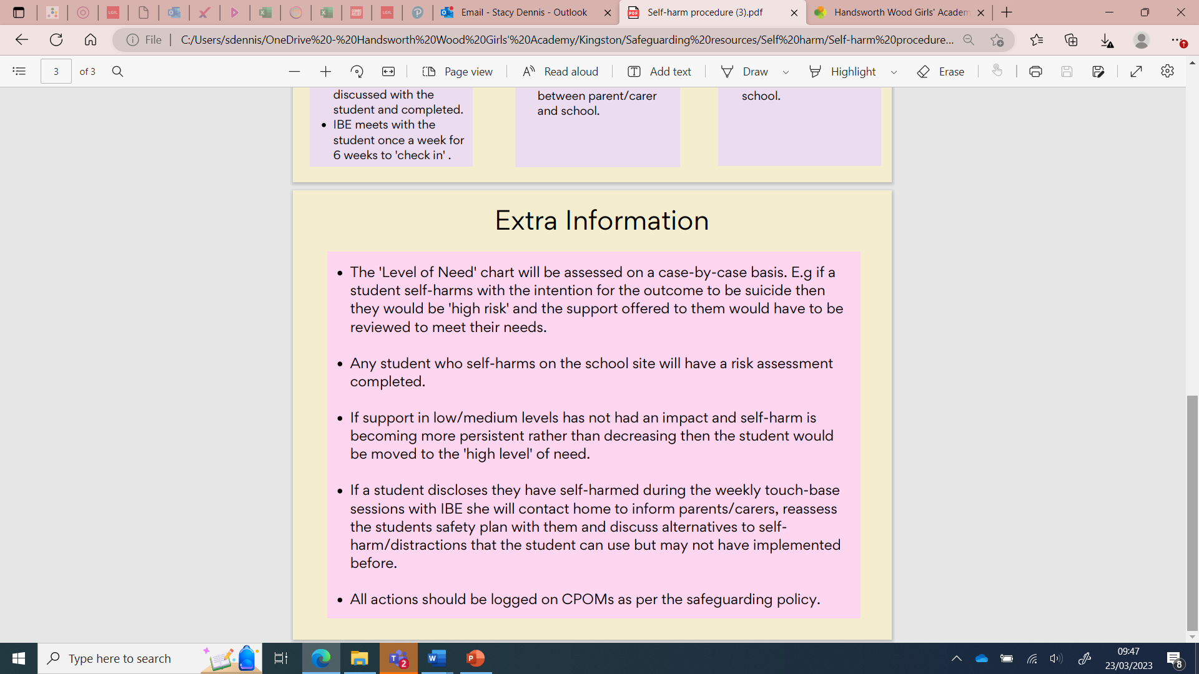

Child-on-child abuse
It is important that staff recognise that children are capable of abusing their peers, and sometimes do, and that this abuse can include bullying, physical abuse, sharing nudes and semi-nudes, initiation/hazing, upskirting, sexual violence and harassment.
Harmful Sexual Behaviour (HSB) can, in some cases, progress on a continuum. Addressing inappropriate behaviour can be an important intervention that helps prevent problematic, abusive and/or violent behaviour in the future. Children displaying HSB have often experienced their own abuse and trauma, so it is important that they are offered appropriate support.
When referring to sexual violence this policy is referring to sexual offences under the Sexual Offences Act 2003 as described below:
- Rape: A person (A) commits an offence of rape if: there is intentional penetration of the vagina, anus or mouth of another person (B) with his penis, (B) does not consent to the penetration and (A) does not reasonably believe that (B) consents.
- Assault by penetration: A person (A) commits an offence if: they intentionally penetrate the vagina, anus or mouth of another person (B) with a part of their body or anything else, the penetration is sexual, (B) does not consent to the penetration and (A) does not reasonably believe that (B) consents.
- Sexual assault: A person (A) commits an offence of sexual assault if: they intentionally touch another person (B), the touching is sexual, (B) does not consent to the touching and (A) does not reasonably believe that (B) consents.
We must follow both national and local guidance and policies to support any young people subject to child on child abuse.
Further information can be found in the following policies: Sexual violence and Harassment Policy and Behaviour and Rewards Policy.

Why is all of this important?
It is important for children to receive the right help at the right time to address risks and prevent issues escalating. Research and serious case reviews have repeatedly shown the dangers of failing to take effective action. Examples of poor practice include:
- failing to act on and refer the early signs of abuse and neglect;
- poor record keeping;
- failing to listen to the views of the child;
- failing to re-assess concerns when situations do not improve;
- not sharing information;
- sharing information too slowly; and
- a lack of challenge to those who appear not to be taking action.

WHAT WE WILL DO WHEN WE ARE CONCERNED – EARLY HELP RESPONSE

Where unmet needs have been identified for a child utilising the Right Help Right Time (https://lscpbirmingham.org.uk/working-with-children/right-help-right-time) model but there is no evidence of a significant risk, the DSL’s will oversee the delivery of an appropriate Early Help response. The young person’s voice will remain paramount within a solution focused practice framework. The primary assessment document is the Family Connect Form (https://www.birmingham.gov.uk/info/50224/birmingham_children_s_partnership/2156/birmingham_children_s_partnership_-_resources) available from the local authority where the young person lives.

If a Think Family or social care response is needed to meet an unmet safeguarding need, the DSL will initiate a Request for Support (https://www.birminghamchildrenstrust.co.uk/downloads/file/24/request_for_support), seeking advice from Children’s Advice and Support Service (CASS - https://www.birminghamchildrenstrust.co.uk/contact) as required. The DSL will lead on liaising with other agencies and setting up the Our Family Plan. They will then oversee the agreed intervention from school as part of the multi-agency safeguarding response and ongoing school-focused support. This multi-agency plan will then be reviewed regularly and progress updated towards the goals until the unmet safeguarding needs have been addressed.

The Senior Leadership Team will analyse safeguarding data and practice to inform strategic planning and staff CDP (CPD). When issues arise, the Headteacher should speak out, addressing them internally where possible and escalating when this is unsuccessful.

All staff must follow this basic procedure to respond to concerns about a young person (appendix 5).

Staff who work directly with children can refer to appendix 4 for additional information about safeguarding issues and forms of abuse.

ROLES AND RESPONSIBILITIES OF THE DESIGNATED SAFEGUARDING LEAD (DSL) AND DEPUTY DSLs

- Governing bodies and proprietors should ensure an appropriate senior member of staff from King Edward VI Handsworth Wood Girls’ School is appointed to the role of Designated Safeguarding Lead (DSL).
- The DSL should take lead responsibility for safeguarding and child protection (including online safety). This should be explicit in the role holder’s job description.
- The DSL should have the appropriate status and authority within King Edward VI Handsworth Wood Girls’ School to carry out the duties of the post.
- The role of the DSL carries a significant level of responsibility, and they should be given the additional time, funding, training, resources and support they need to carry out the role effectively.
- Their additional responsibilities include providing advice and support to other staff on child welfare, safeguarding and child protection matters, taking part in strategy discussions and inter-agency meetings, and/or supporting other staff to do so, and contributing to the assessment of children.
- Any deputies should be trained to the same standard as the DSL and the role should be explicit in their job description.
- Whilst the activities of the DSL can be delegated to appropriately trained deputies, the ultimate lead responsibility for safeguarding and child protection remains with the DSL. This responsibility should not be delegated.
- The DSL team in King Edward VI Handsworth Wood Girls’ School is:
- Lead: Stacy Dennis
- Deputies: Emma Jones, Aroosa Liaquat, and Amy Dingwall
- During term time a member of the DSL team will always be available (during school hours) for staff in King Edward VI Handsworth Wood Girls’’ School to discuss any safeguarding concerns. In exceptional circumstances availability via phone and/or other such media is acceptable.
- During out of hours/out of term time, parents, staff and pupils are signposted via Out of School automated email responses to external agencies, safeguarding policies on the school website (https://www.hwga.org.uk), or
https://www.schoolsofkingedwardvi.co.uk/wellbeinghub/.
- Safeguarding and Child Protection information will be dealt with in a confidential manner. Safeguarding records will be stored securely in a central place separate from academic records. Individual files will be kept on CPOMS for each pupil: King Edward VI Handsworth Wood Girls’’ School will not keep family files. Files will be kept for at least the period during which the student is attending King Edward VI Handsworth Wood Girls’ School, and beyond that in line with current data legislation and guidance.
- The DSL will help promote educational outcomes by sharing the information about the welfare, safeguarding and child protection issues that children, including children with a social worker, are experiencing, or have experienced, with teachers and school and leadership staff. This will include ensuring that school staff know who these children are, understand their academic progress and attainment and maintain a culture of high aspirations for this cohort.
- Staff will be informed of relevant details only when the DSL feels their having knowledge of a situation will improve their ability to support an individual child and/or family. This written record will be made on CPOMS of what information has been shared, with whom, and when.
- The DSL and Deputy DSLs will support teaching staff to identify the challenges that children at risk might face and the additional academic support and adjustments that they could make to best support these children.
- The DSL/Deputy DSLs will refer cases of suspected abuse to the Local Authority Safeguarding Children Partnership as required; support staff who make referrals; refer cases to Channel or support staff who do; refer cases to DBS as required; or refer to the police where a crime may have been committed.
- The DSL/Deputy DSLs will lead on liaising with other agencies and setting up an inter-agency Early Help Assessment if appropriate.
- The DSL and any deputies are expected to:
- act as a point of contact with the three safeguarding partners and work with other agencies in line with Working Together to Safeguard Children. NSPCC- When to call the police (https://www.nspcc.org.uk/keeping-children-safe/reporting-abuse/) should help DSLs understand when they should consider calling the police and what to expect when they do;
- liaise with the headteacher to inform him or her of issues - especially ongoing enquiries under section 47 of the Children Act 1989 and police investigations. This should include being aware of the requirement for children to have an Appropriate Adult. Further information can be found in the Statutory guidance - PACE Code C 2019 (https://www.gov.uk/government/publications/pace-code-c-2019);
- as required, liaise with the “case manager” (as per Part Four KCSiE) and the designated officer(s) at the local authority for child protection concerns in cases which concern a staff member;
- liaise with staff (especially pastoral staff, school nurses, IT Technicians, and SENCO) on matters of safety and safeguarding (including online and digital safety) and when deciding whether to make a referral by liaising with relevant agencies so that children’s needs are considered holistically;
- liaise with the senior mental health lead and, where available, the mental health support team, where safeguarding concerns are linked to mental health;
- promote supportive engagement with parents/carers in safeguarding and promoting the welfare of children, including where families may be facing challenging circumstances;
- work with the headteacher and relevant strategic leads, taking lead responsibility for promoting educational outcomes by knowing the welfare, safeguarding and child protection issues that children in need are experiencing, or have experienced, and identifying the impact that these issues might be having on children’s attendance, engagement and achievement at school. This Includes:
  - ensuring that King Edward VI Handsworth Wood Girls’ School knows who its cohort of children who have or have had a social worker are;
  - understanding their academic progress and attainment, and maintaining a culture of high aspirations for this cohort, and
  - supporting teaching staff to provide additional academic support or reasonable adjustments to help children who have or have had a social worker reach their potential, recognising that even when statutory social care intervention has ended, there is still a lasting impact on children’s educational outcomes.; and
- act as a source of support, advice and expertise for all staff.
- Parents will be made aware of information held on their children and kept up to date regarding any concerns or developments by the appropriate members of staff, if this does not compromise a child’s safety. General communications with parents will be in line with any home school policies and give due regard to which adults have parental responsibility.
- The DSL and any deputies will undergo training to provide them with the knowledge and skills required to carry out the role. The training is updated every two years. The DSL will also undertake Prevent awareness training.
- Training should provide DSLs with a good understanding of their own role, and the processes, procedures and responsibilities of other agencies, particularly children’s social care, so they can:
- understand the assessment process for providing early help and statutory intervention, including local criteria for action and local authority children’s social care referral arrangements; have a working knowledge of how local authorities conduct a child protection case conference and a child protection review conference and be able to attend and contribute to these effectively when required to do so;
- ensure each member of staff has access to, understands, and appropriately uses, King Edward VI Handsworth Wood Girls’ School’s Safeguarding and Child Protection Policy and procedures, especially new and part time staff;
- ensure King Edward VI Handsworth Wood Girls’ School’s Safeguarding and Child Protection Policy is reviewed annually (as a minimum) and the procedures and implementation are updated and reviewed regularly, and work with governing bodies or proprietors regarding this;
- ensure the Safeguarding and Child Protection Policy is available publicly and parents know that referrals about suspected abuse or neglect may be made and the role of King Edward VI Handsworth Wood Girls’ School in this;
- link with the safeguarding partner arrangements to make sure staff are aware of any training opportunities and the latest local policies on local safeguarding arrangements;
- be alert to the specific needs of children in need, those with special educational needs and young carers;
- understand relevant data protection legislation and regulations, especially the Data Protection Act 2018 and the General Data Protection Regulation;
- understand the importance of information sharing, both within King Edward VI Handsworth Wood Girls’ School, and with the three safeguarding partners, other agencies, organisations and practitioners;
- are able to keep detailed, accurate, secure written records of concerns and referrals;
- understand and support King Edward VI Handsworth Wood Girls’ School with regards to the requirements of the Prevent duty and are able to provide advice and support to staff on protecting children from the risk of radicalisation;
- are able to understand the unique risks associated with online safety and be confident that they have the relevant knowledge and up to date capability required to keep children safe whilst they are online at school;
- can recognise the additional risks that children with SEN and disabilities (SEND) face online, for example, from online bullying, grooming and radicalisation and are confident they have the capability to support SEND children to stay safe online;
- obtain access to resources and attend any relevant or refresher training courses; and
- encourage a culture of listening to children and taking account of their wishes and feelings, among all staff, in any measures King Edward VI Handsworth Wood Girls’ School may put in place to protect them.
- In addition to their formal training as set out above, the DSL and deputies’ knowledge and skills should be updated, (for example via e-bulletins, meeting other DSLs, or taking time to read and digest safeguarding developments), at regular intervals, and at least annually, to keep up with any developments relevant to their role.

Information sharing and managing the child protection file

It is not necessary for us to maintain general student paper files as we store records electronically on CPOMs. However, the DSL is responsible for ensuring that child protection files are kept up to date.

All Child Protection files are kept centrally by the DSL and are only accessible to DSLs in school. Access to records by staff other than by the Pastoral Team is restricted. Where the file or content within it is shared, this will be in line with information sharing advice as set out in KCSiE Part One and Part Two.

Records should include:
• a clear and comprehensive summary of the concern;
• details of how the concern was followed up and resolved;
• a note of any action taken, decisions reached and the outcome.

If a student moves from school, Child Protection and Safeguarding records will be forwarded on to the DSL at the new school, with due regard to their confidential nature and in line with current government guidance on the transfer of such records. The child protection file should be transferred to the new school or college as soon as possible, and within 5 days for an in-year transfer or within the first 5 days of the start of a new term. This should be transferred separately from the main pupil file, ensuring secure transit, and confirmation of receipt should be obtained. If sending by post, pupil records will be sent by “Special/Recorded Delivery”.

Receiving schools and colleges should ensure the DSL and/or SENCO is aware as required.

Lack of information about their circumstances can impact on the child’s safety, welfare and educational outcomes. In addition to the child protection file, the DSL will also consider if it would be appropriate to share any additional information with the new school or college in advance of a child leaving to help them put in place the right support to safeguard this child and to help the child thrive in King Edward VI Handsworth Wood Girls’ School or college. For example, information that would allow the new school or college to continue supporting children who have had a social worker and been victims of abuse and have that support in place for when the child arrives.

For audit purposes, a note of all student records transferred or received will be kept in electronic format. This will include the child’s name, date of birth, where and to whom the records have been sent and the date sent and/or received.

If a student is permanently excluded and moves to a Pupil Referral Unit, Child Protection records will be forwarded on to the relevant organisation.

Where a susceptible child is moving to a Further Education establishment, consideration should be given to the pupil’s wishes and feelings regarding their child protection information being passed on in order that the FE establishment can provide appropriate support.

When a DSL resigns their post or no longer has Child Protection responsibility, there should be a full face to face handover/exchange of information with the new post holder. In exceptional circumstances, when a face-to-face handover is unfeasible, the Headteacher will ensure that the new post holder is fully conversant with all procedures and case files.

DSL support
The Foundation recognises the importance of practice oversight and multiple perspectives in safeguarding and child protection work. We support staff by providing opportunities for reflective practice including opportunity to talk through all aspects of safeguarding work within education with a DSL and to seek further support as appropriate.
• Regular safeguarding supervision will be offered to the Lead DSL within school;
• Supervision will be offered half termly but safeguarding supervision may need to be offered more frequently and extended to other members of staff as deemed appropriate by King Edward VI Handsworth Wood Girls’ School;
• DSLs will be supported to access training as appropriate including training in behaviour and mental health;
• All DSLs will have access to the monthly Designated Safeguarding Lead case-consultation sessions organised by BCC’s Education Safeguarding team.

Child Safeguarding Practice Reviews, Domestic Homicide Reviews and Lessons Learnt Reviews
Senior leaders will analyse safeguarding data and practice and ensure that all staff receive updates about the relevant outcomes and findings of local and national Child Safeguarding Practice Reviews, Domestic Homicide Reviews and Lessons Learnt Reviews at least once per year.
Where a case is relevant to King Edward VI Handsworth Wood Girls’ School, we will ensure that we fully support Child Safeguarding Practice Reviews, Domestic Homicide Reviews and Lessons Learnt Reviews with all necessary information and implement the resulting actions and learning. We will collaborate with Birmingham Safeguarding Children Partnership to share information.

THE DESIGNATED TEACHER FOR LOOKED AFTER AND PREVIOUSLY LOOKED AFTER CHILDREN

- The Governing body must appoint a Designated Teacher and should work with local authorities to promote the educational achievement of registered pupils who are looked after.
- Our Designated Teacher will have responsibility for promoting the educational achievement of young people who have left care through adoption, special guardianship or child arrangement orders or who were adopted from state care outside England and Wales.
- The Designated Teacher must have appropriate training and the relevant qualifications and experience. The Designated Teacher is: Stacy Dennis
- Our Designated Teacher will:
- Work with the Virtual school to provide the most appropriate support utilising the pupil premium plus to ensure they meet the needs identified in the child’s personal education plan.
- Work with the Virtual School Headteacher to promote the educational achievement of previously looked after children.
- Keep the details of Birmingham Children’s Trust Personal Advisor appointed to guide and support the care leaver, and will liaise with them as necessary regarding any issues of concern affecting the care leaver.
- Birmingham Children’s Trust has on-going responsibilities to the young people who cease to be looked after and become care leavers. That includes keeping in touch with them, preparing an assessment of their needs and appointing a personal advisor who develops a pathway plan with the young person. This plan describes how the Birmingham Children’s Trust will support the care leaver to participate in education or training. The Designated Person for Looked After Children will have the details of the local authority personal advisor and will liaise with them as necessary regarding any issues of concern affecting the care leaver.

Kinship Care

Our Designated Teacher will have responsibility for promoting the educational achievement of young people who are in kinship care arrangements, have left care through adoption, special guardianship or child arrangement orders or who were adopted from state care outside England and Wales.
The Designated Teacher must have appropriate training and the relevant qualifications and experience. The Designated Teacher is: Stacy Dennis.

Appendix 11 - Information for children and families: Charity Contact Details and Helplines

Suicide prevention and Self Harm

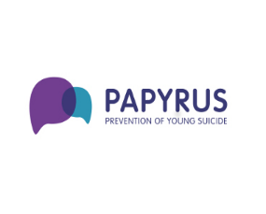
PAPYRUS
The national charity dedicated to the prevention of young suicide.
Helpline - 0800 068 41 41
Text: 07860 039 967
Email: pat@papyrus-uk.org

CALM
The Campaign Against Living Miserably (CALM) is leading a movement against suicide.
Helpline - 0800 58 58 58
Website - https://www.thecalmzone.net/

Forward Thinking Birmingham
The city's mental health partnership for 0-25 year olds.

Phone: 0300 3000 099
Website: https://www.forwardthinkingbirmingham.org.uk/


Samaritans
We’re here, day or night, for anyone who’s struggling to cope, who needs someone to listen without judgement or pressure.
Phone: 116 123
Website: https://www.samaritans.org/
Write to them: Chris
Freepost RSRB-KKBY-CYJK
PO Box 9090
STIRLING FK8 2S
Email: jo@samaratans.org


Forward For Life
A Social Enterprise that through our programmes of work and training aim to support our communities and professionals from across the board to become more suicide aware and be enablers of improved quality of life.
Phone: 07585776800
Website: https://forwardforlife.org/
Email: info@forwardforlife.org

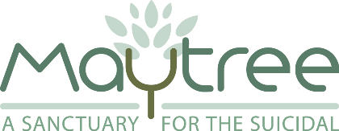
Maytree
Maytree is a national registered charity. We provide a unique residential service for people in suicidal crises so they can talk about their suicidal thoughts and behaviour.

Phone: 02072 637 070.
Website: https://www.maytree.org.uk/
Email : maytree@maytree.org.uk

Common Unity
We are a Health and Social Care organisation with a difference working in mental health and well-being. We work with communities traditionally seen as ‘hard to reach.’
Phone: 01215 549 360
Website: https://www.common-unity.org/

Self Injury Support
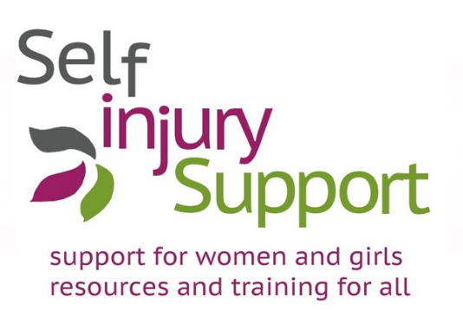
We run a UK-wide multi-channel support service for women & Girls’ affected by self-injury, trauma and abuse.
Helpline: 0808 800 8088 (Open Tuesday, Wednesday and Thursday, 7pm – 9.30pm)
Text: 07537 432444 (Open Tuesday, Wednesday and Thursday, 7pm – 9.30pm)
Email: tessmail@selfinjurysupport.org.uk
Website: https://selfinjurysupportltd.eu.rit.org.uk/


Abuse
NAPAC - National Association of People Abused in Childhood
NAPAC (the National Association for People Abused in Childhood) offers support to adult survivors of all types of childhood abuse, including physical, sexual, emotional abuse or neglect.
Phone: 08088 010 331
Website: https://napac.org.uk/


See me, Hear me
Fight against child sexual exploitation .
Website: https://www.seeme-hearme.org.uk/helpandadvice


Rape and Sexual Violence Project
Providing support across Birmingham and Solihull
Helpline: 0121 643 4136
Website: https://rsvporg.co.uk/

Horizon sexual assault referral centre

Supporting the victims of Rape or Serious Sexual Assault
Helpline: 0800 970 0375 (self referral)
Website: https://horizonsarc.org.uk/

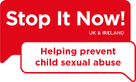
Stop it Now
Helpling prevent child sexual abuse. As a child protection charity, we campaign and raise awareness across the UK to help adults to do their part to stop child sexual abuse by addressing personal, family and community concerns.
Helpline: 0808 1000 900
Website: https://www.stopitnow.org.uk/helpline/


Birmingham and Solihull Women’s Aid
We support women and children affected by domestic violence and abuse.

Helpline: 0808 800 0028
Text service helpline: 18001 0808 800 0028
Website: https://bswaid.org/

National Domestic Violence Helpline
The freephone, 24-hour National Domestic Abuse Helpline
Helpline: 0808 2000 247


Children's Advice and Support Service (CASS)
The Children's Advice and Support Service (CASS) provides a single point of contact for professionals and members of the public who want to seek support or raise concerns about a child.

Helpline: 0121 303 1888
Emergency out of hours contact no: 0121 675 4806


Cranstoun Domestic Abuse
Offer a wide range of serices across England including community-based substance misuse services, supported housing, specialist services for young people, families, carers, and domestic abuse services.
Helpline: 020 5335 1830

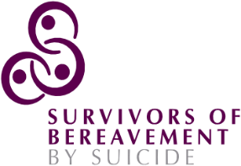
Bereavement
SOBS - Survivors of Bereavement by Suicide
We exist to meet the needs and overcome the isolation experienced by people over 18 who have been bereaved by suicide.
Helpline: 0300 111 5065
Website: https://uksobs.org/
Email: email.support@uksobs.org

Cruse Bereavement Birmingham

Our mission is to offer support, advice and information to children, young people and adults when someone dies and to enhance society’s care of bereaved people.
Helpline: 0808 808 1677
Website: https://www.cruse.org.uk/

National Bereavement Partnership
Our purpose is to provide a helpline for all individuals seeking information, advice and support.
Helpline: 0800 448 0800
Text message service: 07860 022 814
Website: https://www.nationalbereavementpartnership.org/


Eating disorders
Anorexia and Bulimia Care
We provide on-going care, emotional support and practical guidance for anyone affected by eating disorders and eating distress.
Helpline: 03000 11 12 13
Website: https://www.anorexiabulimiacare.org.uk/


Newbridge
Our service is for children and young people aged 8 to 18 with distinct units for younger and older age groups and an outpatient clinic which is open to adults as well as young people, treating a range of eating disorders.
Website: https://www.newbridge-health.org.uk/

Phone: 0121 580 8362
BEAT Eating disorders
Helpline: 0808 801 0711 (under 18)
Helpline: 0808 801 0677 (over 18)
Website: https://www.beateatingdisorders.org.uk/


National Centre for Eating Disorders
Have personal, telephone or Skype counselling from someone who fully understands and cares.
Helpline: 0845 838 2040
Website: https://eating-disorders.org.uk/

Mental Health

Birmingham Solihull Mental Health foundation trust (BSMHFT)
Birmingham and Solihull Mental Health NHS Foundation Trust provides a comprehensive mental healthcare service for residents of Birmingham and Solihull, and a range of specialist mental health services to communities across the West Midlands and beyond
Phone: 012130100000
Website : https://www.bsmhft.nhs.uk/


Mind
Birmingham Mind is the largest independent mental health charity providing services in and beyond the City of Birmingham’s boundaries.
Helpline : 01216088001
Website: https://birminghammind.org/


Samaritans - Birmingham
Samaritans is a registered charity aimed at providing emotional support to anyone in emotional distress, struggling to cope, or at risk of suicide throughout the United Kingdom and Ireland, often through their telephone helpline.
Helpline: 116 123
Website: https://www.samaritans.org/branches/birmingham/


Young minds
Young Minds exists so that young people have the strongest possible voice in improving their mental health. We need your help to make sure that voice is heard.
Child Helpline: If you need urgent help text YM to 85258.
Parent helpline: 0808 802 5544

Recovery focus
We are Recovery Focus, a group of charities highly experienced in providing specialist support services to individuals and families living with the effects of mental ill health, drug and alcohol use, gambling and domestic violence.
Website: https://www.recoveryfocus.org.uk/contact-us/

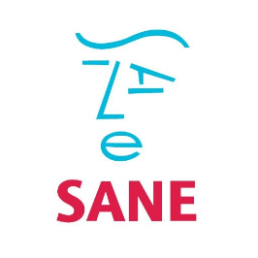
Sane
SANE is a leading UK mental health charity. We work to improve the quality of life for anyone affected by mental illness.
Helpline: 07984 967 708
Email: support@sane.org.uk
Website: http://www.sane.org.uk/

Bipolar UK

Our mission is to empower everyone affected by bipolar to live well and fulfil their potential.
Phone: 03333 233 880
Website: https://www.bipolaruk.org/


No Panic
No Panic is a registered charity which helps people who suffer from Panic Attacks, Phobias, Obsessive Compulsive Disorders and other related anxiety disorders including those people who are trying to give up Tranquillizers.
Helpline: 0300 7729844
Youth Helpline: 0330 606 1174


The Association for Child and Adolescent Mental Health
Professor Jess Deighton, Professor of Child Mental Health and Wellbeing at University College London and Director of the Evidence Based Practice Unit at the Anna Freud National Centre for Children and Families, talks about the role schools can play in young people’s mental health, about school-based interventions, and some insights from her latest research.
https://www.acamh.org/about-acamh/


Mentally Healthy Schools
The Anna Freud Centre has an entire resource hub devoted to getting pupils and staff on the path to becoming a mentally healthy school, featuring a new toolkit for transitions into new schools, college, or leaving education, published this month. Other resources offer guidance to support children with anxiety, promote gender equality, Girls’’ rights in schools and tips for lesson plans on coercive control and sexual harassment in the workplace.
https://www.mentallyhealthyschools.org.uk/getting-started/secondary-and-fe/

Child marriage

Karma Nirvana
Supporting victims of honour based abuse and child marriage.
Helpline: 0800 5999 247

Right to choose
West midlands child marriage and honour based abuse helpline.
Helpline: 0800 953 9777


Child marriage Unit
The Child marriage Unit was set up in 2005 and provides support to victims as well as expert training and guidance to professionals. It is jointly run by the Home Office and Foreign and Commonwealth Office. In 2011 they dealt with over 1400 calls in relation to child marriages.

Phone: 020 7008 0151
Website: https://www.haloproject.org.uk/forced-marriage-unit-W21page-31

Homelessness

Shelter
Shelter helps millions of people every year struggling with bad housing or homelessness through our advice, support, and legal services.
Helpline: 0808 800 4444
Website: https://england.shelter.org.uk/


BCC Emergency Accommodation- out of hours
If you have nowhere to stay tonight then we may provide you with emergency accommodation to relieve your homelessness providing you are eligible for social housing.

Over 18’s helpline: 0121 303 2296
Under 18’s helpline: 0121 675 4806
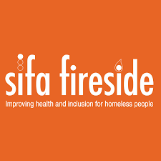
Sifa Fireside
Birmingham’s main day centre for homeless and vulnerably housed adults.
Drop-in centre address: 48-52 Allcock St, Deritend, Birmingham B9 4DY
Drop in - Monday-Friday, 9am-12.45pm.
Breakfast: 9am-10am Lunch: 12pm-12:45pm.
Information line: 0121 766 1700

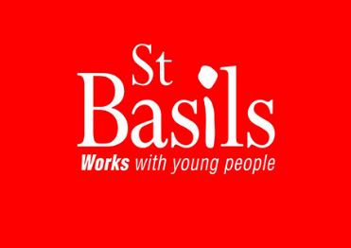
St Basil’s (16-25)
St Basils works with young people to enable them to find and keep a home, grow their confidence, develop their skills, increase opportunities and prevent homelessness.

Helpline: 0300 303 0099
Text: NEED ST BASILS’ to 62277.
Email: youthline@stbasils.org.uk
Website: https://stbasils.org.uk

Sexuality

Birmingham LGBT

A local charity that delivers services to the Lesbian, Gay, Bisexual and Trans community in the city.
Phone: 0121 643 0821
Website : https://blgbt.org/

Quest - Pastoral Support for LGBT catholics
Bearing witness to the reality of LGBT+ Catholic lives since 1973.
Phone: 0300 123 1989
Website: https://questlgbti.uk/

Sarbat - LGBT Sikhs
Sarbat is a volunteer led group addressing LGBT issues from a Sikh perspective. We empower our members to encourage discussions, tackle homophobia/biphobia/transphobia and build bridges within and beyond their communities
Website: http://www.sarbat.net/


Stonewall
We work to ensure that LGBT people, across all communities, are valued, welcomed by all and can participate fully in society, and to ensure that LGBT people better understand and respect difference across LGBT life.

Website and contact details: https://www.stonewall.org.uk/contact-us
Umbrella
Free sexual health services for Birmingham and Solihull.
Phone: 0121 237 5700
Website: https://umbrellahealth.co.uk/


Brook
Your free and confidential sexual health and wellbeing experts.
Website: https://www.brook.org.uk/


Saving Lives
Saving Lives is a national charity with a simple aim: to reduce the stigma that still surrounds testing for the blood-borne viruses [BBVs] known as HIV andHepatitis. We also focus on other Sexually Transmitted Infections [STIs].
Website: https://www.savinglivesuk.com/
Contact: https://www.savinglivesuk.com/contact-us/

Positively UK

Talk to us about any aspect of your diagnosis, care and living with HIV.
Website: https://positivelyuk.org/
Phone: 02077130444

Substance Misuse

Drugwise

To provide drug information which is topical, evidence-based and non-judgemental – and to promote this through media work, public speaking and lecturing.
Website: https://www.drugwise.org.uk/


Reach Out Recovery Birmingham
Phone: 01212275890
Website: https://www.changegrowlive.org/drug-alcohol-service-birmingham/north

Reach Out Recovery is a free and confidential drug and alcohol service for adults and affected others in Birmingham. We offer treatment and recovery services to support anyone experiencing difficulties with drugs and/or alcohol in a range of local community settings across Birmingham.


Beyond recovery
Beyond Recovery is a fast growing new social enterprise already making a proven difference to people with repeat offending behaviour, complex mental health issues and drug and alcohol problems who are involved in the criminal justice system.
Phone: 01788 315694
Website: https://beyond-recovery.co.uk/

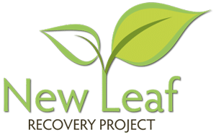
New Leaf recovery project
Our rehabilitation centre is based in Birmingham offers 24-hour support for all of our residents and our drug and alcohol rehab programmes will help you to overcome your addiction and turn over a new leaf.
Phone: 0300 999 0330
Website: https://www.newleafrecovery.co.uk/


Turning Point
We provide a wide range of health and wellbeing services.
Whether you come to us with drug or alcohol issues, a mental health concern or a learning disability, we'll give you the individual support you need.
Phone: 01216326363
Website: https://www.turning-point.co.uk/


We Are With You
Get free, confidential support with alcohol, drugs or mental health from one of our local services or online.
Website: https://www.wearewithyou.org.uk/
Online webchat: https://www.wearewithyou.org.uk/help-and-advice/about-our-online-chat/#open-webchat


Talk to Frank
A-Z list of substances
Phone: 03001236600
Website: https://www.talktofrank.com/


Aquarius/ Life Line
We help workplaces and education providers support their people with issues relating to alcohol, drugs and gambling.
Website: https://www.aquariuslife.org.uk/
Phone: 01216228181

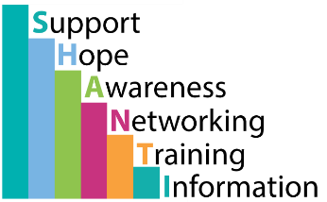
Shanti
SHANTI is a service provided by Aquarius, funded by the Big Lottery to reduce the harms around alcohol misuse within the Punjabi Sikh community in Birmingham.
Phone: 01214509650
Website: http://www.ipwm.org.uk/SHANTI/Pathway-Services/

Kikit
KIKIT supports the health and social care needs of people from hard to reach and marginalised communities, including Black, Asian, Minority and Ethnic communities (BAME).
Website: https://kikitproject.org/
Phone: 01214483883

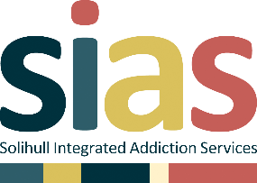
Sias
SIAS is a partnership of organisations that work closely together to offer easy access to appropriate support and treatment for individuals whose drug or alcohol use, or gambling has become problematic. We also offer support to their families and friends.
Website: https://www.sias-solihull.org.uk/
Phone: 01213014141

Female Genital Mutilation (FGM)

NSPCC FGM Helpline

Contact the NSPCC anonymously if you’re worried that a girl or young woman is at risk or is a victim of FGM.
Email: fgmhelp@nspcc.org.uk
Phone: 0800 028 3550

Orchid Project
Orchid Project are an NGO catalysing the global movement to end female genital cutting (FGC).
Phone: +44 (0) 20 3752 5505
Email: info@orchidproject.org


Young Carers

Forward Carers
Our mission is to improve the physical and mental wellbeing of Carers, young and old, including parent Carers, so that families stay healthier and happier together, for longer.
Phone: 0333 006 9711
Website: https://forwardcarers.org.uk/


Birmingham Young Carers
Birmingham Young Carers provides support for Young Carers up to the age of 18.
Phone: 0121 638 0876
Email: birminghamyc@spurgeons.org
Website: https://spurgeonsyc.org/birmingham/

Carers UK
We give carers expert advice, information and support. We campaign and innovate to find better ways to reach and support carers.
Phone: 020 7378 4999
Website: https://www.carersuk.org/

Debt Advice


Birmingham Citizens Advice
Our team of specialist debt advisers can help you resolve your debt problems, whatever the cause or amount you owe.
Phone: 0121 214 8367
Email: debthelp@bcabs.cabnet.org.uk
Website: http://www.bcabs.org.uk/page/view/debt


National debtline
National Debtline is a debt advice charity run by the Money Advice Trust. We are a free and confidential debt advice service for people in England, Wales and Scotland.
Phone: 0808 808 4000
Website: https://www.nationaldebtline.org/

Stepchange debt charity
We provide the UK’s most comprehensive debt advice service. We help people with debt problems take back control of their finances and their lives.
Phone: 0800 138 1111
Website: https://www.stepchange.org/

Counselling

Kooth
Free, safe and anonymous support
Website: https://www.kooth.com/

7 cups

7 cups connects you to caring listeners for free emotional support.
Website: https://www.7cups.com/


Pause
Offering telephone support 10am - 6pm, 7 days a week.
Helpline: 0207 841 4470

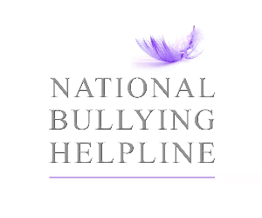
Bullying

National Bullying Helpline
Practical help and advice for children and adults dealing with bullying at school or work.
Phone: 0845 22 55 787
Website: https://www.nationalbullyinghelpline.co.uk/


Bullying UK
Get advice on all aspects of bullying, from online to bullying at work.
Phone: 0808 800 2222
Website: https://www.bullying.co.uk/general-advice/

Family support

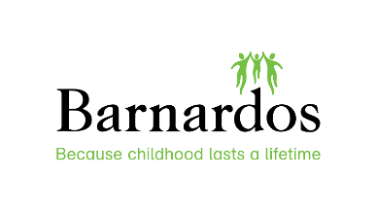
Barnardos
Parenting support.
Phone: 01215 505 271
Website:https://barnardos-parenting.org.uk/


The Springfield Project
Support for families in the local area.
Phone: 0121 777 2722
Website: https://www.springfieldproject.org.uk/

Malachi Specialist Family Support
Malachi are a not for profit, therapeutic family support organisation founded in 1991, working across the Midlands and Staffordshire.
Phone: 0121 441 4556
Website: https://www.malachi.org.uk/


The Meriden Family programme
Within this site you will find useful information and resources if you are a person living with mental health issues, a carer, family member, friend, mental health professional or commissioner.
Phone: +44 (0)121 301 2896
Website: https://www.meridenfamilyprogramme.com/


Birmingham Central Foodbank
Helping local people in crisis.
Phone: 0121 236 2997
Address: Birmingham City Church
Parade
Birmingham
B1 3QQ
Website: https://birminghamcentral.foodbank.org.uk/


Harmful Sexual Behaviour Helpline
SWGfL and The Marie Collins Foundation has created a support service for professionals working with children and young people in tackling harmful sexual behaviours, funded by the Home Office and in collaboration with the Department for Education.
The support service is available for anyone in England working with children and young people, particularly, designated safeguarding leads within primary and secondary schools and alternative provision.
Harmful Sexual Behaviour Helpline can support with changing the culture that Ofsted highlighted in their report around sexual abuse in schools. The service, run by trained professionals, provides the tools to equip and empower adults through:
Advice on individual cases or incidents of harmful sexual behaviour
Guidance on policy development on tackling harmful sexual behaviour
Sharing relevant resources, best practice and contacts around harmful sexual behaviour
Harmful Sexual Behaviour Helpline
Available 8am - 8pm Monday - Friday
Phone: 0344 2250623
Email: hsbsupport@swgfl.org.uk

Appendix 12 - Website links

- https://assets.publishing.service.gov.uk/government/uploads/system/uploads/attachment_data/file/1161273/Keeping_children_safe_in_education_2023_-_statutory_guidance_for_schools_and_colleges.pdf
- https://www.legislation.gov.uk/ukpga/2006/40/contents
- https://www.legislation.gov.uk/ukpga/2011/21/notes
- https://www.legislation.gov.uk/ukpga/1989/41/contents
- https://www.equalityhumanrights.com/en/equality-act/protected-characteristics
- https://www.equalityhumanrights.com/en/equality-act-2010/what-equality-act
- https://www.legislation.gov.uk/ukpga/2014/6/part/3/enacted
- https://www.gov.uk/government/publications/working-together-to-safeguard-children--2
- https://www.gov.uk/government/publications/working-together-to-safeguard-children--2
- http://westmidlands.procedures.org.uk/page/contents
- http://www.legislation.gov.uk/ukpga/2002/32/contents
- https://www.gov.uk/government/groups/uk-council-for-child-internet-safety-ukccis
- https://ec.europa.eu/commission/priorities/justice-and-fundamental-rights/data-protection/2018-reform-eu-data-protection-rules_enn)
- https://www.gov.uk/government/publications/data-protection-toolkit-for-schools - Guidance to support schools with data protection activity, including compliance with the GDPR.
- https://ec.europa.eu/commission/priorities/justice-and-fundamental-rights/data-protection/2018-reform-eu-data-protection-rules_en
- https://www.gov.uk/government/publications/mental-health-and-behaviour-in-schools--2
- https://www.birmingham.gov.uk/downloads/file/11545/birmingham_criminal_exploitation_and_gang_affiliation_practice_guidance_2018
- https://www.gov.uk/government/publications/send-code-of-practice-0-to-25
- https://www.gov.uk/government/publications/bullying-in-england-april-2013-to-march-2018
- https://www.pshe-association.org.uk/curriculum-and-resources/resources/sex-and-relationships-education-guidance-dfe-2000
- https://www.lscpbirmingham.org.uk/delivering-effective-support
- https://assets.publishing.service.gov.uk/government/uploads/system/uploads/attachment_data/file/905125/6-1914-HO-Multi_Agency_Statutory_Guidance_on_FGM__-_MASTER_V7_-_FINAL__July_2020.pdf
- https://www.gov.uk/government/publications/prevent-duty-guidance
- https://www.birmingham.gov.uk/rshe
- https://www.nspcc.org.uk/keeping-children-safe/online-safety/sexting-sending-nudes/
- https://assets.publishing.service.gov.uk/government/uploads/system/uploads/attachment_data/file/790549/circular-voyeurism-offences-act-2019.pdf
- https://assets.publishing.service.gov.uk/government/uploads/system/uploads/attachment_data/file/550416/Children_Missing_Education_-_statutory_guidance.pdf
- https://assets.publishing.service.gov.uk/government/uploads/system/uploads/attachment_data/file/1099677/Working_together_to_improve_school_attendance.pdf
- cc) Behaviour in schools - GOV.UK (www.gov.uk)
- https://www.gov.uk/guidance/meeting-digital-and-technology-standards-in-schools-and-colleges/filtering-and-monitoring-standards-for-schools-and-colleges
- https://www.gov.uk/guidance/meeting-digital-and-technology-standards-in-schools-and-colleges/cyber-security-standards-for-schools-and-colleges
- https://www.gov.uk/government/publications/teachers-standards
- https://www.ncsc.gov.uk/information/cyber-security-training-schools
- https://www.gov.uk/government/publications/supporting-pupils-at-school-with-medical-conditions--3
- https://councilfordisabledchildren.org.uk/about-us-0/networks/information-advice-and-support-services-network/find-your-local-ias-service
jj) https://www.gov.uk/government/publications/forced-marriage-resource-pack

Appendix 13 – Online safety

All schools and colleges should continue to consider the safety of their children when they are asked to work online. The starting point for online teaching should be that the same principles as set out in the school’s or college’s staff behaviour policy (sometimes known as a code of conduct) should be followed. This policy should amongst other things include acceptable use of technologies, staff pupil/student relationships and communication including the use of social media. The policy should apply equally to any existing or new online and distance learning arrangements which are introduced.

Schools and colleges should, as much as is reasonably possible, consider if their existing policies adequately reflect that some children (and in some cases staff) continue to work remotely online. As with the child protection policy, in some cases an annex/addendum summarising key coronavirus related changes may be more effective than re-writing/re-issuing the whole policy.

The principles set out in the guidance for safer working practice for those working with children and young people in education settings published by the Safer Recruitment Consortium may help schools and colleges satisfy themselves that their staff behaviour policies are robust and effective. In some areas schools and colleges may be able to seek support from their local authority when planning online lessons/activities and considering online safety.

Schools and colleges should continue to ensure any use of online learning tools and systems is in line with privacy and data protection requirements.

All students are responsible for the devices that they are provided with and must be the sole users of the device. Agreements must be signed and collated to receive a device. It is also the responsibility of students to ensure devices are kept safe and free from damage.

An essential part of the online planning process will be ensuring children who are being asked to work online have very clear reporting routes in place so they can raise any concerns whilst online. As well as reporting routes back to the school or college this should also signpost children to age appropriate practical support from the likes of:

- Childline - for support
- UK Safer Internet Centre - to report and remove harmful online content
- CEOP - for advice on making a report about online abuse

Schools and colleges are likely to be in regular contact with parents and carers. Those communications should continue to be used to reinforce the importance of children being safe online. It will be especially important for parents and carers to be aware of what their children are being asked to do online, including the sites they will asked to access and be clear who from the school or college (if anyone) their child is going to be interacting with online.

Parents and carers may choose to supplement the school or college online offer with support from online companies and in some cases individual tutors. In their communications with parents and carers, schools and colleges should emphasise the importance of securing online support from a reputable organisation/individual who can provide evidence that they are safe and can be trusted to have access to children.

Support for parents and carers to keep their children safe online includes:

- Thinkuknow provides advice from the National Crime Agency (NCA) on staying safe online.
- Parent info is a collaboration between Parentzone and the NCA providing support and guidance for parents from leading experts and organisations.
- Childnet offers a toolkit to support parents and carers of children of any age to start discussions about their online life, to set boundaries around online behaviour and technology use, and to find out where to get more help and support.
- Internet Matters provides age-specific online safety checklists, guides on how to set parental controls on a range of devices, and a host of practical tips to help children get the most out of their digital world.
- London Grid for Learning has support for parents and carers to keep their children safe online, including tips to keep primary aged children safe online.
- Net-aware has support for parents and carers from the NSPCC and O2, including a guide to social networks, apps and games.
- Let’s Talk About It has advice for parents and carers to keep children safe from online radicalisation.
- UK Safer Internet Centre has tips, advice, guides and other resources to help keep children safe online, including parental controls offered by home internet providers and safety tools on social networks and other online services.

Government has also provided:

- Support to stay safe online includes security and privacy settings, blocking unsuitable content, and parental controls.

The department encourages schools and colleges to share this support with parents and carers.

Virtual lessons and live streaming

There is no expectation that teachers should live stream or provide pre-recorded videos, but those who do should ensure they have read and understood the Staff Code of Conduct in relation to this.

Teaching from home is different to teaching in the classroom. Teachers should try to find a quiet or private room or area to talk to pupils, parents or carers. When broadcasting a lesson or making a recording, also consider what will be in the background and ensure that attire is appropriate. Guidance should be shared and agreed by pupils and their parents/carers with respect to them also observing appropriate online behaviours (location, attire etc).

The use of Generative AI (Artificial Intelligence)
Please see the Foundation-wide policy on the use of Generative AI.
Generative artificial intelligence (AI) tools are now widespread and easy to access. Staff, students and parents/carers may be familiar with generative chatbots such as ChatGPT, Claude and Google Gemini. The integration of Artificial Intelligence (AI) in UK schools has evolved significantly over recent years, reflecting both technological advances and the educational community's response to the opportunities and challenges it presents.
According to Ofcom’s 2024 Online Nation Report more than half of children have used generative AI tools in the past year. Teenagers aged 13-15 are more likely to use AI (66%) than those aged 8-12 (46%) and combining both age groups, over half (53%) have made use of AI to support with homework tasks. There is a broad range of purposes for children using AI including finding information, creating images/videos, seeking advice and summarising text, with the most popular tool among 8-15s being ChatGPT (37%) followed by Snapchat My AI (30%).

Our approach and expectations:

- Handsworth Wood Girls Academy acknowledges the benefits of the use of AI in an educational context - including enhancing teaching and learning and outcomes, improving administrative processes, reducing workload and preparing staff and learners for a future in which AI technology will be an integral part. Staff are encouraged to use AI based tools to support their work where appropriate, within the frameworks provided within the wider policy, and are required to be professionally responsible and accountable for this area of their work.
- We will comply with all relevant legislation and guidance, with reference to guidance contained in Keeping Learners Safe.
- We will provide relevant training for staff and governors in the advantages, use of and potential risks of AI. We will support staff in identifying training and development needs to enable relevant opportunities.
- We will ensure that, within our PSHE programme, the students understand the ethics and use of AI and the potential benefits and risks of its use, in an age and stage appropriate manner, in line with their level of understanding. The school recognises the importance of equipping learners with the knowledge, skills and strategies to engage responsibly with AI tools.
- As set out in acceptable use agreements, the school will use AI responsibly and with awareness of data sensitivity. Where used, staff should use AI tools responsibly, ensuring the protection of both personal and sensitive data. Staff should only input anonymised data to avoid the exposure of personally identifiable or sensitive information.
- Staff should always ensure AI tools that are used comply with UK GDPR and other data protection regulations. They must verify that tools meet data security standards before using them for work related to the school.
- Only those AI technologies approved by the school may be used. Staff should always use school-provided AI accounts for work purposes. These accounts are configured to comply with organisational security and oversight requirements, reducing the risk of data breaches.
- We will protect sensitive information. Staff must not input sensitive information, such as internal documents or strategic plans, into third-party AI tools unless explicitly vetted for that purpose. It is imperative that staff must ALWAYS recognise and safeguard sensitive data.
- The school will ensure that when AI is used, it will not infringe copyright or intellectual property conventions – care will be taken to avoid intellectual property, including that of the learners, being used to train generative AI models without appropriate consent.

- AI incidents must be reported promptly. Staff must report any incidents involving AI misuse, data breaches, or inappropriate outputs immediately to SLT and the IT team. Quick reporting helps mitigate risks and facilitates a prompt response. If an AI incident presents a potential safeguarding risk to a child/ren, this must also be reported via CPOMS, in line with this policy.
- The school will audit all AI systems in use and assess their potential impact on staff, learners and the school’s systems and procedures, creating an AI inventory listing all tools in use, their purpose and potential risks.
- We are aware of the potential risk for discrimination and bias in the outputs from AI tools and have in place interventions and protocols to deal with any issues that may arise. When procuring and implementing AI systems, we will follow due care and diligence to prioritise fairness and safety.
- The school will support parents and carers in their understanding of the use of AI in the school including via the newsletter, updates on the Reach More Parents app, and information on the school website.
- AI tools may be used to assist teachers in the assessment of learner’s work and identify areas for improvement. Teachers may also support learners to gain feedback on their own work using AI. Use of these tools should be purposeful, considered and with a clear focus on ensuring impact and understanding and mitigating risk.
- Staff should ensure that documents, emails, presentations, and other outputs influenced by AI include clear labels or notes indicating AI assistance. Clearly marking AI-generated content helps build trust and ensures that others are informed when AI has been used in communications or documents.
- We will prioritise human oversight. AI should assist, not replace, human decision-making. Staff must ensure that final judgements, particularly those affecting people, are made by humans and critically evaluate AI-generated outputs. They must ensure that all AI-generated content is fact-checked and reviewed for accuracy before sharing or publishing. This is especially important for external communication to avoid spreading misinformation.
- Recourse for improper use and disciplinary procedures. Improper use of AI tools, including breaches of data protection standards, misuse of sensitive information, or failure to adhere to this agreement, will be subject to disciplinary action as defined in Staff Disciplinary Policy.
- Staff members must not – unless given specific direction by SLT – use student, staff or family photographs and images in order to create AI-assisted images, often referred to as “deepfakes”.
It is the responsibility of all staff to have read and understood this policy and associated Acceptable Use Agreements. All staff must report any incidents or suspected incidents concerning the use of AI in line with school policy. All staff will challenge any inappropriate behaviour by following the low-level concerns policy and/or the whistleblowing policy.

We recognise that vulnerable learners are more likely to be at risk from the misuse of AI (both in their own use or through the actions of others). We ensure that vulnerable learners are offered appropriate support to allow them to gain full benefit of the use of AI, while being aware of the potential risks.
Children are considered to be vulnerable data subjects and therefore any process involving their personal data is likely to be “high risk”. If an AI/ automated process is used to make significant decisions about people, this is likely to trigger the need for a Data Protection Impact Assessment (DPIA).
We recognise that as a girls’ academy, our students are statistically at an increased risk of being a victim of “deepfake” indecent images and videos. Our students may also engage in the creation of such images, for a variety of reasons including as part of online bullying or “revenge porn”.
We will ensure all students have a thorough understanding of their rights and different options for reporting concerns and seeking support. We will also educate our students on the risks of AI and the legalities around the creation and sharing of such images.
In addition, students with SEND may be at increased risk from the use of AI – in the creation of images but also, in challenges related to critically assessing and spotting AI-generated content. We will therefore ensure these students are educated in an age-and stage – appropriate manner around the risks, and how to critically evaluate information and images online.

Education

The academy’s educational approach seeks to develop knowledge and understanding of emerging digital technologies, including AI. Our approach is to deliver this knowledge and understanding wherever it is relevant within the curriculum. This will include: (
- Computing
- PSHE
- Cross curricular programmes
- 1-1 targeted interventions

Staff Training
- We will provide comprehensive training to all staff on the effective, responsible, and ethical use of AI technologies in education, ensuring these tools enhance teaching, learning, and administrative processes.
- We will integrate AI-related risks and safeguards into annual safeguarding training, aligning with statutory guidance, including "Keeping Learners Safe."
- We will ensure all staff are equipped with the knowledge and skills to confidently integrate AI into their professional practice and to prepare pupils for a future shaped by AI-driven innovation and opportunities.
- We will train staff to identify, assess, and mitigate risks associated with AI technologies, including issues such as biased algorithms, privacy breaches, and harmful content.
- We will train staff on robust data protection practices, ensuring compliance with UK GDPR and other relevant regulations while using AI systems.
- We will promote ethical practices in the use of AI, ensuring that these technologies contribute to equity, fairness, and inclusivity in education.

Appendix 14 – Use of Restrictive Interventions

Restrictive Interventions including Reasonable Force:

Restrictive Interventions is a term we use to describe any means to prevent, restrict, or subdue movement of the body, or part of the body, of a pupil. It is used as an umbrella term to describe both physical and non-physical actions aimed to restrain pupils in different ways. This includes the use of seclusion – a non-disciplinary intervention involving keeping a pupil confined to a place away from others, and preventing them from leaving either by physical obstruction, blocking, or making them believe they will be punished if they try to leave.
The guidance is clear that any restrictive intervention must be:
- Proportionate to the risk
- Reasonable in the circumstances
- Necessary to prevent harm
- Time limited
- The least intrusive option available

Although teachers may not use corporal punishment as a disciplinary sanction, they and others, if authorised to do so by the principal, may use such force as is reasonable. This is otherwise known as “reasonable force”.
Put simply, reasonable force means using no more force than is needed, for the shortest possible time, to prevent immediate harm. It may be used only to prevent a child from:
1. causing injury to themselves or others
2. committing a criminal offence
3. damaging property
4. causing disorder among pupils at the school, whether during a teaching session or otherwise.

Teachers’ Duty of Care
The teacher has a duty of care to exercise disciplinary control. Specifically, this includes:
• the maintenance of good order and discipline among the students
• the safeguarding of students’ health and safety.

These are duties required to ensure the efficient conduct of the education process and also to protect students against causing harm to themselves and to other students. If one student causes injury to another, the teacher may bear a responsibility if it can be shown that the injury occurred as the result of the teacher’s failure to maintain order
Teachers have a discretionary power to use force. However, failure to take action (including failure to use reasonable force) could in some circumstances be argued as being a breach of the duty of care towards students.

A very great deal will depend upon the circumstances of the incident. Teachers cannot reasonably be expected to foresee every incident nor, of course, to be everywhere on the school premises at the same time. A teacher is not under a duty to run the risk of personal injury by, for example, breaking up a fight, unless this can be done without the likelihood of harm to the teacher. However, if an injured student was involved in misbehaviour, issues of contributory negligence may arise.
This policy is in line with the updated guidance on “Restrictive interventions including use of reasonable force in schools.” Which was published by the DfE in December 2025 and becomes statutory guidance from April 2026.
https://assets.publishing.service.gov.uk/media/6943dad6501cdd438f4cf5aa/Restrictive_interventions_including_use_of_reasonable_force_in_schools.pdf
The purpose of any intervention is always to protect, not to punish or control.
The updated guidance places a strong emphasis on prevention, de-escalation and safeguarding. Reasonable force should always be used as a last resort when all other methods have been unsuccessful.
Staff are trained and therefore, expected to use calm, skilled and respectful approaches to manage behaviour wherever possible. This includes using:
- Clear communication
- De-escalation techniques
- Emotional regulation strategies
- Space and time
- Support from other adults
- Trauma informed responses

Staff must never use force to:
- Enforce compliance
- Manage behaviour that is not a safety risk
- Punish or humiliate
- Compel a child to do something they are refusing unless safety is at risk

Control can either involve:
- Passive measures, such as blocking a pupil’s path
- Actual physical contact, such as taking a student by the arm out of a classroom.

Situations where reasonable force might be justified include:
• The removal of disruptive children from the classroom where they have refused to follow an instruction to do so;
• Preventing a student behaving in a way that disrupts a school event or a school trip or visit;
• Preventing a student leaving the classroom where allowing the student to leave would risk their safety or lead to behaviour that disrupts the behaviour of others;
• Preventing a student from attacking a member of staff or another student, or to stop a fight
in the playground; and
• Restrain a student at risk of harming themselves through physical outbursts.

At Handsworth Wood Girls’ Academy, we also utilise “reflection” as a part of our behaviour management processes. More can be read about this in our behaviour policy, which can be found here:

Reflection is different to Seclusion being used as a restrictive intervention.
Time in Reflection is used as a consequence of a student not following the behaviour expectations, and is in essence a form of discipline designed to enable the child to reflect upon their behaviour choices and to consider what would constitute better choices in future.

Seclusion is to be considered a restrictive intervention and in line with this policy, should only be used as a last resort and not as a punishment or disciplinary measure. Rather, seclusion should be used once all other de-escalation strategies have been attempted and exhausted. Seclusion should only be used as a supportive measure and to ensure the physical safety of the child themselves and/or others. Other reasons for the use of seclusion are outlined above, regarding appropriate use of restrictive interventions. We use seclusion in order to safeguard a child and to ensure they are supported to self-regulate.

In regard to the use of Reflection, this should not be considered the same as Seclusion (whereby, for instance, a child may be removed from a classroom and taken to a separate area OR where other children are removed from an area leaving the child themselves alone, with supportive adults present). All use of seclusion should be recorded and analysed using the form below whereas all use of Reflection will be recorded on Arbor and analysed regularly by the behaviour lead (as outlined in the behaviour policy).

Restrictive Interventions for children with SEND
The updated guidance highlights the importance of recognising vulnerability and additional needs. Children with special educational needs, disabilities, experiences of trauma or emotional distress may statistically be more likely to experience restrictive interventions. In addition, interventions such as placing a child in seclusion can be particularly humiliating and isolating for a child with SEND who may already experience increased social isolation.

HWGA staff therefore take extra care to:
- Avoid the use of restrictive interventions for all students but particularly those with SEND. Rather, they will prioritise non-restrictive techniques such as those listed above.
- Understand a child’s triggers
- Use personalised behaviour and support plans in collaboration with parents/carers
- Avoid repeated or prolonged restraint
- Consider the emotional impact on the child

Following any use of reasonable force or restrictive intervention, it is vital that a Restrictive Intervention form is completed by the staff member and handed to – and discussed with – the DSL.
This form can be found on page 65.
These forms enable the staff member and members of SLT to analyse the incident and the context to ensure restrictive interventions (RI) are used appropriately and in line with the DfE guidance and this policy.
In summary:

- The incident must be recorded clearly and factually including details of witnesses (and whether they may need further support)
- Contact made with parents/carers – how they were informed and their response (Please note: Parents or carers must be informed as soon as reasonably possible)
- The child’s views and wellbeing must be considered – as well as any follow up safeguarding or pastoral support that needs to be put in place such as restorative meetings taking place between the staff member and child where necessary.
- A review must take place to understand what led to the incident and how it can be avoided in future

We understand that restrictive interventions carry safeguarding risks. They can be frightening, distressing and physically or emotionally harmful if not handled properly.
This school is therefore committed to:
- Reducing the need for physical intervention
- Using relationship-based and trauma-aware approaches
- Protecting the dignity, rights and safety of every child
- Learning from every incident to improve practice

Use of reasonable force and searching
The law distinguishes from corporal punishment any action by a teacher which averts the danger of a pupil causing personal injury or damage to property. Reasonable force may also be used in exercising the statutory power, introduced by the Violent Crime Reduction Act 2006, to search students without their consent for weapons. However, in situations where resistance is expected, the Academy reserves the right to call the police instead.

Power to Search Students - Banned Items
The principal and authorised staff have the general power to use reasonably force to search, without consent, students if they suspect them to be carrying prohibited items. These include:
• knives and weapons
• alcohol
• illegal drugs
• legal highs
• stolen items
• tobacco/e-cigarettes
• vapes
• fireworks
• pornographic images
• any article likely to be used to commit an offence, cause personal injury or damage to • property.

o Any students found with drugs or weapons: As per the new WMP guidelines, SIPOs will now be able to deal with drug and weapons crime directly.
o as such, any student bringing a knife or other weapon into school will need to be arrested. A 999 call will be made. If there is no threat, it may be downgraded. Staff member who found the weapon will provide a statement. Academy staff can seize any prohibited item found as a result of a search.
An electronic detection wand will be used to search a student, or students suspected of carrying a weapon or knife. An electronic search will only be deemed necessary based on intelligence received. A dated record will be kept of all searches carried out.

Use of Restrictive Intervention Form
Record of use of Restrictive Intervention

Initial Details
Name of staff member reporting (please note, each staff member involved should complete this separately)
Date restrictive intervention (RI) was used: | Name of child |  |  |  |  | Date of birth
Location and time whereby RI took place:
Form of RI (please tick and give brief summary) | Physical Restraint (Please include method if trained e.g. Team Teach) | Other physical intervention |  |  | Child placed in seclusion |  |  | Reasonable Force
Contextual information (e.g. students had made threats regarding a physical altercation, student had a weapon etc.)
Rationale behind use of RI:
Further incident details (if necessary)
Staff member trained in physical restraint? (please tick) | Yes |  |  |  |  | No
If so, when (year) and which method?
Were preventative methods used beforehand? If so, what? (e.g. de-escalation methods, co-regulation)
Were other students involved? Please list:
Staff members who witnessed:
Students who witnessed:
Injuries and risks to student:
Injuries and risks to staff member:

Has first aid been sought for injuries (Please tick and briefly outline the method/form of first aid provided)? | Yes |  |  | No |  |  | Not yet, but needed
Was the child or young person physically moved to another place without their consent? If so, who took the decision, how were they moved and where to?
Was the child or young person prevented from leaving? If so, how and for what reason?

Was the child or young person supervised during this time? By whom?
How long did the child or young person spend in this situation (in minutes)?

Please note – this section is to be completed by the DSL and/or member of SLT responsible for handling incidents of physical restraint.

Further analysis
Child’s gender
Child’s ethnicity
Upon analysis, are there any potential issues relating to protected characteristics?
Does the child have SEND? These can be with or without an official diagnosis or EHCP. Please provide details. | Yes |  |  |  |  |  | No
If the child has an EHCP and/or behaviour support plan – were the recommendations in these implemented before resorting to restrictive interventions?
Does the child have a pre-existing behaviour support plan in which the use of restrictive interventions in certain circumstances is agreed with parents/carers?
Additional health needs/diagnosis
Social care status | Early Help | Child Protection |  |  |  | Child in Need |  | Looked After Child |  |  | Adopted |  | Other (please specify)
Any current safeguarding concerns?
What support needs to be put in place following the incident (e.g. restorative meeting, mentoring, therapy, external support)
Is there a risk of this happening again?  If so, has a risk assessment been completed? | Yes |  |  |  | No |  |  |  |  | Not yet but needed
Please note – it is imperative that parents/carers are informed as soon as possible. Please provide date and approx. time of contact and a summary of their response.
If parents/carers were not notified, provide brief rationale as to why not, and give date and time of when Local Authority was notified.
Other professionals notified? If so, outline who.
Child’s response to physical intervention (NB. Please use child’s own words as much as possible)
Does support need to be put in place for any witnesses?
Are there any concerns about staff practice during this time, that require a report to the Headteacher/Chair of governors as either a low-level concern or LADO referral (Please tick and if yes, provide date this information was passed on to the Headteacher)? | Yes |  |  | No |  |  |  |  | Not sure (if you tick this, action should be to discuss with the Headteacher/Chair of Governors as a cautionary measure)

Appendix 15 – Vetting and due diligence checks

At HWGA we recognise that external organisations and speakers can provide a varied and useful range of information and resources that can help schools and colleges enrich children’s education. However, careful consideration is always given to the suitability of any external organisations or speakers to risk assess, ensure appropriate information is being shared, and in order to guard against giving a platform for extremist ideologies.

To this end, staff will open-source due diligence checks on all external speakers invited to King Edward VI Handsworth Wood Girls’ School. Our checks may include (but are not limited to):
- Online checks
- Seeking recommendations from other schools
- Seeking references from other schools/clients
- Requesting to view materials beforehand.

The following form should also be completed and referred to during the planning stage of external visitors who will be interacting with the students at any time of the academic year and for any duration:

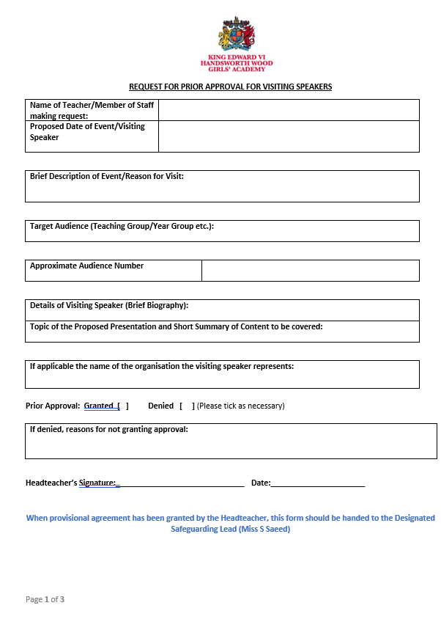
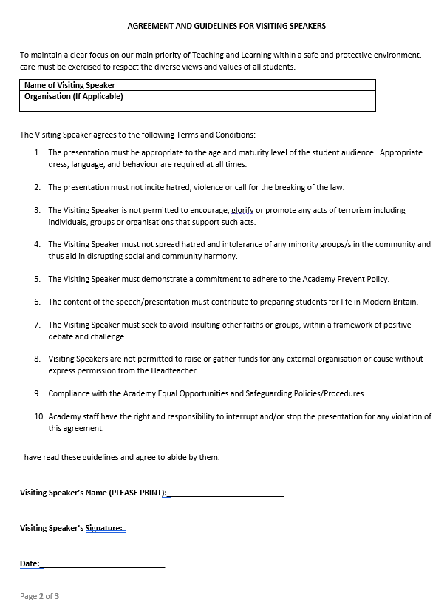

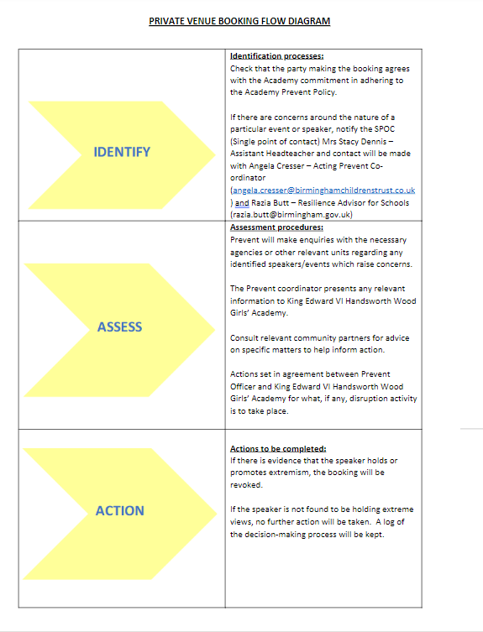

Appendix 16 - Individual behaviour for learning plan

Name: | Tutor group: |  |  |  | Date: |  | Review dat
 | Teaching group: |  |  |  | Written by: |  | Present at planning meeting:
Cause for concern:

Outside agency involved:

School based support details: |  |  |  | Staff key support:
Triggers/reasons for behaviour/cause for concern  E.g. In a busy or noisy environment, XX finds it difficult to remain focused. |  |  |  | Support to improve behaviour/reduce cause for concern  - Joe can choose to wear headphones at any time of day.
P Pro-social/positive behaviours:  - E.g. Following instructions. |  | Strategies to respond  Use simple praise  Clear instructions given  Non-verbal praise e.g. thumbs up
Anxiety and difficult behaviours |  | Strategies to respond  Use simple commands that clearly explain what you want to happen (positive phrasing).  Use simple commands: ‘walk with me.’ Repeat slowly and calmly three times (to help him to process the instruction).  Useful teaching strategies (including rewards and consequences) – what does student think will help?  Plans to process request before response is required
Crisis behaviours: |  | Strategies to respond  E.g. careful pairing/grouping
Post-incident recovery and debrief measures
E.g.
Give XX time to calm down following an incident (considering that it takes 45 minutes for a child’s metabolism to return to normal).

Consequences will be determined by staff after incidents have taken place.

- Protective consequences:
- Educational consequences: a suitable member of staff will be sought to undertake a restorative conversation to help XX to reflect on their behaviour. (Sometimes a different face is better placed to do this.)

Al staff will aim to use the same language with XX when debriefing.

- What happened? (Allow them to recount the story.)
- What were you thinking when it happened? How do you feel now?
- Who has been upset by it? How are they upset? (Name the behaviour to help give Joe the emotional literacy: ‘You made Miss Bradshaw worried when …. Because…...’)
- What do you think you can do to make things better?

Targets to improve behaviour for learning:

WHAT:  Targets to include success/ exit criteria (3 – 4 targets |  |  | HOW:  Strategies/ activities/ material |  |  | WHO/WHEN/WHERE:  Input by/ frequency/ duration
E.g.  Issues with homework  Improve concentration |  |  | Write task on board  Make sure task is written in planner / check planner  Ask if don’t understand  Start early, do not put off, break task into manageable chunks.  Try omega 3 fish oil tablets  Doodle on paper  Use ‘stress ball’  Sit in appropriate position in class so as not to get distracted  Vary delivery – visual stimuli/working in small groups |  |  | Teacher  Self  Self  Self  Self  Self  Self  Teacher  Teacher

Signature of plan coordinator: Date:
Signature of parent/carer: Date:
Signature of young person: Date:

REVIEW MEETING
Date of meeting:
Present at meeting:
Summary of achievements and comments from subject teachers, pupil and parent(s):

Future action:

Signed:

Appendix 17 – Fabricated and induced illnesses

- Fabricated or Induced Illness (formerly known as Munchausen’s Syndrome by Proxy)
- Fabricated or induced illness (FII) is a rare form of child abuse. It happens when a parent or carer exaggerates or deliberately causes symptoms of illness in the child. The parent or carer tries to convince doctors that the child is ill, or that their condition is worse than it really is. The parent or carer does not necessarily intend to deceive doctors, but their behaviour is likely to harm the child. For example, the child may have unnecessary treatment or tests, be made to believe they're ill, or have their education disrupted.
FII used to be known as "Munchausen's syndrome by proxy" - not to be confused with Munchausen's syndrome, where a person pretends to be ill or causes illness or injury to themselves. However, it should be considered by staff to be a risk of emotional harm to the child where a parent/carer fabricates their own illness/injury.
Signs of fabricated or induced illness | Fabricated or induced illness (FII) covers a wide range of symptoms and behaviours involving parents or carers seeking healthcare for a child. This ranges from exaggerating or inventing symptoms, to deliberately making the child ill.  Behaviors in FII can include a parent or carer who:  - persuades healthcare professionals that their child is ill when they're healthy.  - exaggerates or lies about their child's symptoms.  - manipulates test results to suggest the child is ill, for example, by putting glucose in urine samples to suggest the child has diabetes.  - deliberately induces symptoms of illness, for example, by poisoning their child with unnecessary medicine or other substances.  - Cases where the parent or carer wrongly reports symptoms are much more common than cases where they induce illness in the child.
What to do if you suspect a child is at risk | FII is a child safeguarding issue and needs specialist guidance and intervention.  Organization staff who suspect FII is happening must report their concerns to the DSL who will liaise with social services and the police and must follow local child safeguarding procedures.  If you suspect someone you know may be fabricating or inducing illness in their child, do not confront them directly. It's unlikely to make the person admit to wrongdoing and it may give them the opportunity to dispose of any evidence of abuse.  The government guidance on this is found in ‘Safeguarding Children in whom illness is Fabricated of Induced’ (15th March 2008).

