RSE and PSHE Policy
Responsible Board/ Committee | Academy Trust  Foundation Trust
Policy Type | Standalone policy
Policy Owner | Director of Student Character and Personal Development  & Assistant Head Teacher – Welfare & Well-being
Statutory | Yes
Publish Online | Yes
Date Adopted | March 2023
Last Review Date | N/A
Review Cycle | Annual
Next Review Date | February 2024
Expiry Date | March 2025
Version | 1

School | King Edward VI Handsworth Wood Girls Academy
School Policy Owner | Michelle Morgan & Stacy Denis
LGB Approval Date | March 2023

Related Documents/Policies

Reference | Title
 | Behaviour and rewards policy
 | Safeguarding and child protection policy
 | Online Safety Policy
 | E-Safety policy

Please note that this and all other policies have been created with stakeholders in mind. Policies are compliant with our legal and statutory guidance and adhere to best practice; however, they are laid out in a way that is accessible to those for whom the policies are intended: school staff and governors; students and parents.

Introduction

  - This policy outlines our school’s commitment to provide effective Relationships, Sex and Health Education for all pupils in support of that offered by parents, who are the first educators of their children in this area. It has been written regarding the DfE Relationships Education, Relationships and Sex Education (RSE) and Health Education guidance 2019 and other relevant guidance documents and statutory requirements.

  - The RSE/PSHE teaching in this school contributes to our statutory duty to safeguard pupils and prepare them for the responsibilities and experiences of adult life. RSE/PSHE is taught in a progressive, sequenced, age-appropriate manner throughout the school.

Formulation, dissemination, monitoring and review of policy

  - In developing our policy and curriculum we have given due regard to the government’s statutory guidance for RSE issued under Section 80A of the Education Act 2002 and section 403 of the Education Act 1996.

  - The Relationships Education, Relationships and Sex Education and Health Education (England) Regulations 2019 made under sections 34 and 35 of the Children and Social Work Act 2017 make Relationships, Sex and Health Education compulsory for pupils receiving secondary education. They also make Health Education compulsory in all schools except independent schools. Personal, Social, Health and Economic Education (PSHE) continues to be compulsory in independent schools.

  - This policy is available on our school website where it can be accessed by the community. Copies are available from the school office on request from parents/carers.

  - The RSE/PSHE policy and RSE/PSHE curriculum will be reviewed annually by the PSHE coordinator and governors. This review will be informed by the following: pupil and staff evaluation of the programme; changes in legislation and guidance; and, parent feedback.

  - The PSHE coordinator will monitor delivery of the programme through observation and discussion with teaching staff to ensure consistent and coherent curriculum provision.

  - Evaluation of the programme’s effectiveness will be conducted on the basis of: Pupil, teacher and parent evaluation of the content and learning processes and staff meetings to review and share experience.

What is RSE/PSHE?

  - RSE/PSHE is lifelong learning about the physical, moral, emotional, social and cultural development of pupils, and involves learning about healthy relationships, sexual health, sexuality, healthy lifestyles, diversity, safety online and offline, respect, love, puberty and personal identity. RSE/PSHE involves a combination of sharing information and exploring issues and values.
There is often concern that RSE/PSHE will encourage sexual experimentation however evidence shows that those who receive comprehensive RSE/PSHE at school are more likely to delay their first sexual activity and to use contraception when they do have sex.

  - At secondary level we are building on the foundations of skills and knowledge that pupils have learnt at primary school.

  - Our key aim in providing RSE/PSHE throughout the school is to safeguard our pupils. During their time at this school pupils will learn key knowledge and skills to help keep themselves, and others, safe, healthy, and prepare them for the responsibilities of adult life.

Why RSE/PSHE is important in our school?

  - The Trust believes that RSE should be set in the context of clear values, including the value of family life, marriage and of loving and stable relationships in bringing up children. It should teach children and young people to develop values, attitudes, personal and social skills, and increase their knowledge and understanding to make informed decisions and life choices.

  - The Trust believes that RSE makes an essential and significant contribution to safeguarding children and young people during their school-age years and into the future. RSE should enable young people to develop skills and confidence to access professional advice and appropriate health services. It enables young people to understand their physical and emotional development and enables them to take increasing responsibility for their own health and wellbeing and that of others.

  - The Trust recognise the role RSE has in supporting the health and well-being of our students, and the contribution it makes to ensuring we meet the ethos of Every Child Matters agenda.

  - The Trust believes that RSE can have a positive impact on young people’s sexual behaviour, helping them to make sense of the sexual messages and imagery around them, to understand risks and consequences and to gain the knowledge and skills they need to stay safe and be healthy.

  - The Trust believes that contributions can be made by different curricular areas and that teaching can be reinforced by the general ethos of the Trust in creating a supportive environment for all students.

  - The Trust will ensure that RSE is accessible to all students including those with Special Educational Needs.

  - Whilst the Trust acknowledges that parents have the right to withdraw their child from the non- national curriculum aspects of RSE, we also note that they have a responsibility to provide alternative RSE.

  - We acknowledge that not all parents feel confident or comfortable talking to their children about this area therefore our work in school ensures that all pupils have a standard level of education about key aspects needed to keep safe and make positive, informed and healthy choices.

PSHE Key Objectives/Curriculum Intent

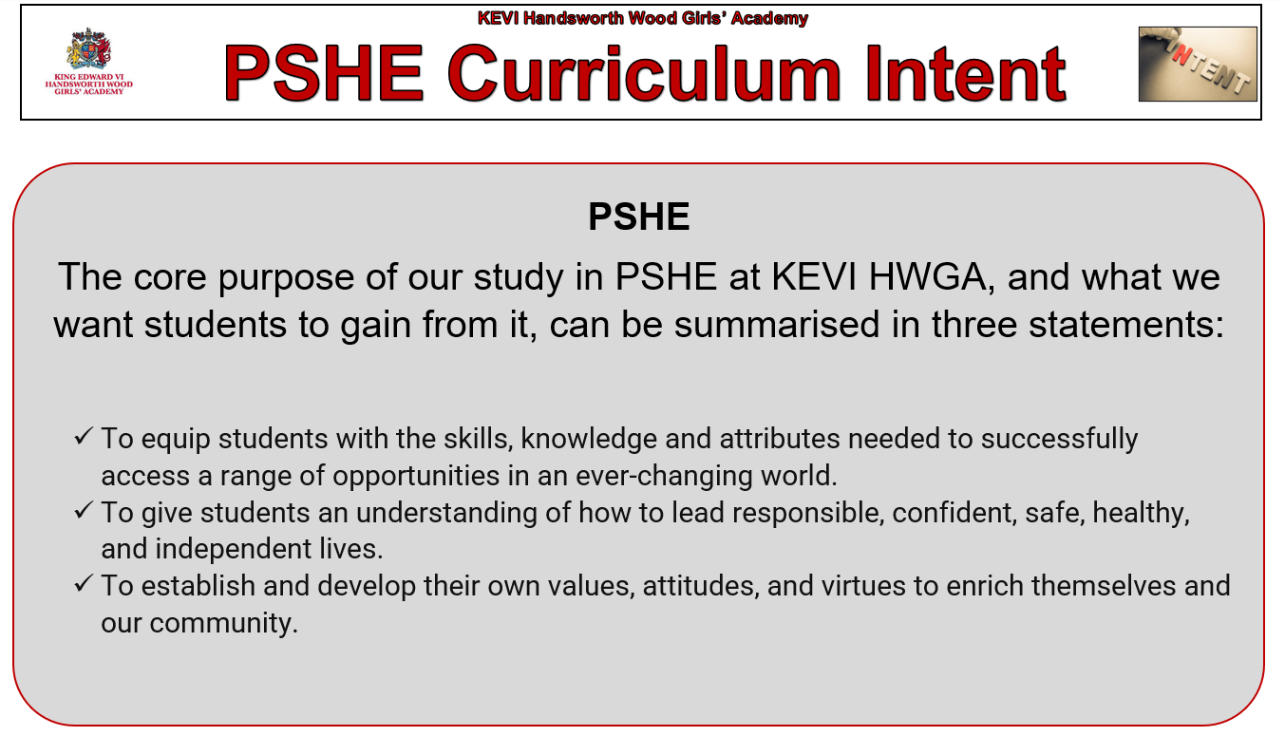
  - Our key objectives through delivery of RSE/PSHE/PSHE

    - To develop well-rounded individuals who respect themselves and others, can communicate effectively and take responsibility for their actions.
    - To develop skills in making informed decisions and in combating exploitation or peer pressure.
    - To encourage openness and better communication about sexual matters.
    - To promote respect for themselves and others.
    - To learn about the nature of marriage and appreciate the value of stable family life and the responsibilities of parenthood.
    - To enable students to recognise the physical, emotional and moral implications of certain types of behaviour and to accept that both sexes must behave responsibly in sexual matters.
    - To ensure that students are given appropriate teaching materials that have regard to any religious or cultural background of the students, meet legal requirements and are not explicit or unrelated to the lesson.
    - To combat ignorance and increase understanding to reduce guilt and anxiety.
    - To promote responsible behaviour among students.
    - To raise awareness of outside influences e.g. the media.

  - The PSHE/RSE/PSHE programme is based on the needs of pupils in the school with learning outcomes appropriate to their age, ability and level of maturity. PSHE/RSE/PSHE will be firmly embedded within our broader curriculum areas, including Science and PE, in addition to more focused learning through PSHE/RSE/PSHE sessions, tutor-time, enrichment afternoons and assemblies.

  - The DFE’s statutory guidance on Relationships Education, Relationships and Sex Education (RSE/PSHE) and Health Education, states that schools should continue to develop knowledge on topics specified for primary as required and in addition cover the following content by the end of secondary:

Mental wellbeing | Pupils should know  - how to talk about their emotions accurately and sensitively, using appropriate vocabulary.  - that happiness is linked to being connected to others.  - how to recognise the early signs of mental wellbeing concerns.  - common types of mental ill health (e.g. anxiety and depression).  - how to critically evaluate when something they do or are involved in has a positive or negative effect on their own or others’ mental health.  - the benefits and importance of physical exercise, time outdoors, community participation and voluntary and service-based activities on mental wellbeing and happiness.

Internet safety and harms | Pupils should know  - the similarities and differences between the online world and the physical world, including: the impact of unhealthy or obsessive comparison with others online (including through setting unrealistic expectations for body image), how people may curate a specific image of their life online, over- reliance on online relationships including social media, the risks related to online gambling including the accumulation of debt, how advertising and information is targeted at them and how to be a discerning consumer of information online.
 | - how to identify harmful behaviours online (including bullying, abuse or harassment) and how to report, or find support, if they have been affected by those behaviours.
Physical health and fitness | Pupils should know  - the positive associations between physical activity and promotion of mental wellbeing, including as an approach to combat stress.  - the characteristics and evidence of what constitutes a healthy lifestyle, maintaining a healthy weight, including the links between an inactive lifestyle and ill health, including cancer and cardio- vascular ill-health.  - about the science relating to blood, organ and stem cell donation.
Healthy eating | Pupils should know  - how to maintain healthy eating and the links between a poor diet and health risks, including tooth decay and cancer.
Drugs, | Pupils should know
alcohol and tobacco | - the facts about legal and illegal drugs and their associated risks, including the link between drug use, and the associated risks, including the link to serious mental health conditions.
 | - the law relating to the supply and possession of illegal substances.
 | - the physical and psychological risks associated with alcohol consumption and what constitutes low risk alcohol consumption in adulthood.
 | - the physical and psychological consequences of addiction, including alcohol dependency.
 | - awareness of the dangers of drugs which are prescribed but still present serious health risks.

 | - the facts about the harms from smoking tobacco (particularly the link to lung cancer), the benefits of quitting and how to access support to do so.
Health and | Pupils should know
prevention | - about personal hygiene, germs including bacteria, viruses, how they are spread, treatment and prevention of infection, and about antibiotics.
 | - about dental health and the benefits of good oral hygiene and dental flossing, including healthy eating and regular check-ups at the dentist.
 | - (Key stage 4) the benefits of regular self-examination and screening.
- the facts and science relating to immunisation and vaccination.
- the importance of sufficient good quality sleep for good health and how a lack of sleep can affect weight, mood and ability to learn.
Basic first aid | Pupils should know  - basic treatment for common injuries.  - life-saving skills, including how to administer CPR.¹⁵  - the purpose of defibrillators and when one might be needed.
Changing adolescent body | Pupils should know  - key facts about puberty, the changing adolescent body and menstrual wellbeing.  - the main changes which take place in males and females, and the implications for emotional and physical health.

Structure and content

  - King Edward VI Handsworth Wood Girls’ Academy combines the Jigsaw PSHE programme which perfectly connects the pieces of Personal, Social and Health Education, emotional literacy, social skills and spiritual development. It is designed as a whole-school approach that is used in year 7-11 to provide a detailed and comprehensive scheme of learning. We also adapt and build upon the Jigsaw programme through our own bespoke PSHE lessons that are pertinent to our students at HWGA.
  - Year 12 and 13 have a bespoke scheme of work that builds on the content taught in KS4. Teaching strategies are varied and are mindful of preferred learning styles and the need for differentiation.

  - Informed by DFE guidance, Jigsaw 11-16 fulfils the statutory requirements for RSE/PSHE and Health Education and supports Ofsted.
  - Some of the below topics are also delivered in assemblies, extended tutor time and personal development days.

PSHE Key Concepts
Relationships (including RSE)
Health & Well Being (including Mental Health)
Living in the Wider World
Key
Purple text = Includes online safety
Green text = Includes Health & well being/ mental health
Red text = Includes Relationships/RSE

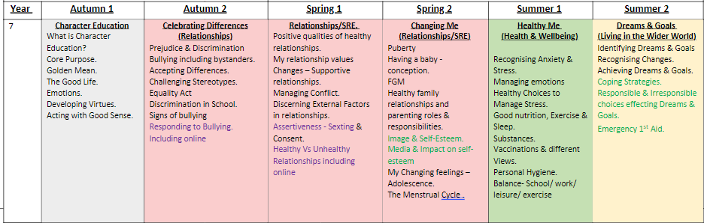
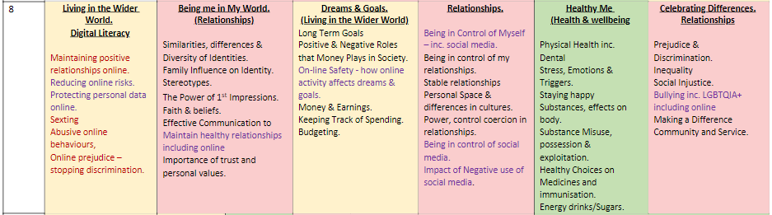

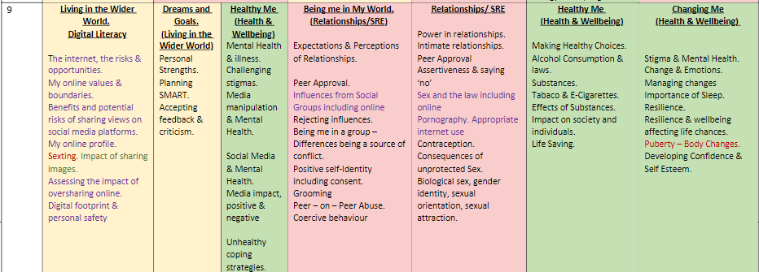

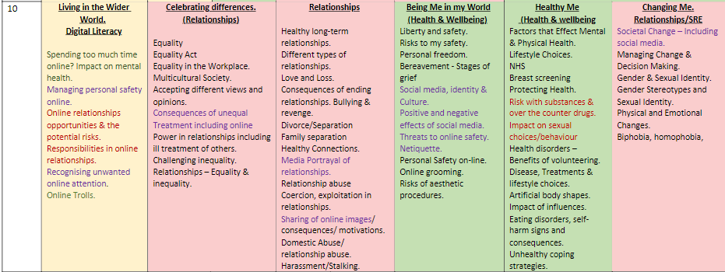

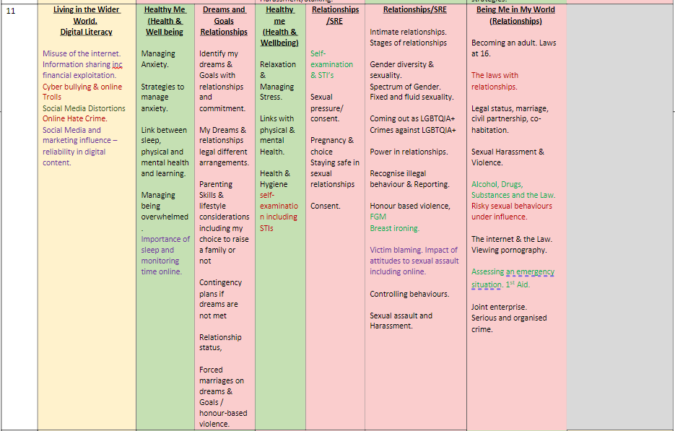

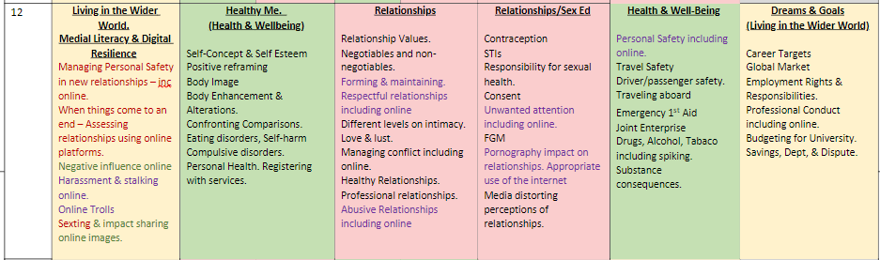

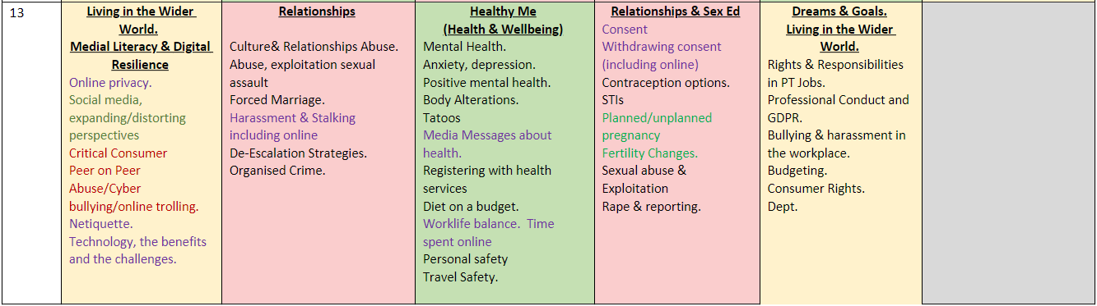

Equality, Inclusion and Support

  - We are required to comply with the requirements of the Equality Act 2010. Our school values diversity, encourages respect for all and promotes tolerance for, and celebration of, difference. We do not discriminate against pupils because of any protected characteristic (age, sex, race, disability, religion or belief, gender reassignment, pregnancy or maternity, marriage or civil partnership, or sexual orientation). At times, when there is an identified need, we may take positive action through our planning and delivery of RSE/PSHE to deal with disadvantages facing those with particular characteristics.

  - RSE/PSHE will be accessible to all regardless of their gender. Through the delivery of RSE/PSHE teachers will explore gender stereotypes and how they may limit a person’s potential and ensure that people of all genders receive information that is relevant to their needs.

  - There are many different faith and cultural perspectives on aspects of RSE/PSHE. As a school we will deliver RSE/PSHE in a factual, non-judgmental way ensuring that teachers do not promote one faith or cultural viewpoint but rather provide a balanced approach that acknowledges the wealth of views and opinions of our community and teaches tolerance. Parents and carers are key partners in RSE/PSHE and are best placed to support their children to understand how learning at school fits with their family’s faith, beliefs and values. To support this process, we will ensure that parents are made aware of what will be taught in our RSE/PSHE programme through providing up to date information on the schools website and providing opportunities for parents to attend consultation sessions in school.

  - We will use a range of materials and resources that reflect the diversity of our school population and encourage acceptance and tolerance. We want every pupil and family to feel included, celebrated, respected and valued.

  - Teachers will plan in different ways and use a variety of teaching strategies to meet the needs of individuals. For some pupils, particularly those with special educational needs and disabilities, a differentiated approach may be necessary to ensure learning outcomes are met. Some pupils may have experienced adverse childhood experiences that may impact on their ability to engage with RSE/PSHE in a variety of ways. Care will be taken to ensure that, where this is the case parents/carers are consulted about the most appropriate way for the pupil to access the curriculum.

  - A range of different families and relationships will be explored within RSE/PSHE, including same-sex relationships. Referencing a range of relationships will be integral to our programme of RSE/PSHE. All pupils whatever their identity, developing identity, or family background need to feel that RSE/PSHE is relevant to them and sensitive to their needs. This means that resources and books used will reflect both our school community and wider society.

  - We will ensure that LGBT content is fully integrated into programme of study for this area of the curriculum rather than delivered as a stand-alone unit or lesson. We expect all pupils to have been taught some LGBT content at a timely point as part of the curriculum.

RSE/PSHE in the curriculum

  - RSE/PSHE will be taught in each year group throughout the school. The curriculum we deliver is age- appropriate and progressive, building the pupil’s knowledge, understanding and skills year on year. We work to objectives in each year group that support the achievement of outcomes outlined in the government guidance.

  - By the end of secondary, schools should continue to develop knowledge on topics specified for primary as required and in addition cover the following content by the end of secondary:

Key Stage 3

Pupils should be taught about:
- reproduction in humans (as an example of a mammal), including the structure and function of the male and female reproductive systems, menstrual cycle (without details of hormones), gametes, fertilisation, gestation and birth, to include the effect of maternal lifestyle on the foetus through the placenta.
- The effects of recreational drugs (including substance misuse) on behaviour, health and life processes
- Comparing energy values of different foods (from labels) (kJ)

Key Stage 4

Pupils should be taught about:
- The relationship between health and disease
- communicable diseases including sexually transmitted infections in humans (including HIV/AIDs)
- reducing and preventing the spread of infectious diseases in animals and plants
- the impact of lifestyle factors in the incidence of non-communicable diseases
- hormones in human reproduction, hormonal and non-hormonal methods of contraception
- sex determination in humans

  - Some elements of RSE/PSHE are delivered through national curriculum Science.
In addition to the Science curriculum we will work towards the outcomes outlined in the government’s RSE/PSHE Guidance, under the headings shown below:

- Families
- Respectful relationships, including friendships
- Online and media
- Being safe
- Intimate and sexual relationships including sexual health
- Mental wellbeing
- Internet safety and harms
- Physical health and fitness
- Healthy Eating
- Drugs, Alcohol and Tobacco
- Health and Prevention
- Basic First Aid
- Changing adolescent body
- Careers
- Character and culture
- Finance

  - Each topic will be covered in an age-appropriate way during a pupil’s time at the school, with regular repetition of key themes. These elements will be delivered through timetabled RSE/PSHE lessons, enrichment, tutor time and assemblies. Learning will also be supported through cross- curricular approaches.

Resources

  - As with any other subject, the breadth of the RSE/PSHE curriculum necessitates the use of a wide variety of age-appropriate activities, textbooks and resources. You can see a selection of resources mapped on the school’s website in the RSE/PSHE area. We offer opportunities for parents to familiarize themselves with the content of RSE/PSHE through newsletters, open evenings and parent’s meetings.

  - If you would like to discuss any of the resources used in more detail, please contact the PSHE coordinator.

Teaching and Learning

  - Our PSHE Coordinator is responsible for planning lesson content and providing relevant resources to all teaching staff who deliver. Teaching assistants may provide additional support for pupils with SEND. Everyone involved in the teaching of RSE/PSHE will follow the school policy.

  - The personal beliefs and attitudes of staff will not influence the delivery of RSE/PSHE. A balanced and non-judgmental approach will be taken. Teachers, and all those contributing to RSE/PSHE, will work to the agreed values within this policy.

  - To ensure that all pupils feel able to contribute effectively to RSE/PSHE several teaching strategies will be used, including:

    - Establishing a group agreement with pupils;
    - Using ‘distancing’ techniques (eg. Case studies and role-play)
    - Providing opportunities for questions
    - Dealing with questions in an age-appropriate manner
    - Using discussion and appropriate materials
    - Encouraging reflection.

  - RSE/PSHE will be delivered all year round – parents/carers will be informed of what will be covered on the school’s website.

External speakers

  - We may use outside visitors to enhance the RSE/PSHE provision delivered by teachers. We plan these inputs carefully to ensure effectiveness. All visiting speakers will:

    - be suitably qualified to deliver RSE/PSHE sessions
    - be aware of the school policy on RSE/PSHE and work within this
    - be supervised by a member of staff always when on school premises
    - alert the teacher to any safeguarding concerns
    - understand their contribution they make to the broader RSE/PSHE programme
    - be suitably vetted prior to being booked

Safe learning in RSE/PSHE

  - It is important that all pupils feel safe and able to participate in RSE/PSHE lessons. To support the involvement of all pupils, teachers will create a group agreement with each class outlining expectations around rights, responsibilities and respect. The group agreement will be a working document that all pupils agree to follow.

  - As with any topic pupils will ask questions during RSE/PSHE to further their understanding. Due to the sensitive nature of the topic teachers will employ strategies to ensure that questions are asked and answered in a factual, balanced and age-appropriate way. The group agreement will remind pupils that personal questions of the teacher or other pupils are not appropriate.

  - Some staff may feel it is appropriate to use a ‘question box’ to allow all pupils an opportunity to write questions down if they do not choose to ask these in front of the whole class.

  - Teachers will use the following strategies to deal with unexpected questions:
- If a question is personal, the teacher will remind pupils of the rules set in the group agreement
- If the teacher doesn’t know the answer to a question, the teacher will acknowledge this and will research the question and provide an appropriate answer later.

  - Sometimes pupils may ask questions about issues that are not part of the planned programme, this could show that the taught curriculum is not meeting their needs. These questions will be answered in a factual and balanced manner appropriate to the age of pupils. The questions will also be fed back to the Coordinator as part of the evaluation and monitoring process.

Staff training and support

  - All staff delivering RSE/PSHE will receive training. If a staff member has additional learning and development needs these will be supported either through mentoring from a more experienced staff member in school, team-teaching, observations, regular weekly meetings or attendance at an internal or external training event. Training on more specific RSE/PSHE topics will take place as and when required to support the needs of teachers, pupils and the school.

Assessment and Review

  - Teachers use a range of assessment strategies to track pupils’ progress. This includes marked books, self-assessment and peer assessment. Governors will monitor the achievement of pupils in RSE/PSHE. Pupil’s attitude to learning in RSE/PSHE will be included on pupil reports.

  - Delivery of RSE, within RSE/PSHE lessons will be monitored during the year in the same way as all other curricular subjects.

  - Teaching materials and resources will be reviewed on an annual basis by the PSHE Coordinator, whilst the delivery and effectiveness of the programme will be monitored by the appropriate member of SLT. Teaching staff will have access to on-going, high quality support through in the Trust induction and continuing professional development opportunities.

  - Each unit of work has a built-in assessment tasks. This task is the formal opportunity for teacher assessment, but also offers children the chance to assess their own learning. PSHE and RSE/PSHE is assessed through quizzes, responses to scenarios, discussion based tasks and self reflection activities.

Parents

  - We believe that RSE/PSHE is a partnership between school and parents/carers. We recognise that parents are the first teachers of their children and welcome their engagement with our RSE/PSHE programme. It is important that RSE/PSHE delivered in school is explored in more detail within the context of individual families. Parents will be routinely informed about RSE/PSHE through the school’s website

  - Any parents wanting more information about our RSE/PSHE curriculum can contact the PSHE coordinator.

Right to be excused from sex education:

  - Whilst we always try to work with parents to explore their views, we also accept that parents can exercise their right to excuse their child from the sex education elements of our programme
(other than that which comes within the Science curriculum). There is no right to withdraw from Relationships Education or Health Education.

  - The RSE/PSHE we provide is planned to meet the needs of all pupils and give them the knowledge and skills they need to lead healthy lives. Withdrawing pupils from RSE/PSHE can be detrimental and lead to them receiving less accurate, second-hand information from peers.

  - To request that a pupil be excused from Sex Education parents should write to the head teacher. The head teacher will arrange to speak with parents to explore their views and ensure that the nature and purpose of RSE/PSHE is understood. A written record will be kept of this discussion. Except in exceptional circumstances the school will respect a parent’s right to excuse their child up until three terms before a pupil’s 16th birthday when the child can choose to be included in Sex Education.

  - The process above is the same for pupils with SEND, however in exceptional circumstances the head teacher may take account of a pupil’s specific needs arising from their SEND when agreeing or not any application to be excused.

  - Teachers will plan appropriate, purposeful education for pupils who are withdrawn from sex education.

Differentiation and SEND

  - The Jigsaw programme is written as a universal core curriculum provision for all children. Inclusivity is part of its philosophy. To support this differentiation, many lessons suggest creative learning activities that allow children to choose the media with which they work and give them scope to work to their full potential.

  - We are aware that some pupils are more vulnerable to exploitation, bullying and other issues due to the nature of their SEND. Relationships Education and RSE/PSHE can also be particularly important subjects for some pupils; for example, those with Social, Emotional and Mental Health needs or learning disabilities. These factors will be taken into consideration in designing and teaching these subjects.

  - We will ensure teaching is sensitive, age-appropriate, developmentally appropriate and delivered with reference to the law.

Confidentiality, safeguarding and child protection

  - Everyone involved in RSE/PSHE will be clear about the boundaries of their legal and professional roles and responsibilities. Teachers will discuss confidentiality with pupils through the development of a group agreement at the start of lessons, making it clear that teachers cannot offer unconditional confidentiality. Pupils will be informed if confidentiality has to be broken, due to safeguarding concerns, and supported as appropriate. Please see our Safeguarding policy for more details of risk factors.

  - Through taught lessons, teaching staff will signpost pupils to sources of confidential local and national support services.

  - Sometimes disclosures may be made during these sessions; in which case, safeguarding procedures will be followed immediately. Sometimes it is clear that certain children may need time to talk one-to-one after the circle closes. It is important to allow the time and appropriate staffing for this to happen. If disclosures occur, the school’s disclosure and/or confidentiality policy is followed.

  - As a general rule a child’s confidentiality is maintained by the teacher or member of staff concerned. If this person believes that the child is at risk or in danger, she/he talks to the named child protection coordinator who takes action as laid down in the Child Protection Policy. All staff members are familiar with the policy and know the identity of the member of staff with responsibility for Child Protection issues. The child concerned will be informed that confidentiality is being breached and reasons why. The child will be supported by the teacher throughout the process.

Menstrual wellbeing

  - Pupils who are menstruating will be supported in the following ways:

- Sanitary disposal units are available in female and unisex/accessible toilets
- Pupils can access emergency sanitary products from reception
- For those experiencing period poverty free sanitary protection can be accessed from the PSHE Coordinator

Links to other policies and guidance

- Anti-bullying policy
- Religious Education Intent Guidance
- Safeguarding and child protection policy
- Equality and inclusion policy
- Online safety policy
- E-Learning policy

More information

  - If you would like to discuss our provision of RSE/PSHE further, please contact the PSHE Coordinator.

  - If you have a complaint about any aspect of our RSE/PSHE provision, please follow the school’s complaints procedure.

Policy Review

This policy is reviewed annually.

Approved by | Date of review: | Date of next review:
Head Teacher
RSE/PSHE Governor

