W J E C C R I M I N O L O G Y
Level 3 Diploma

Summer Independent Learning

The following work aims to provide you with an introduction to various aspects of the Criminology course. Please read the material provided (you can highlight and/or annotate the document as you go through) and complete the questions and tasks throughout the document. There are compulsory elements that you must to complete to a high standard. There are also additional tasks it is strongly recommended that you complete these to broaden your knowledge of the subject further. Please bring this work with you to your first Criminology lesson.

What is Criminology?
Criminology is an interdisciplinary social science that combines content regarding crime from sociology, psychology, law and politics.
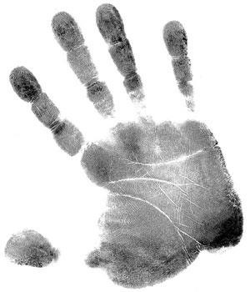

Crime or Deviance?

The concepts of crime and deviance are often used interchangeably,
suggesting that people may reg
ard them as the same thing.
However, in C
riminol
ogy it is essential that w
e

can
discuss

and
identify

the distinct differences between the two terms.

Newburn (2007)

defines Criminology as:

•

The study of crime

•

The study of those
who commit crime

•

The study of the criminal justice system and penal systems

Defining Crime
The term crime is not easy to define, in Criminology we explain the meaning of the word through various definitions, and you are required to know two of these:
1. The social definition - Crime is any act so identified by groups in society
The social definition of crime suggests that an act is only labelled as a crime if society decides that the act is criminal.
This definition of crime focuses predominantly on the social reaction and the actual process of criminalisation as opposed to the behaviour and the individual. This definition of crime is conditional and can change over time and between societies.
For example views regarding sexual conduct in the UK have changed, in the past consensual sex between men was prohibited, this is now accepted and legal in the UK but is still labelled as criminal in other countries across the world.
It is important to acknowledge the strengths and weaknesses of the social constructionist definition of crime; whilst ensuring that the definition of crime is always up to date and acknowledges the fluidity of society, this definition could lead to a lack of consensus (agreement) in society.
2. The legal definition – Crime is an act that is against written law
In the UK the legal system defines a crime as any act that breaks the law and can result in formal punishments, set by the judiciary.
In law a crime must have two elements:
Actus reus = is the physical ‘doing’ part of the crime and committing a guilty act, this can be physically acting (causation) or failing to act (omissions).

Mens rea = is the intention for the crime.

For example, if Keith takes a knife and purposely stabs Alan in the chest multiple times and kills him, he has committed the actus reus (murder) and has the mens rea (intent to kill).
However, in instances of defence, such as self-defence, infancy, insanity etc. even if both parts of the law are present a person may not be found guilty.
Again, it is important to acknowledge the strengths and weaknesses of the legal definition of crime, it allows for crime to be easily understood and identified due to its fixed certainty, however it responds slowly to social developments (e.g. cyber-crime) and still differs across location for example jaywalking is illegal in Australia but not here in the UK.
So … whether an action is criminal depends on:
- Time
- Place
- Situation
✓

Culture

TASK 1:

Can you find examples of the following:

•

An act that was illegal in the UK and is now legal

•

An act that is illegal in the UK but legal elsewhere in the world

•

An act th
at is legal in the UK but illegal elsewhere in the world

E.g.
An act

that was legal in the UK and is now illegal

The laws on selling cigarettes in the UK has changed over time. In the 1950’s cigarette companies
could advertise their products openly. Now
, advertising is banned, cigarettes can only be bought
by those over the age of 18 and shops must store cigarettes behind the counter and not on display.
In 2020, selling rolling tobacco and menthol cigarettes will be banned.

Stretch: Think about why these changes have occurred / exist.

•

WHY

do different countries have different laws?

•

WHY
do our laws continue to change?

Defining Deviance
Deviance is a term that should be used when describing an act or behaviour that goes against societal norms. Deviance is any behaviour that would receive a critical reaction or disapproval from a specific group or the society in which it is carried out. There are no written rules (or laws) regarding what is or is not deemed socially acceptable, meaning that like crime, the concept of deviance is complex and will vary depending upon the time, place situation and culture – referred to as situational deviance.
Norms, moral codes and values are what distinguish deviant behaviour in a society.

- Norms are social expectations in a society that guide behaviour and explain why people behave in the way that they do. E.g. In the UK it is the norm to eat with a knife and fork, however in India it is customary to eat using your hands.

- Moral codes define what is regarded as good behaviour. Breaking a moral code would be considered as serious in society and could even cross the boundary of committing a crime, such as burglary.

- Values are ideas or beliefs about general principles or goals within a society or culture, they are things that we deem to be important for example the value of ‘honesty’, ‘respect’, ‘‘fairness’ and equality.

Forms of Deviance
It tends to be assumed that "deviant behaviour" is somehow always behaviour that is generally frowned upon by people in a society or viewed as negatively, that is not necessarily always the case. We can categorise various basic forms of rule-breaking behaviour in terms of three basic ideas:
- Admired Behaviour - An example of deviance that might be considered as "good" or "admirable" behaviour (whilst also breaking social norms) might be something like heroism - the saving of the life of another person whilst putting your own life in great danger.

- Odd Behaviour - This form of deviance ranges from such things as outlandish modes of dress, through mildly eccentric forms of behaviour (the person who shares their house with 50 cats, for example). The behaviour is not criminal but somewhat differs to
‘normal’ behaviour.

- Bad Behaviour - This category of deviant behaviour tends to be restricted to lawbreaking or criminal behaviour that in some way is seen as being something more than odd or out of the ordinary, for example assault.

It is not uncommon for behaviour to overlap in the categories of deviance. Some behaviour may be deemed as both odd and bad for example exposing yourself in public.
It is important to remember that these boundaries are blurred and that some acts may be deviant and not criminal, some acts are criminal but not necessarily deviant and some acts would be classified as both criminal and deviant.
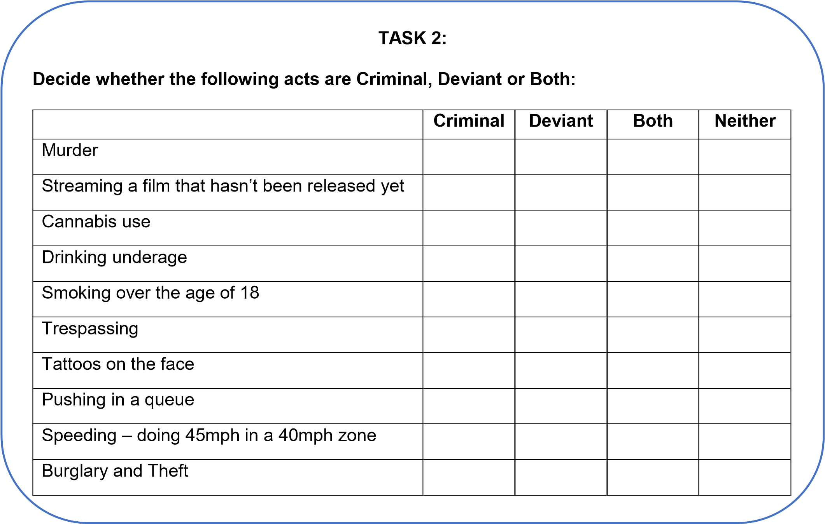

TASK 3:

Decide whether the following acts are Criminal, Deviant or Both:

Using the informat
ion in the table below, write a

short explanation for
each crime
,

acknowledging
whether
or not
you think the crime is c
riminal, deviant or both
.

1.

White collar

2.

Moral

3.

State

4.

Technological

5.

Hate crime

6.

Honour crime

7.

Domestic abuse

Does the act break a law?

Does the action go against the norms of society?

Why?

Different Types of Crime
Type of crime | Criminal offences |  | Types of victim | Types of offender | Level of public awareness
White-collar  crimes | - Non-violent  - Usually committed in commercial situations for financial gain  - E.g. credit card fraud, computer and internet fraud and tax evasion | •  •  • | Those with funds to  invest in a financial  scheme  Anyone with accessible money  The government (tax evasion) | - Usually, people of a high status who have power and are respected, this leads to them not raising suspicion.  - Offenders can also have connections with organised crime groups such as the Mafia and gangs | - Relatively low due to violence related crimes being more widely.  publicised  - White-collar crimes are difficult to prosecute because the  perpetrator’s identity is hidden and their activities are usually concealed through a series of complex processes and  transactions
Moral crimes | - Committed against the normal standard of  morality in society  - E.g. underage  drinking, assisted suicide, illegal gambling, illegal drug use, prostitution, and vagrancy | •  • | Moral crimes are sometimes regarded as being victimless However, arguably the offender and the victim can be the same person, for example under-age drinking | - The offenders of moral crimes differ depending on the type of crime committed.  - As stated before, the offender can be the same person as the victim.  - It is important to acknowledge however that some people may commit a moral crime due to a difficult situation, for example a homeless person cannot do anything other than commit a crime of vagrancy | - A lot of moral crimes are hidden, for example drug use may not be widely discussed within the family.  - In addition to the point made above if the crime is known a family or the public may not report the crime to the police due to sympathy.  - The victim may receive help as opposed to a conviction for example giving a homeless person money rather than reporting them to the police

State crimes | - Carried out by (or by the order of) the state or state agencies  - E.g. genocide, war crimes, torture and  imprisonment without  trial | •  • | Citizens from a different country to the government committing the crime  Those with a different political or religious view  point to the government | •  • | The government High ranking personnel working for government agencies | •  • | High due to the extremity and seriousness of the crime  High levels of media reporting in society heightens the awareness
Technological crimes (cyber-crime) | - Offences are committed through the use of technology.  - E.g. internet-enabled  fraud, illegal  downloads/streaming & inappropriate use of social media to promote hate crimes | •  •  • | Anyone who uses or has access to the  internet  Cyber-crime can affect individuals or large organisations/businesses.  Vulnerable or gullible people often become victim to fishing scams (a scam or an attempt to persuade someone to give out their personal information and details) | •  •  • | The offender must have basic knowledge of and access to the internet to instigate the  crimes  Offenders can be based overseas where they can gain access to bank accounts.  Recent investigation shows that the number of young people committing cyber-crime.  in the UK is increasing | •  • | Initially the public perception of cybercrime was low but over recent years the awareness has increased dramatically.  in line with the popularity and expansion of technology  Increased publicity and promotion of technological crimes is now more apparent
Hate crime | - Crimes that are perceived by the victim or any other person as being motivated by  prejudice or hate.  - A crime committed due to aggravation against race, religion, sexual.  orientation, disability, or transgender is regarded as a hate crime | •  • | Anyone that falls under any of the  characteristics already outlined.  Through association with anyone who categorises under any of the five strands | •  • | A person that has a prejudicial view against anyone who comes  under the five strands already outlined Offenders are likely to hold traditional views that do not respect the diversity of today’s society | •  • | Due to having a high media focus, the public awareness of hate crimes has grown recently.  A new crackdown on hate crime that occurs due to or through social media has aided the rising awareness of this type of crime

Honour crime | •  • | Honour crimes are punishments for causing issues or bringing shame to a family.  E.g. Murder, beatings, acid attacks, abductions and mutilations | •  • | Usually, the victims of honour crimes are females within the family  Commonly it is the Asian community that are associated with honour crimes | •  • | The offender is usually a male from the same family as the female victim.  As stated previously, usually Asian communities are associated with honour crimes | • | Honour crimes have a low level of public awareness, this may be due to a difference in culture and lack of understanding.  Within societies where honour crimes are deemed acceptable the community will support the crime and regard it as appropriate retaliation to the shameful behaviour
 |  |  |  |  |  |  | • | Due to the acceptance within communities, it is unlikely that the crimes are widely reported, hence the unfamiliarity and lack of awareness of this type of crime
Domestic abuse | •  •  • | Domestic abuse is any act or abusive behaviour that is targeted at a partner or family member This type of crime is usually hidden and not often reported to authorities  Domestic abuse can include physical violence to the extent of murder, as well as emotional abuse and coercive and controlling behaviour | •  • | Women are usually regarded as the victims of domestic violence, yet it should be noted that men are also victims  just to not the same volume  Domestic abuse victims cannot be categorised with characteristics, they are not restricted by  age or any circumstances | •  • | Usually the offender is the dominant male in the relationship, however as mentioned before this is not always the scenario  Offenders usually ensure that victims do not report or speak about the crime and this subsequently means that the crimes are kept hidden and are not common knowledge | •  • | The public awareness of the type of crime itself is relatively high due to major cases and publication surrounding them However, as mentioned before, this type of crime is kept private and this means that the crimes are not always reported, this could be down to fear of the repercussions from the offender

