Bereavement Policy

Version: September 2021

Ratified by the Governing Body: TBC

Signed by the Governing Body: Vijai Kumar

__________________________
Chair of the Governing Body

To be reviewed (annually): September 2022

King Edward VI Handsworth Wood Girls’ Academy is fully committed to supporting all those affected by loss and death in a supportive and caring environment, in which everyone can respond appropriately to individual circumstances. Our schools are fully committed to the emotional health and well-being of our children and young people and that of our staff. We are dedicated to the continual development of mentally healthy and thriving school communities and strive to work towards this in all aspects of school life. We are passionate about providing an ethos, environment and curriculum that can provide support during difficult times, including a time of death or dying.

We will endeavour, to the best of our ability, to work in partnership with parents to provide the children with the support needed to manage the effects of bereavement and to maintain their emotional well-being.

This policy outlines practical measures to be taken when people are in shock, or upset, especially with sudden or multiple deaths or traumatic circumstances to include:

- Ensuring that there are designated, named members of the school staff who will provide support to children and/or staff before (where applicable) during and after bereavement

- Enhancing effective communication and clarifying the pathway of support between school, family and the community

- Setting out how to inform children/colleagues about a death and what to do if required to tell a child that someone close to them has died

- Identifying key staff within the school and Local Authority and clarifying the pathway of support that will be offered to staff/children if they have been bereaved

- Setting out clear procedures in respect of what do in the case of a crisis or disaster situation on school premises or on a school trip

- Ensuring that all staff members are trained and are able to recognise common symptoms and behaviours associated with grief

- SLT to discuss how to respond to behaviours which may be exhibited as a result of grief and how to manage these in conjunction with our Behaviour policy.

- Ensuring that the contact details of local and national support agencies specialising in bereavement such as Cruse Bereavement Care, Child Bereavement UK and See-saw are available (see links at end of this policy)

The role of the Governing Body

- To approve the policy and ensure it is implemented

- To review the policy

The role of the Headteacher

- To keep the Governing Body informed

- To monitor progress and liaise with external agencies

- To refer media enquiries to the Local Authority

- To be the first point of contact for the family/families and child/children concerned

- To keep the Governing Body fully informed

The role of the Local Authority

In the event of a death in the school community (something deemed a critical incident) the following flowchart will be followed, as advocated by Birmingham City Council:
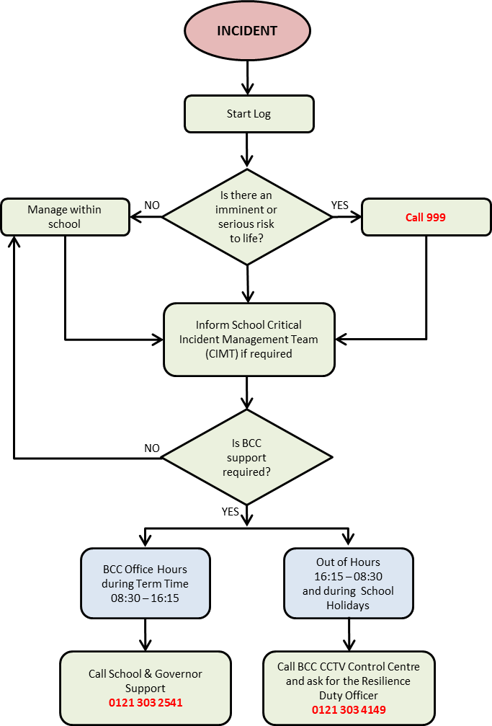

A bereavement protocol will be produced by the EP (Educational Psychology) service and will be shared ASAP.

Their role is to:

- To advise and support staff

- To consult on referral pathways and identification of complex grief

- To manage media enquiries through the Press office

Procedures if the school is notified of a bereavement of a staff member or child

- Contact with the deceased’s family should be established by the Headteacher and their wishes respected in communicating with others. Factual information is essential to avoid rumour and confusion, whilst being sensitive to cultural and religious considerations

- Staff should be informed before pupils and be prepared to share information in age-appropriate ways, as agreed for each individual circumstance

- Children who are affected should be informed, preferably in small groups, by someone known to them

- If it is appropriate, and with the agreement of the deceased’s family, a letter to all school families affected should be composed at the earliest opportunity and a decision made as to whom, and how, it should be distributed

- If during term time, the school timetable may need a degree of flexibility to accommodate the needs and wellbeing of children affected by the situation. However, we will aim for minimal disruption to the timetable, as this also offers a sense of security and familiarity
- Staff affected by the death will be offered support

- In consultation with the bereaved family, arrangements for funeral attendance may be clarified, with the consideration of full or partial school closure in some circumstances

- Where necessary, the Headteacher will work with the School Counsellor and Local Authority to prepare a press statement

Staff Support

It is important that staff feel confident in delivering support for children and mutual support for each other and for implementing this policy.

If possible, bereavement support training will be sourced for staff as required.

Staff will have opportunities to speak to a bereavement counsellor (e.g. from See-Saw) and will also be referred to Local Authority wellbeing provision.

Breaking news to Staff, Children & Families

This is usually done when a member of staff or a child has died and would not usually be appropriate when a single child/family has experienced the death of a parent or close family member.

- Headteacher will speak to the family to offer condolences and support and to ascertain what the family would like to happen. The family will be given details of a school contact

- Headteacher and DSL will prioritise obtaining of factual information

- Headteacher will inform all staff immediately (including lunch supervisors/peripatetic staff etc) ideally before children are told

- Headteacher and DSL to decide how and when children will be told, having first identified any vulnerable children and considered what additional support they may need

- Children should be told as soon as possible, ideally in familiar groups by an adult who is someone they know (staff may need guidance on words to used and approach to take)

- If possible, send a letter to families on the same day

- Consider including guidelines for parents on supporting bereaved children with the letter

The first few days (if the bereavement takes place when schools are open) Map out the first few days after an incident.

- It is usually best to have minimum disruption to the timetable, but some flexibility may be required.

- Consider what the school approach will be if pupils or staff are too upset to attend lessons.

- If it is a teacher who has died, what will happen to his/her class?

Procedures if the school is notified of a bereavement of member of a pupil’s family or the bereavement of a member of the community that has had strong links with King Edward VI Handsworth Wood Girls’ Academy

- Contact with the deceased’s family should be established by the Headteacher and their wishes respected in communicating with others. Factual information is essential to avoid rumour and confusion, whilst being sensitive to cultural and religious considerations

Funeral

- Adhere to any Government guidelines imposed due to exceptional circumstances e.g. Covid 19

Where no restrictions apply:

- Establish whether the family would welcome involvement of members of the school community or if they wish to keep it private

- Identify which members of staff and/or pupils may want to attend and the practicalities of issues such as staff cover and transport if appropriate

- Decide if flowers are to be sent and/or a collection made

- Take into account any cultural or religious implications

- If necessary, a familiar member of staff could talk to the child regarding expectations of the funeral

Support for a bereaved child following the death of a family member

Return to School of a bereaved child

- Consider a home visit, return interviews, prior to the pupil returning to school

- Ensure that the appropriate staff are aware and prepared
- Inform peers and prepare them on how to support their classmate

Not all children will need the support of specialist practitioners; they will need support from familiar people who care.

- Offer the child(ren) the opportunity to speak with a familiar and safe adult eg the school Home Link Worker /designated adult

- Keep a routine, providing a sense of normality

- Offer a safe place, away from an emotionally intense atmosphere

- Neutral space and people to share their feelings without the worry of upsetting a loved one (i.e. a surviving parent)

- Time to be themselves without feeling guilty (being with friends, time to play in a safe space outside the home environment)

- Regular correspondence with home, providing assurance about behaviours and general well- being, will ensure the child is managing the grief

- Access to appropriate resources via Bereavement counselling, See-Saw or other support agencies

- An individual link person to support the child(ren) when necessary

- A suitable place in school for children who need some space if too upset to stay in the classroom and people to whom they can go for support (e.g. school counsellor/nurture room)

- Ensure that the information is passed to the next class/school as part of transition

Monitoring & supporting children

- Support may need to be offered to other vulnerable children.

- The anti-bullying message needs to be reiterated and monitored closely.

- Therapeutic books should be readily available to assist with counselling. These can be found in the library.

- Staff will be aware of important dates which may need to be prepared for. E.g.:
Birthdays, religious celebrations such as Christmas/Eid, Mothers’ Day, Fathers’ Day,

- Anniversary of the death.

- There should be appropriate expectations around homework

- Where appropriate additional support for SEND

- Where appropriate, further additional support for the family via the relevant external agencies

Monitoring & supporting staff

- We recognize that supporting bereaved children will be very stressful for staff who may already be struggling with their own reactions and emotions. A list of outside agencies that may offer help, both in the short and long term will be shared with staff

- We will give staff time to attend the funeral if appropriate

- Staff will be made aware of available resources and time to become familiar with these.

Support for bereaved families of a member of staff or a child who has died

We will:

- Communicate with the family straight away and offer our support

- Send a letter of condolence from the school

- Depending on the wishes of the family, give out information to appropriate people

- Give the parents and/or family the opportunity to collect any personal belongings of the person who died

- Send a representative to the funeral unless Government guidelines do not permit this

- Hold a collection or send flowers, as appropriate

- Invite parents/family to any commemorative events held by the school, both at the time and in subsequent years

- If memorial work has been completed, for example a remembrance book, this will be returned to the parents at an appropriate time and the children informed where it has gone

Cruse Bereavement Care has published a helpful range of booklets for children young people and their carers that can be found here: https://www.cruse.org.uk/get-help/parents/free-booklets-children-young-people-and-their-carers

Organisations offering bereavement support and advice include the following:

For children and young people :

Winston’s Wish www.winstonswish.org/coronavirus 0808 802 0021

Helpful guidance specific to coronavirus:

https://www.winstonswish.org/coronavirus-schools-support-children-young-people/

https://www.winstonswish.org/telling-children-young-people-serious-illness/

https://www.winstonswish.org/telling-a-child-someone-died-from-coronavirus/

https://www.winstonswish.org/coronavirus-funerals-alternative-goodbyes/

Seesaw www.facebook.com/SeeSawCharity 01865 744768

Child Bereavement UK www.childbereavementuk.org 0800 028 8840

For adults :

Bereavement Care www.bereavementcareandsupport.co.uk 0208 427 5720 Cruse Bereavement Counselling www.cruse.org.uk 0808 808 1677

Note: as the situation and sources of information are developing, the above guidance may be updated

