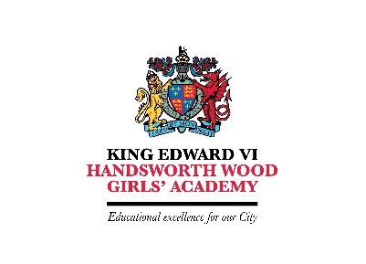
Senior Science Technician
Point 16 – 22
£24,012 - £27,041
36.50 hours per week
All year round (although this is negotiable)

King Edward VI Handsworth Wood Girls’ Academy
Church Lane, Handsworth, Birmingham B20 2HL
T: 0121 554 8122
E: enquiry@hwga.org.uk
W: www.hwga.org.uk

An exciting opportunity has arisen to join King Edward VI Handsworth Wood Girls’ Academy as our Senior Science Technician. The successful candidate will support teaching staff in the development and education of children, including the provision of specialist technical skills and knowledge at an advanced level, across a range of disciplines. Other key duties will include taking management responsibilities for other technicians, issuing and maintaining chemicals, apparatus, equipment and materials in accordance with specified procedures, and staying up to date with Health and Safety legislation. The successful candidate will be fully supported in their career and professional development through CPD and a commitment to supporting up to date training and development needs.

King Edward VI Handsworth Wood Girls’ Academy is an 11-18 comprehensive school in the north-west of Birmingham. Our student intake is from a variety of ethnic backgrounds, making for a very harmonious and happy school. We truly believe that high aspirations can transform the life chances of our students, underpinned by our drive to develop in our students the universal values of Scholarship, Character and Community.

Further details and application forms can be downloaded from the website (https://www.hwga.org.uk/the-academy/staff/vacancies/). Applications can only be considered if they are on an Academy Trust application form. Completed application forms to be returned to recruitment@hwga.org.uk. Early application is encouraged as we will review applications throughout the advertising period and reserve the right to close the advert early.

This school is committed to safeguarding and promoting the welfare of children and young people and expects all staff to share this commitment. An enhanced DBS check is required for all successful applicants.

Closing date: Thursday 25 November 2021 at 9.00 am

Interviews will take place on: tbc

