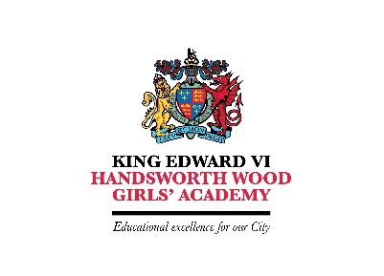
IT Support Technician
36.50 hours per week, Term time only plus 2 weeks
Point 3 – 8
£18,562 - £20,493 FTE
£17,041 - £18,814 – Actual

King Edward VI Handsworth Wood Girls’ Academy
Church Lane, Handsworth, Birmingham B20 2HL
T: 0121 554 8122
E: enquiry@hwga.org.uk
W: www.hwga.org.uk

An exciting opportunity has arisen to join King Edward VI Handsworth Wood Girls’ Academy as an IT Support Technician. The successful candidate will work alongside the Director of IT Systems and Services to continually develop the ICT infrastructure in the Academy. Specific duties are, to be responsible for provision of ICT support in all areas of the Academy, repair and maintenance, assist with network security and to teach the basic use of software programmes as necessary. The successful candidate will be fully supported in their career and professional development through CPD and a commitment to supporting up to date training and development needs.

King Edward VI Handsworth Wood Girls’ Academy is an 11-18 comprehensive school in the north-west of Birmingham. Our student intake is from a variety of ethnic backgrounds, making for a very harmonious and happy school. We truly believe that high aspirations can transform the life chances of our students, underpinned by our drive to develop in our students the universal values of Scholarship, Character and Community.

Further details and application forms can be downloaded from the website (https://www.hwga.org.uk/the-academy/staff/vacancies/). Applications can only be considered if they are on an Academy Trust application form. Completed application forms to be returned to recruitment@hwga.org.uk. Early application is encouraged as we will review applications throughout the advertising period and reserve the right to close the advert early. Please note CVs on their own are not accepted.

This school is committed to safeguarding and promoting the welfare of children and young people and expects all staff to share this commitment. An enhanced DBS check is required for all successful applicants.

Closing date: Wednesday 8 December at 9.30 am

Interviews will take place on: tbc

