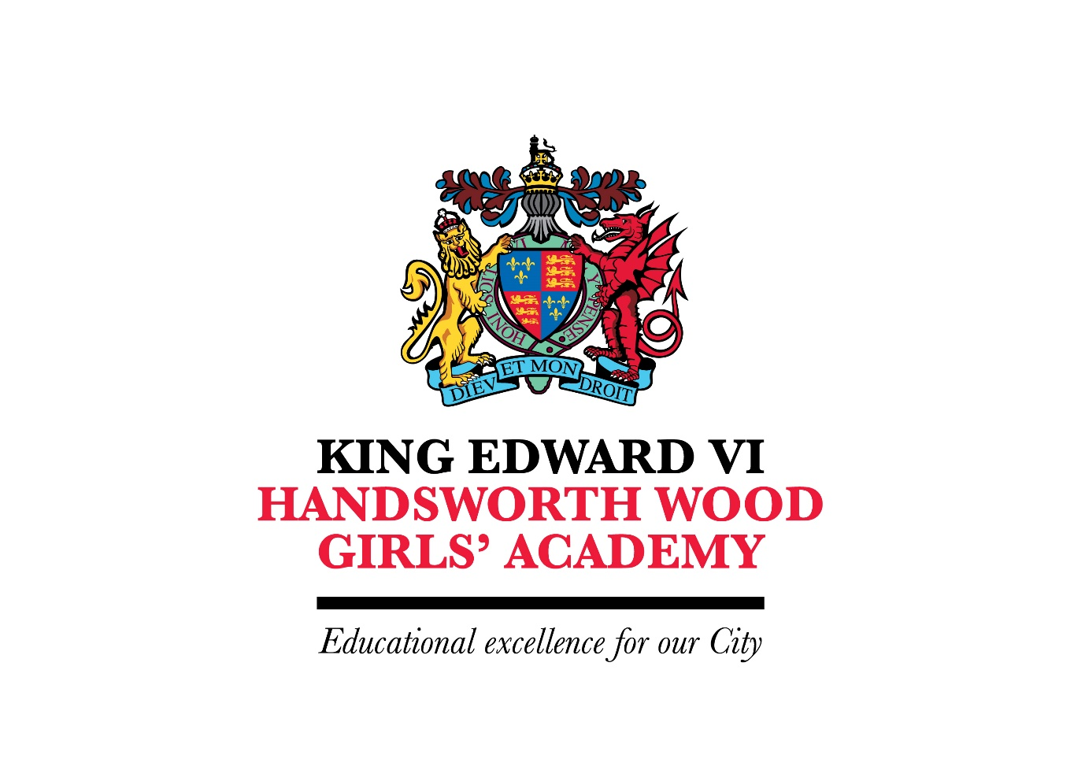

King Edward VI Handsworth Wood Girls’ Academy

CEIAG Policy

November 2020

King Edward VI Handsworth Wood Girls’ Academy
Policy for Careers Education, Information, Advice and Guidance (CEIAG)

Introduction

The careers programme at King Edward VI Handsworth Wood Girls’ Academy (KEVI HWGA hereafter) aims to encourage our students to be aspirational and ambitious in their career goals, in line with the High Performance Learning approach taken to teaching and learning at the Academy. It is part of the vision and mission of the Academy that all students will be provided with opportunities to plan and manage their careers effectively through appropriate education, information and guidance at each key stage.

Commitment

KEVI HWGA recognises that it has a statutory duty to provide careers education in Years 7-13 (1997 Education Act, 2003 Education Regulations) and to give learners access to impartial careers information, education and guidance (1997 Education Act, 2009 Education and Skills Act). It is committed to providing a planned programme of impartial careers education and information, advice and guidance (IAG) for all students in Years 7-13, in partnership with local specialist providers; as well as providing extra support as required for vulnerable students and students with special educational needs. Our commitment to careers education is in line with the Gatsby bench marks for the delivery of robust careers education.

The Gatsby Benchmarks are as follows:
1. A stable careers programme
2. Learning from career and labour market information
3. Addressing the needs of each student
4. Linking curriculum learning to careers
5. Encounters with employers and employees
6. Experience of work places
7. Encounters with further and higher education
8. Personal guidance

KEVI HWGA endeavours to follow best practice guidance from the careers’ profession, from other expert bodies such as Ofsted and from Government departments such as the Careers Enterprise Company.

KEVI HWGA is also committed to delivering a high quality careers education, information and guidance service, which has led to the achievement of a Quality in Careers Award.

Development

This policy was developed and is reviewed annually in discussion with senior leadership team, teaching and teaching support staff, students, parents, governors, advisory staff and other external partners (e.g. Prospects, Birmingham Careers Service, the 14-19 Partnership and the Careers Enterprise Company).

Links with other policies

The policy for CEIAG supports and is itself underpinned by a range of key school policies especially those for Teaching and Learning, Assessment, Recording and Reporting Achievement, Equality and Diversity, Inclusion and SEND. The academy has a separate Provider Access Policy.
Objectives
Learners’ Needs
The careers programme is designed to equally meet the needs of all students at KEVI HWGA. Activities are differentiated and personalised to ensure progression in their career learning and development and to strengthen their motivation, aspirations and attainment at school.
Entitlement
Learners are entitled to CEIAG which meets professional standards of practice, delivered by trained staff and which is person-centred, impartial and confidential. Activities will be embedded in the curriculum and based on a partnership with students and their families. The programme will raise aspirations, challenge stereo-typing and promote equality and diversity.
Implementation
Management
The Director of Communication and Operations (Education) has strategic responsibility for leading on careers education and manages the overall careers programme, and is accountable to the Head Teacher. An Aspirations Leader supports the Director of Communication and Operations (Education) in managing and coordinating the IAG provided to students. This area is also supported by a link governor. The Aspirations Leader is also responsible for planning and implementing the work experience programme and coordinating vocational links across the curriculum in conjunction with the Assistant Head Teacher for Quality of Education and Curriculum Leaders.
Staffing
All members of staff contribute to CEIAG through their roles as tutors and subject teachers. The CEIAG programme is planned, monitored and evaluated by the Director of Communication and Operations (Education) in consultation with the Senior Leadership Team. Careers information is available in the Learning Resource Centre which is maintained by the Aspirations Leader, in the Careers’ Office and within the TEAMS platform. Administrative support is also made available.
Curriculum
The careers programme includes careers education sessions, career guidance activities (e.g. group work and individual interviews), information and research activities (using bespoke commercial careers packages), work related learning (including work experience), and individual progression planning. Career and Enterprise activities are part of the school’s personal development programme. Other focused events, e.g. a Careers Fair, visits by and to Employers and Enterprise Days are delivered at appropriate times in the curriculum and students are actively involved in the planning, delivery and evaluation of activities.
Each curriculum department has an identified Careers Champion, who is responsible for promoting subject-specific careers education as well as monitoring and reporting on the careers education delivered each term to identified groups of students.
Assessment and Accreditation
The intended career learning outcomes for learners are based on the careers education framework 11-19, the statutory guidance and the ACEG framework.

Partnerships
An annual Partnership Agreement is negotiated between the school and a designated impartial IAG provider which identifies the contributions to the programme that each will make. Other links are continually being developed, e.g. with local 14-19 partners, local employers and KE/HE/training providers.

Resources
Funding is allocated in the annual budget planning round in the context of whole school priorities and particular needs in the CEIAG area. The Director of Communication and Operations (Education) is responsible for the effective deployment of resources. Sources of external funding for activities are actively sought.

Staff Development
Staff training needs are identified in conjunction with the senior leadership team. The school endeavours to meet training needs within a reasonable period of time.

Monitoring, Review and Evaluation
The Partnership Agreements with designated providers will be reviewed as agreed. The programme is reviewed annually by the Director of Communication and Operations (Education) and the quality standards for CEIAG will be used as a benchmark to identify areas for improvement. A report will be submitted to the senior leadership team and governors. Evaluation of different aspects of CEIAG will be undertaken regularly.

References
(1) DfE (Jan 2018) Careers guidance and inspiration in schools: Statutory guidance for governing bodies, school leaders and school staff
(2) DfE (April 2014) Careers guidance and inspiration in schools: Non-statutory departmental advice for governing bodies, school leaders and school staff
(3) HM Government (September 2013) Inspiration Vision Statement
(4) Ofsted (September 2012) Going in the right direction? Careers guidance in schools from September 2012
(5) Gatsby Charitable Foundation (May 2014) Good Career Guidance (a report produced by Sir John Holman)
(6) Association of Careers Education and Guidance (2012) The ACEG framework for careers and work-related education: A practical guide (Adopted by the Careers Develop
(7) Careers Strategy – Making the most of everyone’s skills and talents (Dec 2018)

Policy signed off by:

Chair of Curriculum Committee

Date:

Review date for school policy:

Person responsible for policy: Deputy Headteacher Director of Curriculum and Assessment

