How to access Fire Fly

Handsworth Wood Girls’ Academy

Year 6 – Year 7 Transition
2020 - 2021

Welcome to using our Fire Fly platform!!

You will start to use Fire Fly in Year 7, to access a range of tasks including home study, quizzes, receive important information, plus much more.
To get you used to accessing Fire Fly before you start in September, we have provided you with a temporary password, which will enable you to access the Transition Page, the letter to self-task, the summer project and a number of other resources.

Please use the following steps to help you log into Fire Fly:
- Go to the Academy website – www.hwga.org.uk which will take you to the main homepage.

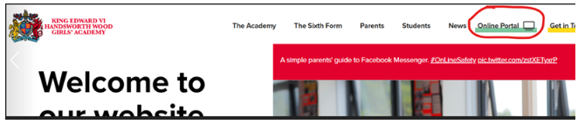

At the top of the page, you will see the ‘Online Portal’ link and symbol. Please click on this.

Please then select the ‘Student’ option as your portal.

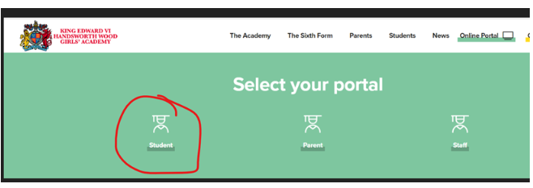

Please click onto this and you will be directed to the log in page as below.

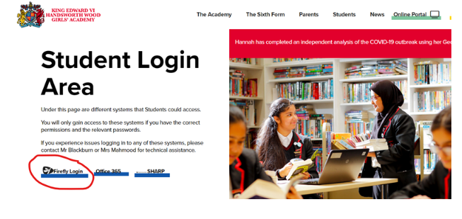
You will now see the Firefly login tab and symbol. Please click on this.
You will now be asked for a username and password. Please enter the account name and password as shown and do not leave any spaces between each character.

Account name – firefly.student@hwga.org.uk

Password - F1refly44

Next, you will be directed to the Dashboard (main page) on Fire Fly.
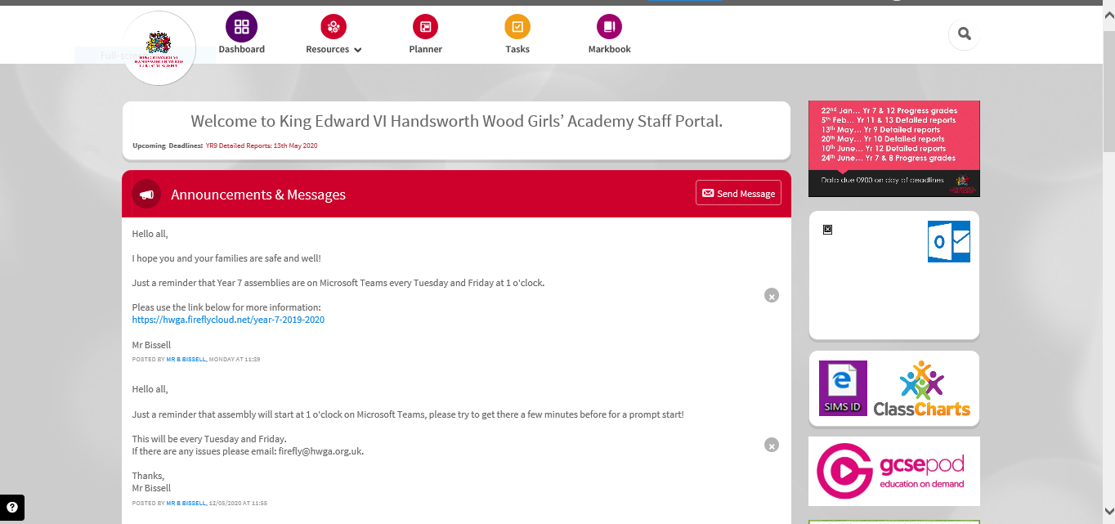
Click on the ‘Resources’ tab as below

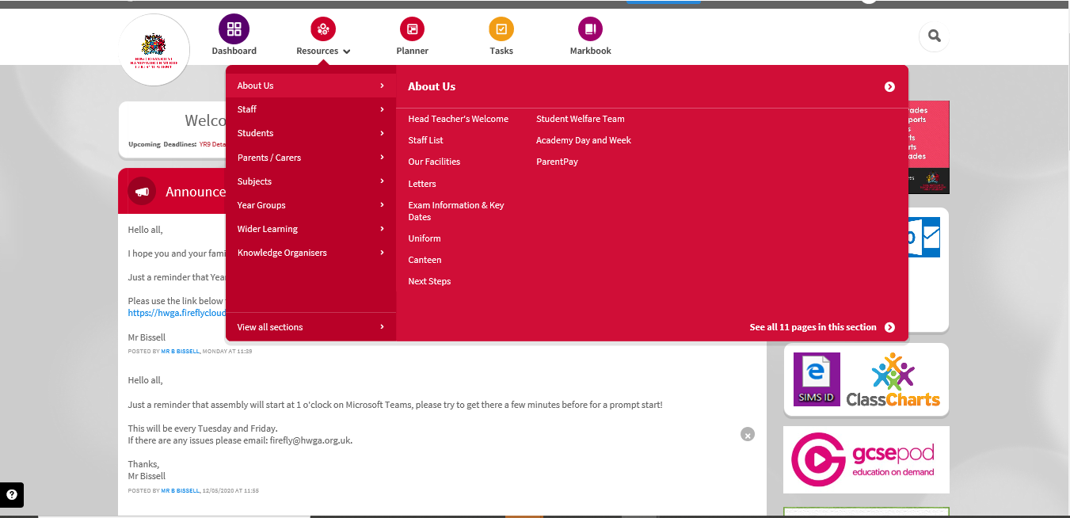

Then hover down and click on ‘Students’.
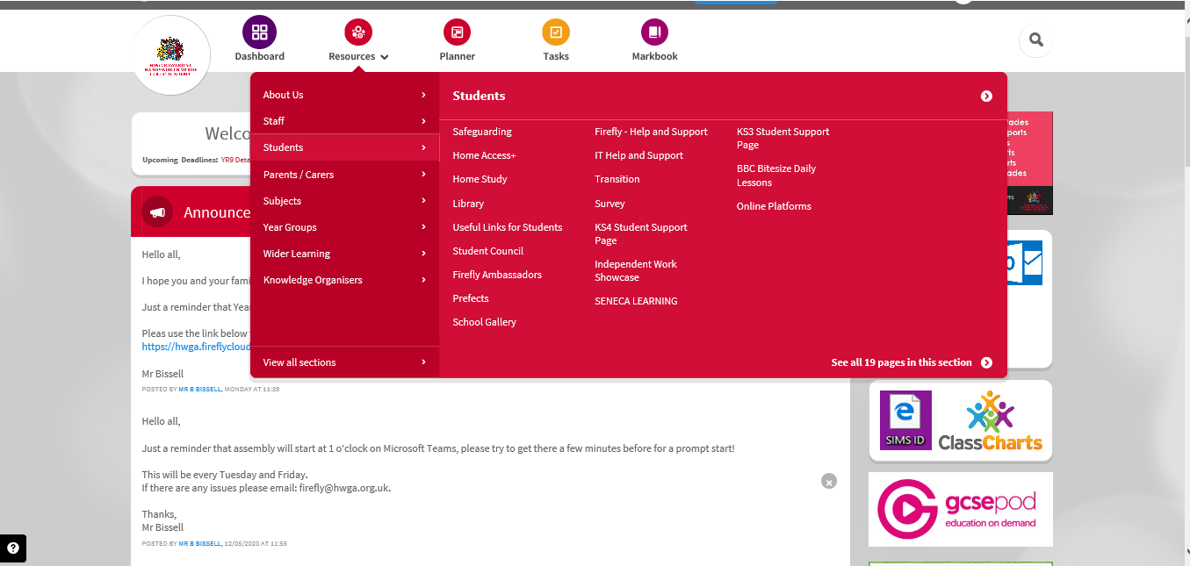

Then select ‘Transition’
Well done!! You will have now arrived at the ‘Transition’ page!!
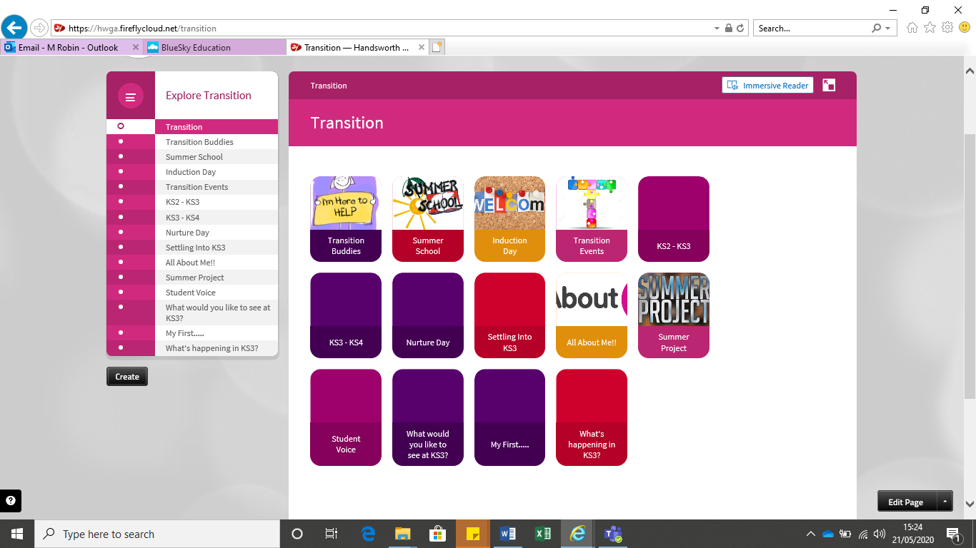

Click on the tab ‘Summer Project’ to access the resources for the project.
Please explore all of the resources that will help you to complete the project. You can also explore the KS2 – KS3 information, by clicking on the tab.

Submitting your project electronically

If you would like to download and submit your completed booklet or any tasks that you would like us to see, please use the following steps:

- When you have finished a task, save this onto your laptop, with a name or title that you will remember. You may want to create a folder, as this will help you to become organised and locate your work easily.

- Using an email account, you can send your work to your Head of Year, Mrs Newman – hnewman@hwga.org.uk. You can also bring your paper version also, on your first day at HWGA.

If you have any questions, again you can email Mrs Newman, Head of Year 7 or Miss Robin, Head of Key Stage 3 – mrobin@hwga.org.uk
We hope that you will enjoy your summer project and very much look forward to seeing you and your tasks, when you join us in September.

Have a lovely summer holiday!!

