 | Geography | Name: __________________________________
A Level Geography

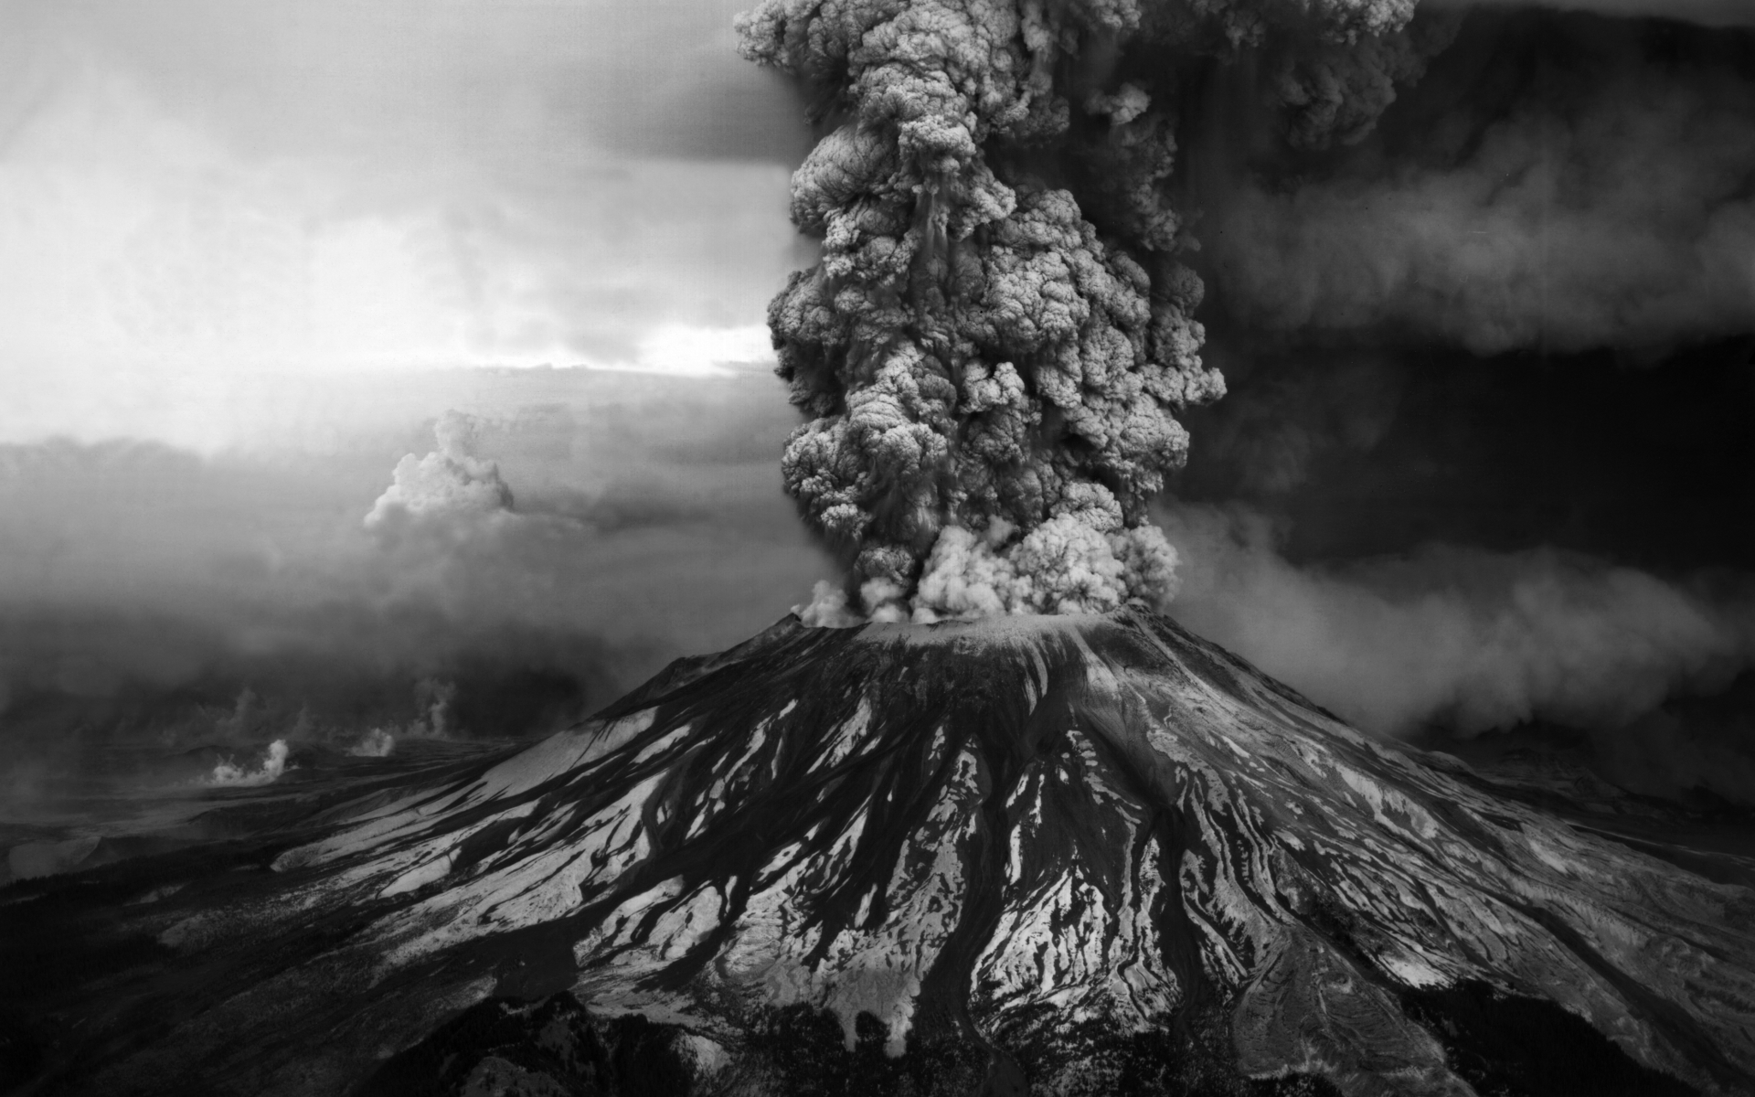
Summer Preparation Work 2019

What you will be studying
Key Features:
- A balance of contemporary human and physical studies in geography.
- Full synopticity throughout to allow students to show their skills as a Geographer.
- A range of assessment.
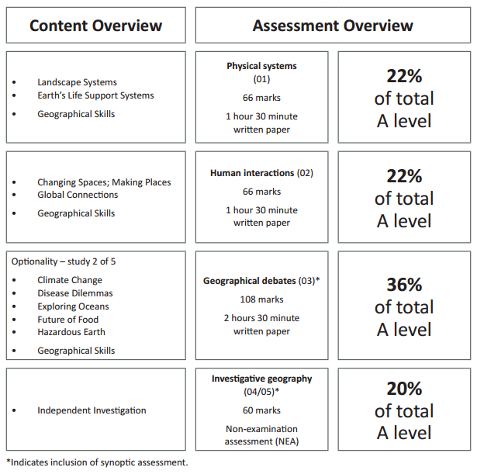

Physical Systems – The Coastal Landscape

Task:
Research and learn about coastal landforms. You must create a fully annotated sketch of a coastal landforms which have been created by:

Processes of Erosion

Processes of Deposition

Processes of Transportation

Human Interactions – Changing Spaces, Making Places

Task:
Watch TV
Choose a TV programme (Soaps are the best). Write an analysis of the ways in which the programme portrays key elements of the place it is located in.

Consider the following:
- The physical geography of the location such as landscape, street layout, architecture, age of buildings, weather and climate
- The human geography of the location such as age and sex structure, occupations, ethnic origins, religion, occupation and sexual orientation.
- With this what is the impact on your perception of the place?

Human Interactions – Global Migration

Task:
Find Donald Trump’s Twitter page.
Scroll until you find two tweets he has made in relation to migration or migrants in The USA and write them in the space below.

Discuss the tweets. Think about; The message he is trying to deliver, The impacts this will have on American people, The impacts it will have on Non-American people, The impact this will have on the wider world.

Geographical Debates – Climate Change

Task:
Research Greta Thunberg. Create a biography of her.

You should include:
- General facts, age, nationality, occupation etc.
- What she is known for
- How she became so well known
- What impact has she had in Europe
- What impact has she had in the wider world
- What could change because of her message

