A-level chemistry
Induction booklet summer 2019
June 1, 2019
King Edwards vi handsworth wood girls academy
Church Lane, Handsworth, Birmingham, B20 2HL

Introduction to A-level Chemistry

Welcome to chemistry at Handsworth Wood Girls Academy.

This booklet recaps the key GCSE content that you will be expected to be competent in before starting the A-level course. All of the content will have been covered in your chemistry studies, whether you did combined or single science chemistry at key stage 4.

Each section presents some of the key ideas that you will need to be secure with to access A-level chemistry. Also included is a model question and answer for each set of idea, together with a practice question. Mark schemes are given at the end of the booklet.

Other good sources of information include your Higher tier revision guide and the flowing websites:

https://www.creative-chemistry.org.uk/gcse

https://www.bbc.com/bitesize/topics/z88jjty

https://chemrevise.org/gcse-aqa-guides/

You will be assessed on this content in your second week of Year 12 and are required to show that you have a sound understanding of the key concepts required.

Section 1: Atomic structure
The atom consists of three subatomic particles: proton, electron and neutron. The nuclear model of the atom was discovered by Rutherford:
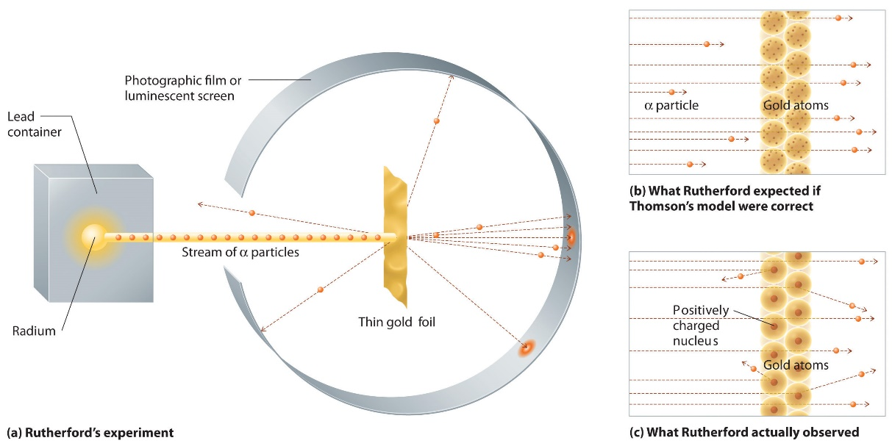

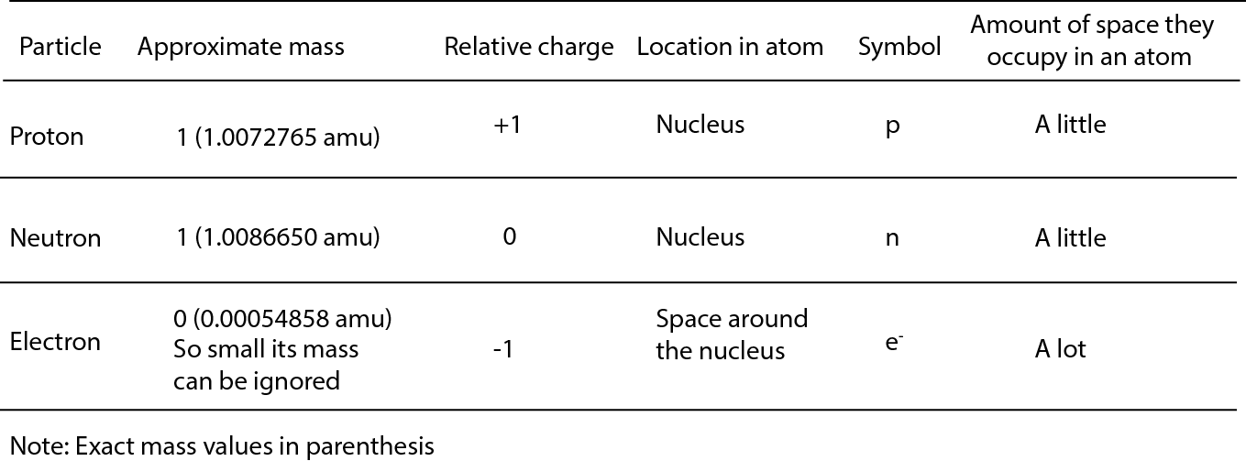
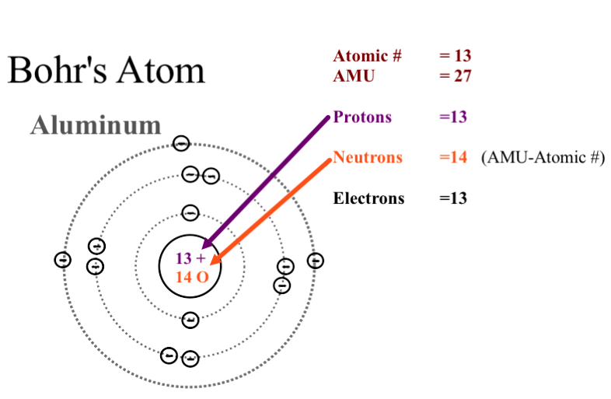
You need to be able to use the periodic table to:
- Work out the number and location of the three particles in any atom up to and including calcium
- To be able to explain why elements in the same group of the periodic table react the same way
- Be able to explain what isotopes are and why they react in exactly the same way as each other.
Eg: carbon has three isotopes:
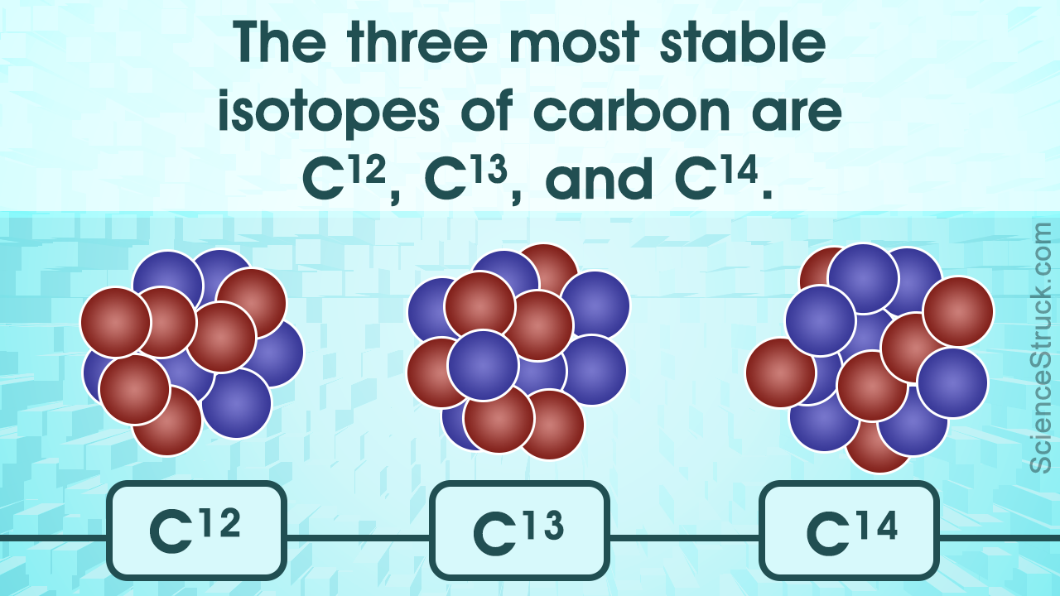

All three contain 6 protons in the nucleus and an electron arrangement of 2.4 – so they react the same way chemically. They differ with number of neutrons contained in the nucleus: C-12 = 6, C-13 = 7 and C-14 = 8

Practice question: How many protons, electrons and neutrons do the following isotopes contain? Why do they all react quickly with water?

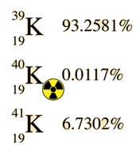

Section 2: Why do elements react?
Elements react to get to stable arrangements of electrons in their outer shells. Group 0 elements already have this as they have full outer shells. Other elements react to get full outer shells by either transfer of electrons (ionic bonding) or sharing of electrons (covalent bonding).
Metals lose electrons (oxidation, remember OILRIG) while non-metals gain electrons (reduction). How quickly they do this determines their relative reactivity within the group.
Eg. What is the reactivity trend of group 7 (halogens)? Explain this using ideas of atomic structure and electron transfer.

Answer: fluorine is the most reactive element, with reactivity decreasing down the group. Halogens react by gaining an electron to get to a full outer shell. Fluorine gains an electron more readily than chlorine

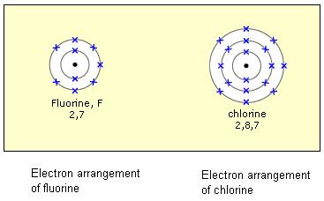
Fluorine has less shielding (screening) shells of electrons between the positive nucleus and the electrons in the outer shell. There is therefore a greater force of attraction for an electron at the outer shell so an electron is gained more readily than in chlorine.

Practice question: what is the trend in reactivity in group 1? Explain your answer using ideas of atomic structure and electron transfer.

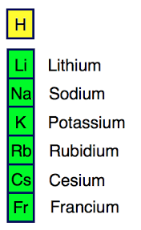

Section 3: Ionic and covalent bonding
Metals and non-metals react together to form ionic compounds. The metal loses electrons and gains a positive charge based upon its group number/how many electrons it loses. The non-metal gains electrons to get to a full outer shell and produces negatively charged ions.
Non-metals form molecules by sharing electrons to achieve a full outer shell. A covalent bond is formed by sharing a pair of electrons (single bond), while double and triple covalent bonds are formed by sharing two and three pairs of electrons
Eg. Show the bonding in sodium chloride (NaCl) and water (H₂O) using outer shell electrons only (blank shells to fill in are given at GCSE level, not at A-level)

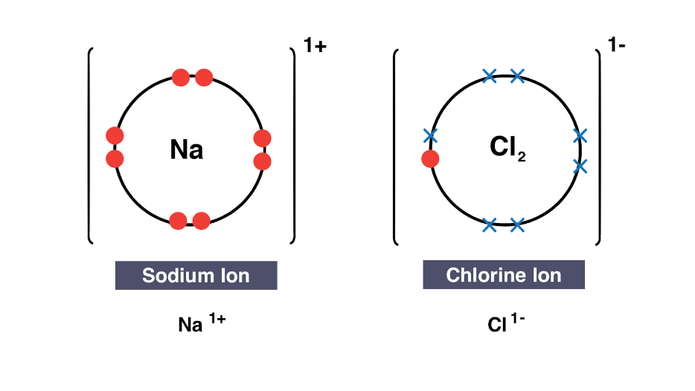
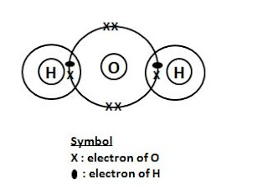

Practice questions: show ionic bonding in potassium fluoride (KF), calcium oxide (CaO), methane (CH₄) and carbon dioxide (CO₂)

Section 4: metallic bonding and giant covalent lattices
Metallic bonding involves metal ions being surrounded by a “sea” of delocalised electrons. Properties due to this include being conductors of electricity, high melting points and metals being malleable.
Some elements and compounds form giant covalent structures (macromolecular). These substance always have anomalously high melting points
Eg: explain why metals and graphite conduct electricity

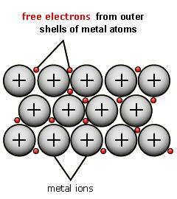

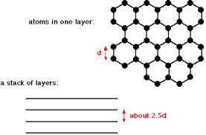

Both structures have delocalised electrons which are free to carry an electrical current

Practice question: explain why metals and macromolecular structures have high metal points by reference to their structures. Why is diamond an insulator of electricity?

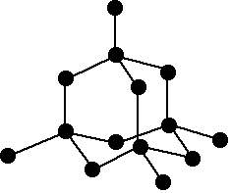

Section 5: Redox reactions and electrolysis
Redox reactions involve one element being oxidised (losing electrons) while another being reduced. We can show this using half equations with e⁻ representing an electron. Electrolysis of an ionic compound produces the metal by reduction of its ions while the non-metal element is made by oxidation
Eg. Why must an ionic compound be molten to conduct electricity?
Using e- to show an electron, write half equations to show how sodium atoms and chlorine molecules are made in this process

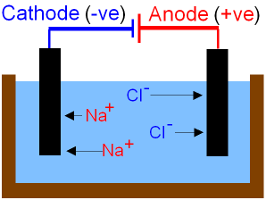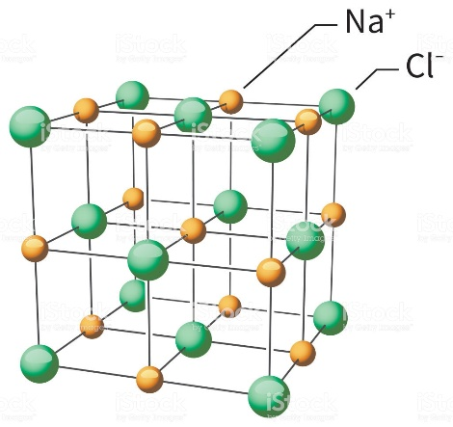

Ions are free to carry electrical when molten.

Na⁺ + e⁻ Na Reduction

2Cl⁻ Cl₂ + 2e⁻ Oxidation

Practice question: why does it take a lot of energy to melt aluminium oxide? Write equations to show how Al atoms are made from Al³⁺ ions and how oxygen O₂ molecules are made from oxide O²⁻ ions

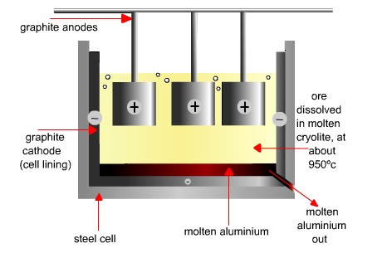

Section 6: relative formula mass and percentage element
The relative atomic mass of an element (compared to carbon-12) is the larger (normally the upper) number listed for the element in the periodic table. The relative molecular mass (also sometimes called the molecular mass or formula weight or m_{r}) is the masses of all atoms in a molecule added together. The percentage by mass of an element in a compound is the mass of the atoms of an element in a compound divided by the relative molecular mass (x100 to give a percentage).
Eg. What are the percentages of the three elements in sulphuric acid H₂SO₄? Add the three up – what do you notice? Repeat this for ammonium sulfate (NH₄)₂SO₄.

H₂SO₄ molecular mass = 98
% H = (2x1/98) x 100 = 2.0%
% S = (32/98) x 100 = 32.7%
%O = (4x16/98) x 100 = 65.3%

2.0 + 32.7 + 65.3 = 100% as the three elements must add up to 100%

(NH₄)₂SO₄ molecular mass = 132
%H = (8x1/132) x 100 = 6.1%
%N = (2x14/132) x 100 = 21.2%
%S = (32/132) x 100 = 24.2%
%O = (64/132) x 100 = 48.5%

6.1 + 21.2 + 24.2 + 48.5 = 100%

Practice question: what are the percentages of the elements in phosphoric acid H₃PO₄ and magnesium phosphate Mg₃(PO₄)₂?

Section 7: the mole
The number of particles in a mole of a substance is given by Avagadro’s number = 6.02 x 10²³. The mass of one mole of an atomic element is the relative atomic mass in grams, while the mass of one mole of a molecule is given by its relative molecular mass in grams. Moles, mass and relative mass are given by the equations:
n = m/a_{r} for atoms or n = m/m_{r} for molecules
where n = moles, m = grams of substance and a_{r} and m_{r} are relative masses of atoms and molecules. You will need to be able to use this equation to get n, m or relative mass if given two of the other three quantities.
Eg: 1. How many moles is 3.21g of carbon? 2. How many moles is 1.13g of carbon dioxide? 3. What is the mass of 100 moles of magnesium oxide MgO? 4. What is the relative atomic mass of an element if 0.100 moles of it have a mass of 5.20g – what element is it?

- n = 3.21/12 = 0.268 moles

- n = 1.13/44 = 0.0257 moles

- m = 100 x 40 = 4000g (4kg)

- ar = 5.20/0.1 = 52.0. Therefore = chromium

Practice questions: 1. What is the number of moles in 1.95g of calcium? 2. How many moles does 109.1g of water contain? 3. What is the mass of 0.125 moles of calcium oxide CaO? 4. 0.25 moles of an element has a mass of 5.75g - what is its relative atomic mass and identify the element

Section 8: simple mole calculations for chemical reactions
A balanced symbol equation tells us how many moles of reactants react together and how many moles of products are made in a specified chemical equation. If the mass of a limiting reactant is known, then the mass of a product can be calculated by using a mole calculation
Eg. Write a balanced equation for the reaction of carbon with oxygen to make carbon dioxide. If there is excess oxygen available for the reaction, what mass of carbon dioxide would be made if 3.24g of carbon was burnt?

C + O₂ CO₂

Use n = m/a_{r}

- Moles of carbon = 3.24/12 = 0.270
- The balanced equation tells us that the moles of carbon dioxide made will be the same as the moles of carbon that react = 0.270
- Work out the moles of carbon by rearranging the mole formula so that m = n x m_{r} (molecule) so
m = 0.270 x 44 = 11.9

Practice question: write a balanced symbol to show the reaction of sulphur with oxygen (O₂) to produce sulphur dioxide (SO₂). If 5.91g of sulphur reacts with excess oxygen, what mass of sulphur dioxide (SO₂) is made – show your calculations clearly

Section 9: mole calculations involving ratios
Most chemical reactions do not simply involve one mole of a reactant producing one mole of a product. For example,
2C + O₂ 2CO
In this reaction, one mole of oxygen reacts with two moles of carbon. If we know the moles of oxygen used, then we need to double this to work out the moles of carbon used (or carbon monoxide used).
Eg. Magnesium reacts with oxygen to make magnesium oxide
Mg + O₂ MgO. Balance the equation and work out the mass of magnesium that would react with 6.97g of oxygen. Also calculate the mass of magnesium oxide made

- 2Mg + O₂ 2MgO

- Moles of oxygen used = n = m/m_{r} = 6.97/32 = 0.218

- Each mole of oxygen will react with two moles of Mg so moles Mg = 2 x 0.218 = 0.436

- Mass of magnesium used = n x ar = 0.436 x 24 = 10.5g

- Each mole of oxygen will make two moles of MgO, so mole MgO also = 0.436
Mass MgO = n x mr = 0.436 x 40 = 17.4g

Practice question: write a balanced symbol equation for the reaction of sodium with chlorine (Cl₂) to make sodium chloride (NaCl). If 45.1g of chlorine was used, what mass of sodium would this react with? What mass of sodium chloride would be made?

Answers for practice questions

Section 1: Isotopes
K-39: 19 protons, 19 electrons, 20 neutrons [1]
K-40: 19 protons, 19 electrons, 21 neutrons [1]
K-41: 19 protons, 19 electrons, 22 neutrons [1]
All react quickly with water as they all have the same electron configuration/one electron in outer shell [1]

Section 2: Reactivity trend in group one
[1-2] Reactivity increases down the group, all lose one electron in outer shell
[3-4] Atoms bigger/more shells, force of attraction between positive nucleus and outer shell electron lower
[5-6] More complete shells of electrons between nucleus and outer shell electrons/shielding or screening

Section 3: Ionic and covalent bonding
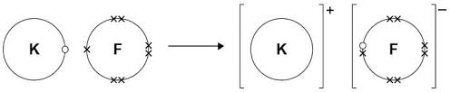
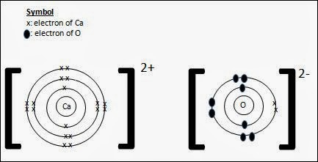

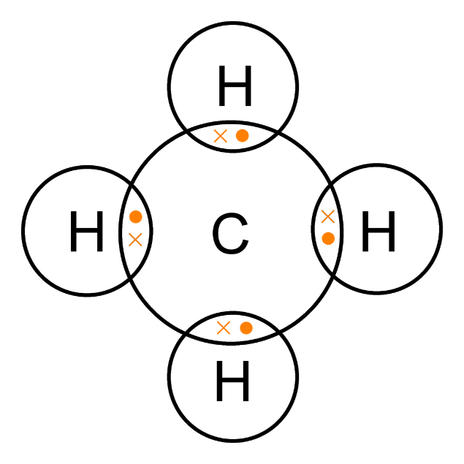

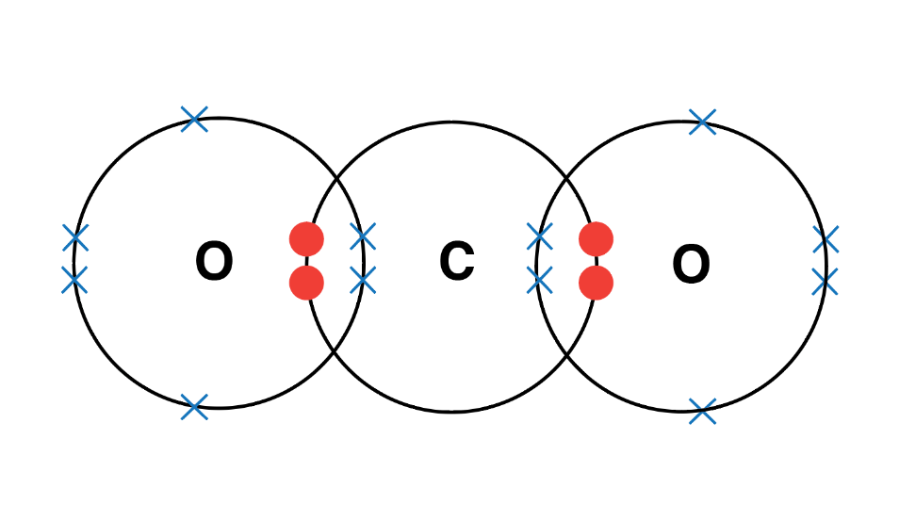

Section 4: metallic bonding and giant covalent lattices
Metals: high melting point due to strong forces of attraction between oppositely charged metal ions and delocalised electrons needing much energy to break.
Macromolecules: high melting point due to giant lattice with many strong covalent bonds which require a large amount of energy to break.
Diamond: insulator due to no delocalised electrons/mobile ions, electrons confined to atoms and covalent bonds

Section 5: Redox reactions and electrolysis
High melting point: strong forces of attraction between oppositely charged ions need a lot of energy to overcome
Al³⁺ + 3e⁻ Al Reduction due to gain of electrons
2O²⁻ O₂ + 4e⁻ Oxidation due to loss of electrons

Section 6: Relative formula mass and percentage element
Phosphoric acid H₃PO₄: m_{r} = 98, H = 3.06%, P = 31.6%, O = 65.3%
Magnesium phosphate Mg₃(PO₄)₂: m_{r} = 262, Mg = 27.5%, P = 23.7%, ) O = 48.9%

Section 7: The mole
- Moles calcium = 1.95/40 = 0.0488
- Moles water = 109.1/18 = 6.06
- Mass CaO = 0.125 x 56 = 7.00g
- Relative atomic mass = m/n = 5.75/0.25 = 23.0, Sodium

Section 8: Simple mole calculations
S + O₂ SO₂
- Moles of sulphur = 5.91/32 = 0.185 moles
- Moles sulphur = moles sulphur dioxide = 0.185
- Mass sulphur dioxide = 0.185 x 64 = 11.8g

Section 9: Mole calculations involving ratios
2Na + Cl₂ 2NaCl
- Moles chlorine = 45.1/71 = 0.635
- Moles sodium reacted with = 2 x moles chlorine = 2 x 0.635 = 1.27. Mass of sodium = 1.27 x 23 = 29.2g
- Moles sodium chloride made = 2 x moles chlorine = 1.27. Mass sodium chloride = 1.27 x 58.5 = 74.3g

