

AQA LEVEL 3 EXTENDED CERTIFICATE IN APPLIED BUSINESS (1832)

Induction day resource pack

Student name: ……………………………………………………

Form: ……………………………………………………

Tutor name: Mrs Sira

Room: W103

## Introduction

This guide is a checklist of what you will be covering in this unit with an outline of the objectives. This guide will help you organise your work



**Staffing**

Head of Business: Mrs N Sira

Class Room: W103

Teacher email: [nsira@hwga.org.uk](mailto:nsira@hwga.org.uk)

**Aims**

* help students fulfil their potential through studying a wide range of business & economics related topics
* develop students’ future work-related and employability skills.

**Objectives**

The courses enable students to :-

* develop independent thinking skills
* solve problems and develop decision-making whilst understanding the dynamics of business activity and the influence this has on decision-making processes within a business
* apply their knowledge and understanding to different business contexts ranging from small enterprises to large multinationals and businesses operating in local, national and global contexts
* develop an understanding of how these contexts impact on business behaviour.

## Overview of course

This Advanced Level course offers students a varied, entertaining and demanding two years. The course enables students to focus on the dynamic nature of the contemporary business world. It provides them with opportunities for research into topical business issues and to follow business developments.

Students will gain an insight into different contexts, which will help them to understand the key issues and to think critically when analysing business situations.

The Level 3 Certificate in Applied Business consists of three mandatory units (units 1–3 below).

The Level 3 Extended Certificate in Applied Business consists of six units (the Certificate units 1-3, plus units 4, 5 and one from units 6, 7 and 8 below).

## What are the benefits of studying this qualification?

The AQA Level 3 Extended Certificate in Applied Business will give learners the opportunity to learn and understand a broad range of business and entrepreneurial knowledge and skills associated with working within a business enterprise.

The learner will understand the way in which any venture in business (big or small) is a function of the relationship between its people, its marketing, its finance and its ability to deliver operationally upon its commitments.

In the Certificate qualification, the learner will undertake a programme of assessment designed to assess not only their business knowledge and understanding, but also the way in which this knowledge and understanding can be applied to shape their practical skill in thinking and realising their own plans about business. Unit 3 Entrepreneurial opportunities is the synoptic assessment unit which enables learners to demonstrate this practical initiative.

The Extended Certificate qualification offers the learner the opportunity to build on the knowledge and understanding gained in the Certificate qualification (eg Managing and developing people begins to address key areas in the management and leadership of business staff) and also build on their business idea developed in the Certificate qualification. Unit 5 Developing a business proposal is the synoptic assessment unit. Drawing on skills and knowledge from all other units, it enables learners to build their business idea into a concrete proposal.

The link between Unit 5 Developing a business proposal and the learner’s choice of optional units offers further opportunities to develop the realism of the exercise, and to undertake their learning experience in a fully integrated way. It’s here that learners can derive the true practical value of the qualification and, finally, (if they wish) develop a business proposal that could be turned into a real business.

## Course Modules

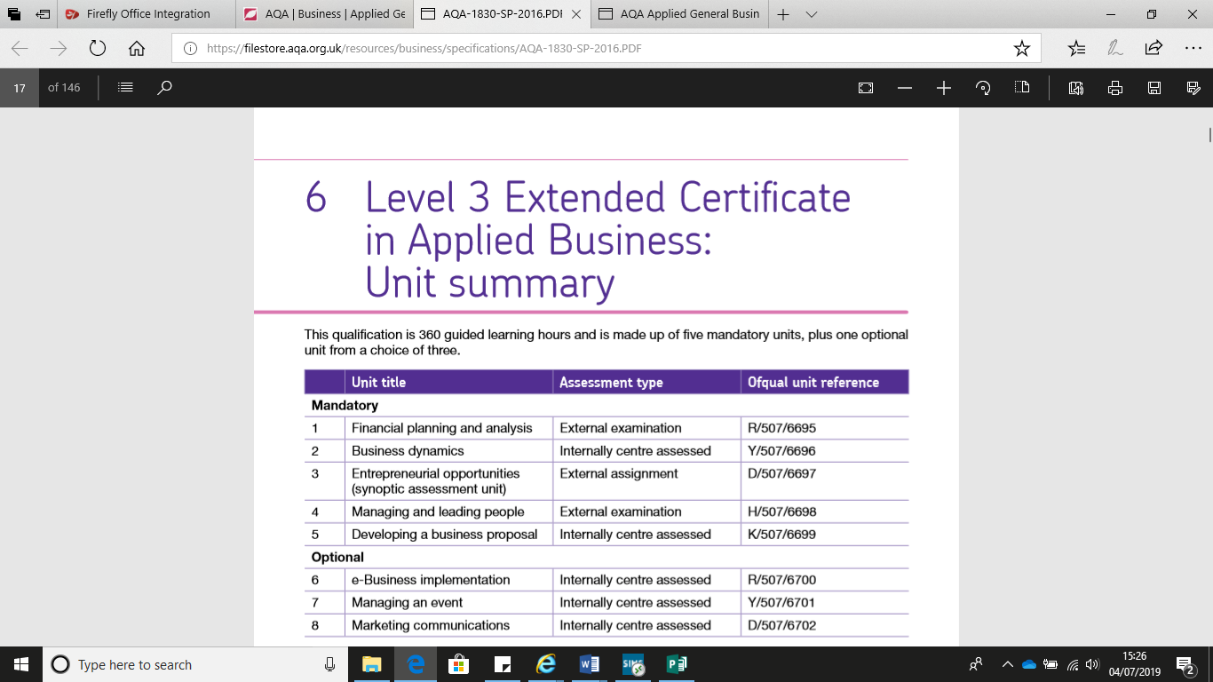

Year 12

* Unit 1
* Unit 2
* Unit 3

Year 13

* Unit 4
* Unit 5
* Unit 6

## Summer Flip Learning Tasks

*In September, you will focus on Unit 1: Financial Planning and Analysis. You will explore the financial issues that enterprises need to consider. To do this, you will need to explore different ways in which enterprises can be owned and how they can be financed. You will need to understand the issues that enterprises face concerning cash-flow. You will calculate profit, break-even and cash-flow to monitor the enterprise. Finally, you will use this information, as well as from final accounts and market information, to make business decisions.*

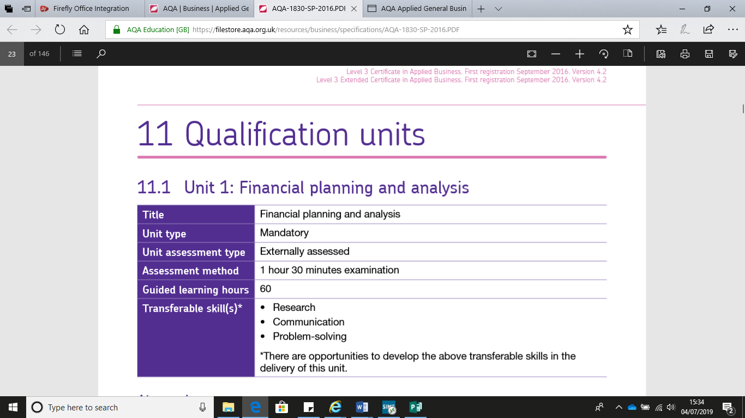

*To prepare you for your examination in January, please read the topics and answer the flip learning questions. Do not worry if you cannot answer all the questions however please make sure you attempt all questions. Please bring these completed booklets to your first lesson. There will be a short base line test to see what you have learnt when you start in September.*

*See you in September!*

***Mrs Sira***

## **Assessment outcome 1: Investigate why business enterprises plan their finances.**

### Topic 1: Business Planning

|  |  |
| --- | --- |
| **Theory** | **Notes** |
| A business plan is an important part of setting up a business and will be used both internally by the entrepreneur and externally by banks, external investors or those willing to provide grants.  Watch the video on Business plans:  <https://www.youtube.com/watch?v=FIoGLHT4wGE>  Planning an enterprise will include the need to plan finances   * This will include:   + **Start-up cost**     - The costs involved in setting up the business     - e.g. market research, legal advice, premises, fixtures and fittings, opening stock   + **Running costs**     - The costs of operating the business on a day to day basis     - e.g. utilities, replenishing stock, wages   + **Profit**     - Profit is the surplus of revenue i.e. the money coming in from sales over the costs i.e. the money going out to fund the business activity     - If a business is to survive it must plan how it will achieve a profit in the medium to long term   Click on the link for more information on financial objectives  <https://smallbusiness.chron.com/examples-start-up-running-costs-10278.html> |  |
| **Questions I have about the topic** | |

1. Fill in the blanks.

An entrepreneur is someone who has an ____________ and is ____________ to take a ____________ to set up a new ____________ ____________ . This will involve carrying out ____________ ____________ to identify the amount of potential ____________ i.e. the number of ____________ interested in ____________ the ____________ or ____________. The entrepreneur may need to raise ____________ and will therefore draw up a ____________ ____________ . This will outline the ____________they want to achieve as well as key financial objectives including:

* ____________ targets
* ____________ ____________ forecast
* ____________ ____________ finance

There will also be an objective to make a ____________ for the ____________.

1. Which 2 of the following are start-up costs?
   1. Wages
   2. Replacing stock
   3. Utility bills
   4. Buying premises
   5. Opening stock
   6. Fuel for delivery van
2. What name is given to the other costs shown in question 2?

______________________________________________________________________________

1. State 3 key stakeholders.
   * _______________________
   * _______________________
   * _______________________
2. What is meant by the term profit?

_____________________________________________________________________________

______________________________________________________________________________

______________________________________________________________________________

### Topic 2: Legal Structures of a Business

|  |  |
| --- | --- |
| **Theory** | **Notes** |
| One of the most important choices you will make when forming your new business is which legal structure to choose from. Choices include LLCs, partnerships, sole proprietorships, corporations, non-profits, and co-operatives.  Watch these videos on legal business structures:  <https://www.youtube.com/watch?v=A-Up-JUkaj0>  <https://www.youtube.com/watch?v=nO1UPU51YKs>  Financial implications using different legal forms of a business:   1. **Sole trader:** a person who is the exclusive owner of a business, entitled to keep all profits after tax has been paid but liable for all losses.   **Limited liability partnerships:** is a partnership in which some or all partners have limited liabilities. It therefore can exhibit elements of partnerships and corporations. Each partner is not responsible or liable for another partner's misconduct or negligence.  **Partnerships:** A partnership is a formal arrangement by two or more parties to manage and operate a business and share its profits.  **Private limited companies:** A private limited company is a type of privately held small business entity, in which owner liability is limited to their shares. Shares are prohibited from being publicly traded.  **Public limited liability:** A public limited company is a company that is able to offer its shares to the public. The minimum number of shareholders must be two.  **Community interest company:** is designed for social enterprises that want to use their profits and assets for the public good.  **Cooperatives:** they are people-centred enterprises owned, controlled and run by and for their members to realise their common economic, social, and cultural needs and aspirations. |  |
| **Questions I have about the topic** | |

1. Identify whether each of the following statements are true or false. Justify your answer.

|  |  |
| --- | --- |
| Statement | True/False |
| A sole trader has unlimited liability |  |
| Justification: | |
| All companies can sell shares |  |
| Justification: | |
| Private limited companies and public limited companies are both in the private sector |  |
| Justification: | |
| Public limited companies have limited liability |  |
| Justification: | |
| Private limited companies are incorporated |  |
| Justification: | |
| A Ltd is a separate legal entity from its shareholders |  |
| Justification: | |
| A profit making company must pay dividends to its shareholders |  |
| Justification: | |
| One disadvantage of a sole trader is they need to do all the work themselves |  |
| Justification: | |
| Partnerships can have limited or unlimited liability |  |
| Justification: | |
| Community interest companies cannot make a profit |  |
| Justification: | |
| Co-operatives are owned by members who can be customers |  |
| Justification: | |

1. What do the following stand for?
   * Ltd ______________________
   * Plc ______________________
   * Llp ______________________
   * Cic ______________________

### Topic 3: Financing the Enterprise

|  |  |
| --- | --- |
| **Theory** | **Notes** |
| **Financing the enterprise:** Financing is the process of providing funds for business activities, making purchases or investing. Financial institutions such as banks are in the business of providing capital to businesses, consumers, and investors to help them achieve their goals.  Operating and expanding the business:   * For a **start-up** business this might be raising sufficient capital to establish the business * For an established business this might be to fund growth or implement a new strategy e.g. relocation   The **running costs** of a business are the amount of money that is regularly spent on things such as salaries, heating, lighting, and rent. The aim is to cut running costs by £90 million per year.   1. **Cash Flow:** the total amount of money being transferred into and out of a business.   **Internal sources of finance** are funds found inside the business. For example, profits can be kept back to finance expansion. Alternatively the business can sell assets that are no longer really needed to free up cash.  **External sources of finance** are equity capital, preferred stock, debentures, term loans, venture capital, leasing, hire purchase, trade credit, bank overdraft, factoring.  Videos you can watch to learn more about this topic:  <https://www.youtube.com/watch?v=c8hIwQ5xFY8>  <https://www.youtube.com/watch?v=_vpehy2vuGQ> |  |
| **Questions I have about the topic** | |

1. What is meant by the term internal finance?

__________________________________________________________________________________________________________________________________________________________________________________________________________________________________________

1. Which three of the following are examples of internal finance?
   1. Share capital
   2. Personal savings
   3. Sale of assets
   4. Family and friends
   5. Crowd funding
   6. Retained profit
2. Which one of the three correct answers in question two is the only option for a new business venture? Explain your answer.

__________________________________________________________________________________________________________________________________________________________________________________________________________________________________________

1. Which one of the following is the best example of an advantage of using sale of an asset to fund expansion?
   1. No interest repayments
   2. Lease new equipment
   3. Available even if making a loss
   4. Disposes of obsolete equipment

Explanation:

__________________________________________________________________________________________________________________________________________________________________________________________________________________________________________

1. State three assets that a dairy farmer may be able to sell to raise finance. Try to give a range of different examples not similar ones.

* ____________________________________
* ____________________________________

### ____________________________________

1. Complete the table below.

|  |  |  |
| --- | --- | --- |
| Source of finance | Definition | Internal or external? |
| Overdraft |  |  |
| Retained profit |  |  |
| Share capital |  |  |
| Loans |  |  |
| Business angel |  |  |
| Crowd funding |  |  |

1. Distinguish between:
   * An overdraft and a bank loan
   * Share capital and capital from a business angel

__________________________________________________________________________________________________________________________________________________________________________________________________________________________________________

* + Internal and external sources of finance

__________________________________________________________________________________________________________________________________________________________________________________________________________________________________________

* + Start-up and running costs

__________________________________________________________________________________________________________________________________________________________________________________________________________________________________________

1. A business has an opening balance of (£50 000). In month 1 the cash outflow is £40 000 and cash inflow 25% higher. What is the closing balance?

__________________________________________________________________________________________________________________________________________________________________________________________________________________________________________

## **Assessment outcome 2: Assessment outcome 1: Investigate why business enterprises plan their finances.**

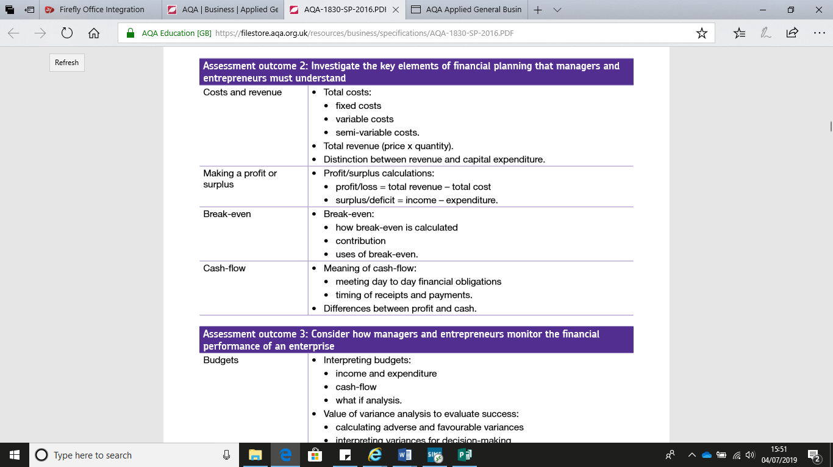

### Topic 4: Cost and Revenue

|  |  |
| --- | --- |
| **Theory** | **Notes** |
| **Revenue** is the same as total income for a business and measures all money taken in through sales of goods and services. **Cost** is the money made by the business and is the key indicator of success.  **Total costs:**   * Fixed costs: business costs, such as rent, that are constant whatever the amount of goods produced. * Variable costs: a cost that varies with the level of output. * The concept of semi-variable cost is often used to project financial performance at various scales of production, where it is an expense which contains both a fixed-cost component and a variable-cost component.   **Total revenue: price x quantity**  **Revenue and profit expenditure:**  A **capital expenditure** is assumed to be consumed over the useful life of the related fixed asset. A **revenue expenditure** is assumed to be consumed within a very short period of time. A more questionable difference is that **capital expenditures** tend to involve larger monetary amounts than **revenue expenditures**.  Financial Planning:  <https://www.youtube.com/watch?v=ggv21pNgbtM> |  |
| **Questions I have about the topic** | |

1. Distinguish between variable and semi-variable costs.

Allocate each cost to the table below.

* Rent and rates £150 000
* Operatives’ wages £100 000
* Raw materials £75 000
* Managers’ salaries £170 000
* Interest payments £22 000
* Promotional expenditure (% of sales) £17 000
* Broadband £ 2 500
* Commission £15 000
* Courier fees £10 000

|  |  |  |  |
| --- | --- | --- | --- |
| Fixed costs | | Variable costs | |
| Cost | £s | Cost | £s |
|  |  |  |  |
|  |  |  |  |
|  |  |  |  |
|  |  |  |  |
|  |  |  |  |

1. Based on the table above what are?
   1. Total fixed costs

___________________________________________________________________________

* 1. Total variable costs

___________________________________________________________________________

* 1. Total costs

___________________________________________________________________________

* 1. Fixed costs as a percentage of total costs

___________________________________________________________________________

* 1. Variable costs as a percentage of total costs

__________________________________________________________________________

### Topic 5: Making a profit or surplus

|  |  |
| --- | --- |
| **Theory** | **Notes** |
| **Profit**-also called net income is the **surplus** after all expenses are deducted from revenue, and it is the basis on which tax is calculated. On the other hand, cash flow is the amount of available cash within a business at any given time as a result of the inflow and outflow of money.  **Profit/ revenue – total costs loss= total**  **Surplus/deficit= income - expenditure**  **Videos you can watch for further explanation:**  <https://www.youtube.com/watch?v=-V-Y5klejSg>  <https://www.youtube.com/watch?v=a0nUWrnuUdo>  **website links:**  <https://www.tutor2u.net/economics/reference/profit>  <https://www.tutor2u.net/economics/reference/producer-surplus>  <https://www.tutor2u.net/economics/reference/consumer-surplus> |  |
| **Questions I have about the topic** | |

Table 1

A firm sells 1 000 items per week

Other data includes:

* Raw material costs £16 per item
* Overhead costs £8 000 per week
* Selling price £30

1. With reference to Table 1 what is the firm’s operating profit?

A £6 000

B £14 000

C £16 000

D £30 000

Show your workings:

_____________________________________________________________________________________________________________________________________________________________________________________________________________________________________________________________________________________________

2. With reference to Table 1 what is the firm’s gross profit?

A £6 000

B £14 000

C £16 000

D £30 000

Show your workings:

_____________________________________________________________________________________________________________________________________________________________________________________________________________________________________________________________________________________________

3. Complete the following bullet points.

* ______________________ > ______________________ = profit
* ______________________ < ______________________ = ______________________
* ______________________ = ______________________ = ______________________
* A ______________________ is excess income achieved by a ______________________
* If a business does not make a surplus it makes a ______________________
* ______________________ - expenses shows whether a business has made a ______________________ or a ______________________

### Topic 6: Break-even

|  |  |
| --- | --- |
| **Theory** | **Notes** |
| The **break-even point** in economics, business and specifically cost accounting is the point at which total cost and total revenue are equal, i.e. **"even".** There is no net loss or gain, and one has "broken even", though opportunity costs have been paid and capital has received the risk-adjusted, expected return.  To **calculate break**-**even** point based on units: Divide fixed costs by the revenue per unit minus the variable cost per unit.  The **contribution** margin is a concept used to interpret different kinds of financial statement data, such as with a **breakeven** point or **break**-**even** analysis. The **contribution** margin represents the amount of money a company has to cover its fixed costs after it pays all of its variable expenses.  **Break**-**even** analysis enables a business organization to: Measure profit and losses at different levels of production and sales. Predict the effect of changes in sales prices.    **Useful websites:**  <https://www.tutor2u.net/business/reference/breakeven-analysis-revision-presentation>  **Videos to watch:**  <https://www.youtube.com/watch?v=ZihWEVWCJYk> |  |
| **Questions I have about the topic** | |

1. Answer the following questions based on the break-even chart for a new bike shop.

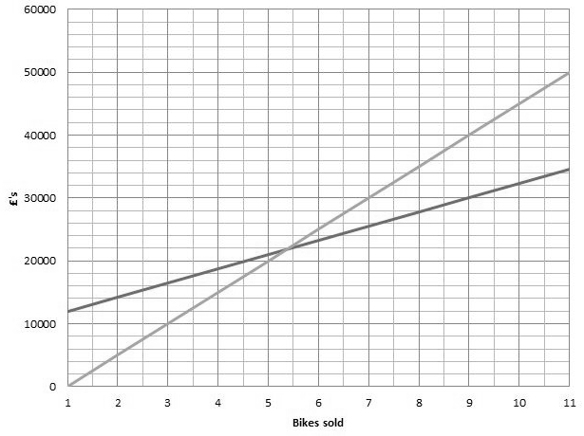

0 10 20 30 40 50 60 70 80 90 100 110

|  |  |
| --- | --- |
| What are the fixed costs? |  |
| What are the variable costs per bike? |  |
| What is the break-even level of bikes sold? |  |
| What is the price per bike? |  |
| What is the contribution per bike? |  |
| What is the profit or loss if 25 bikes are sold? |  |
| What is the profit or loss if 90 bikes are sold? |  |
| What is the margin of safety if 100 bikes are sold? |  |

### Topic 7: Cash-flow

|  |  |
| --- | --- |
| **Theory** | **Notes** |
| **Cash flow:** A cash flow is a real or virtual movement of money: a cash flow in its narrow sense is a payment.   * It meets day to day financial obligations.   **Profit** is defined as revenue less expenses. It may also be referred to as net income. **Cash** flow, on the other hand, refers to the inflows and outflows of **cash** for a particular business. Earning revenue does not always increase **cash** immediately, and incurring an expense does not always decrease **cash** immediately.  **Cash receipts** are money received from consumers for the sale of goods or services.  **Useful websites:**  <https://www.tutor2u.net/business/reference/improving-cash-flow-revision-presentation>  **useful videos:**  <https://www.youtube.com/watch?v=dLHZy4DWKRM> |  |
| **Questions I have about the topic** | |

1. Which of the following methods would improve cash-flow?

Tick as many options as you think are correct.

|  |  |
| --- | --- |
| Method | **** |
| Increase time given to customers to pay |  |
| Buy stock |  |
| Take out a bank loan |  |
| Issue shares |  |
| Slow down payments to suppliers |  |
| Increase overdraft facility |  |
| Become more profitable |  |
| Sell an old machine |  |

1. Explain each of the following statements.
   * Offering longer payment terms to customers can improve profit but have a negative effect on cash-flow

__________________________________________________________________________________________________________________________________________________________________________________________________________________________________________

* + Paying suppliers quickly can improve profits but have a negative effect on cash-flow

__________________________________________________________________________________________________________________________________________________________________________________________________________________________________________

* + It is difficult to improve profits without having a negative effect on cash-flow in the short-run

__________________________________________________________________________________________________________________________________________________________________________________________________________________________________________

1. State three causes of cash-flow problems.
   * _______________________________
   * _______________________________
   * _______________________________

## **Assessment outcome 3: Consider how managers and entrepreneurs monitor the financial performance of an enterprise.**

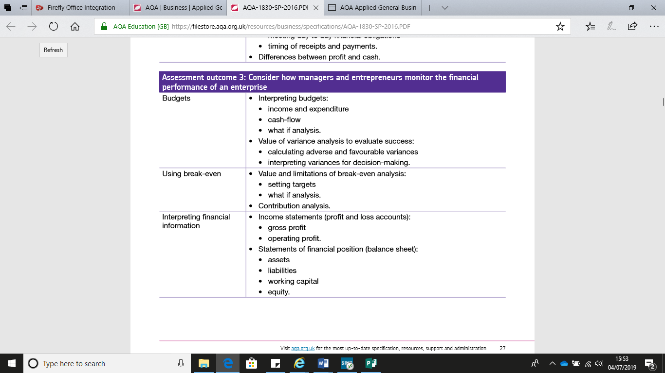

### Topic 8: Budgets

|  |  |
| --- | --- |
| **Theory** | **Notes** |
| A budget is a financial plan for a defined period, often one year. It may also include planned sales volumes and revenues, resource quantities, costs and expenses, assets, liabilities and cash flows   * An **income budget** is a specific type of **budget** that only shows how and where money is earned. * **Expenditure Budget** shows the revenue and capital disbursements of various ministries/departments and presents the estimates in respect of each under 'Plan' and 'Non-Plan'. * A **cash flow budget** is an estimate of all **cash** receipts and all **cash** expenditures that are expected to occur during a certain time period.   **What-If Analysis** is the process of changing the values in cells to see how those changes will affect the outcome of formulas on the worksheet.  **Useful video:**  <https://www.youtube.com/watch?v=bCfaKoBT1EM> for a what -if analysis.  A **favourable variance** is achieved when the actual performance is better than the expected results. An **adverse variance** is achieved when the actual performance is worse than the expected results.  **Variance analysis** is the quantitative investigation of the difference between actual and planned behaviour. This **analysis** is used to maintain control over a business.  **Useful video:**  <https://www.youtube.com/watch?v=3VnOhCr6FHE>  **Useful websites:**  <https://www.tutor2u.net/business/reference/budgets> |  |
| **Questions I have about the topic** | |

* 1. Identify whether each of the following statements are true or false. Justify your answer.

|  |  |
| --- | --- |
| Statement | True/False |
| A negative variance is always adverse |  |
| Justification: | |
| If actual revenue is higher than budget then there is a favourable variance |  |
| Justification: | |
| There will always be a variance between actual and budget |  |
| Justification: | |
| If all other variances are adverse the profit variance must also be adverse |  |
| Justification: | |
| An adverse variance will result in negative net cash flow |  |
| Justification: | |

* 1. **Use the information provided to complete the tables below:**
* All sales were paid in cash at the time of purchase. Monthly sales were £35 000
* Expenditure was 40% of sales paid in the same month
* There was a £2 000 favourable variance on sales
* In month 1 the closing balance was (£3 000)

|  |  |  |  |
| --- | --- | --- | --- |
| Table 1: Budgets | | | |
|  | Budget | Actual | Variance |
| Revenue |  |  |  |
| Expenditure |  |  |  |
| Profit |  |  |  |
| Table 2: Cash-flow | | | |
|  | Month 1 | Month 2 | Month 3 |
| Cash in |  |  |  |
| Cash out |  |  |  |
| Net cash flow |  |  |  |
| Opening balance |  |  |  |
| Closing balance |  |  |  |

### Topic 9: Using Break-even

|  |  |
| --- | --- |
| **Theory** | **Notes** |
| **Using break-even:**  **Setting sales targets:**   * Consider the profit margins each of your **sales** will achieve (there's little point reaching your **sales target** figure but shrinking your margin to achieve it) * Be realistic - your **targets** must be supported by marketing plan information. * Keep all your business costs in mind and plan for growth.   The **break**-**even analysis** lets you determine what you need to sell, monthly or annually, to cover your costs of doing business—your **break**-**even point**.  **Contribution analysis** is an approach to assessing the performance of policies and programmes towards an outcome or outcomes.  **Website link:**  <https://www.tutor2u.net/business/reference/operations-introduction-to-break-even-analysis> |  |
| **Questions I have about the topic** | |

1. Label a-h on the diagram below.

c)

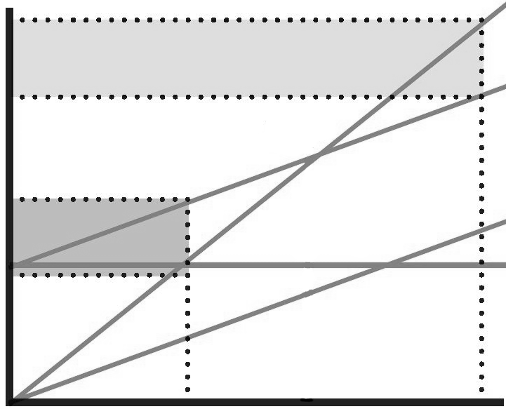

h)

g)

a)

f)

e)

d)

b)

1. What is meant by what-if analysis?

__________________________________________________________________________________________________________________________________________________________________________________________________________________________________________

1. Give 3 examples of what-if analysis for a chain of fast food restaurants.

* _________________________________________________________________________
* _________________________________________________________________________
* _________________________________________________________________________

1. State 1 value of break-even analysis.

____________________________________________________________________________________________________________________________________________________________

1. State 1 limitation of break-even analysis.

____________________________________________________________________________________________________________________________________________________________

### Topic 10: Interpreting financial information

|  |  |
| --- | --- |
| **Theory** | **Notes** |
| **Interpreting financial information:**  For households and individuals, gross income is the sum all wages, salaries, profits, interest payments, rents, and other forms of earnings, before any deductions or taxes. It is opposed to net income, defined as the gross income minus taxes and other deductions.  **Gross profit**= total revenue – cost of goods sold divided by total revenue.  **Operating profit:** a profit from business operations (gross profit minus operating expenses) before deduction of interest and taxes.  **Statements of financial position:**   * **Assets** * **Liabilities** * **Working capital** * **equity**     **Useful websites:**  <https://www.tutor2u.net/business/reference/balance-sheet-revision-presentation>  **Useful Videos:**  <https://www.youtube.com/watch?v=r_t3zjRx4cU> |  |
| **Questions I have about the topic** | |

1. What is meant by the term income statement?

_______________________________________________________________________________________________________________________________________________________________________________________________________________________________________________________________

1. Distinguish between gross and operating profit?

_______________________________________________________________________________________________________________________________________________________________________________________________________________________________________________________________

1. Identify whether each of the following statements are true or false. Justify your answer.

|  |  |
| --- | --- |
| Statement | True/False |
| A profitable business can fail because of cash-flow problems |  |
| Justification: | |
| A business that makes a loss will fail |  |
| Justification: | |
| Cash is more important than profit to business survival |  |
| Justification: | |
| All of a shareholders’ personal assets are at risk if they have invested in a business that fails |  |
| Justification: | |

1. Place the following bullet points in the order they would appear on an income statement.

* Expenses
* Operating profit
* Income statement for company X
* Sales revenue
* Gross profit
* Cost of sales

|  |
| --- |
|  |
|  |
|  |
|  |
|  |
|  |

1. What is meant by the term statement of financial position?

____________________________________________________________________________________________________________________________________________________________________________________________________________________________________________________________________________________________________________________________________________________

1. Identify whether each term is a non-current asset, current asset, current liability or non-current liability.

|  |  |
| --- | --- |
| Terms | NCA, CA, CL, NCL |
| Receivables |  |
| Overdraft |  |
| Cash at bank |  |
| Premises |  |
| Inventory |  |
| Machinery |  |
| Mortgage |  |
| Payables |  |
| Long-term bank loan |  |
| Vehicles |  |

1. Use the bullet points below to complete the statement of financial position.
   * £150 000
   * Share capital
   * Receivables
   * £55 000
   * Non-current assets
   * £25 000
   * £72 000

|  |  |
| --- | --- |
| **Statement of financial position** | |
|  | £ |
|  | 280 000 |
| Current Assets |  |
| Stock |  |
|  | 60 000 |
| Cash and cash equivalents | 20 000 |
| Total current assets | 105 000 |
| Current liabilities |  |
| Net current assets | 50 000 |
| Non-current liabilities | 180 000 |
| Net worth |  |
|  | 78 000 |
| Retained profit |  |
| Capital employed | 150 000 |

## **Assessment outcome 4: Assess information to enable stakeholders to make decisions about the financial performance of an enterprise.**

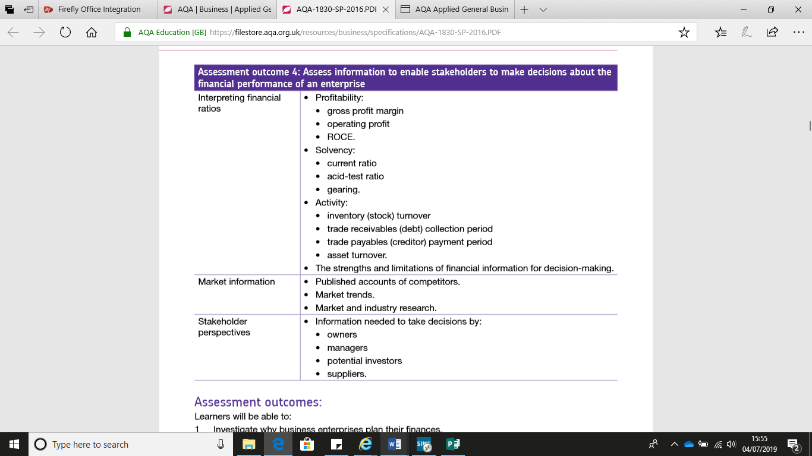

### Topic 11: Interpreting financial ratios

|  |  |
| --- | --- |
| **Theory** | **Notes** |
| **Interpreting financial ratios:**  **Gross profit margin:**  Gross margin is the difference between revenue and cost of goods sold divided by revenue. Gross margin is expressed as a percentage. Generally, it is calculated as the selling price of an item, less the cost of goods sold. Gross Margin is often used interchangeably with Gross Profit, but the terms are different.   1. **Operating profit:**  a profit from business operations (gross profit minus operating expenses) before deduction of interest and taxes. 2. **Current ratios:** The current ratio is a liquidity ratio that measures whether a firm has enough resources to meet its short-term obligations. It compares a firm's current assets to its current liabilities, and is expressed as follows: The current ratio is an indication of a firm's liquidity. 3. **Acid-** **test ratio:** In finance, the quick ratio, also known as the acid-test ratio is a type of liquidity ratio which measures the ability of a company to use its near cash or quick assets to extinguish or retire its current liabilities immediately. 4. **Gearing:** The debt-to-equity ratio is a financial ratio indicating the relative proportion of shareholders' equity and debt used to finance a company's assets. Closely related to leveraging, the ratio is also known as risk, gearing or leverage. 5. **Inventory stock turnover:** it’s a ratio showing how many times a company has sold and replaced **inventory** during a given period. A company can then divide the days in the period by the **inventory turnover** formula to calculate the days it takes to sell the **inventory** on hand. 6. **Trade receivables collection period:** One calculation of the average **collection period** is to first determine the **accounts receivable** turnover ratio. 7. **Trade payables payment period:** Accounts **payable payment period** measures the average number of days it takes an entity to **pay** its suppliers. 8. The **asset turnover ratio** is an efficiency **ratio** that measures a company's ability to generate sales from its **assets** by comparing net sales with average total **assets**. <https://www.tutor2u.net/business/reference/financial-ratios-explained>   **Useful video:**  <https://www.youtube.com/watch?v=GoKIZqSFMIE> |  |
| **Questions I have about the topic** | |

1. Which one of the following is a measure of profitability?
   * Profit variance analysis
   * Gross profit margin
   * Margin of safety
   * Profit for the year

Explanation:

__________________________________________________________________________________________________________________________________________________________________________________________________________________________________________

1. Use the following words and numbers to complete the table below.
   1. Gross profit
   2. £45 000
   3. Revenue
   4. £85 000
   5. Expenses

|  |  |
| --- | --- |
|  | £300 000 |
| Cost of sales |  |
|  | £215 000 |
|  | £170 000 |
| Operating profit |  |

1. Based on the completed income statement above calculate:
   * Gross profit margin
   * Operating profit margin
2. State one other measure of profitability.
3. What is meant by the term solvency?

__________________________________________________________________________________________________________________________________________________________________________________________________________________________________________

1. Briefly explain why solvency is crucial to business survival.
2. Match the three solvency ratios to the correct formula.

|  |  |
| --- | --- |
| Ratio | Formula |
| Current ratio | Non-current liabilities x 100  Total equity + non-current liabilities |
| Acid-test ratio | Current assets  Current liabilities |
| Gearing | Current assets – stock  Current liabilities |

1. Which financial statement is needed to calculate solvency ratios?

­­­­­­­­­­­______________________________________________________________________________

1. Which ratio is of greatest concern when interest rates are rising?
   1. Current ratio
   2. Acid-test ratio
   3. Gearing
2. State one other measure of solvency.

______________________________________________________________________________

1. Why is the acid-test ratio considered a tougher measure of solvency than the current ratio?

__________________________________________________________________________________________________________________________________________________________________________________________________________________________________________

### Topic 12: Market information

|  |  |
| --- | --- |
| **Theory** | **Notes** |
| **Market information:** A system that analysis and assesses **marketing information**, gathered continuously from sources inside and outside an organization. Timely **marketing information** provides basis for decisions such as product development or improvement, pricing, packaging, distribution, media selection, and promotion.  **Published accounts:** the **accounts** of a company which have been prepared and audited and then must be **published** by sending to the shareholders and other interested parties.  **Market trend**. It’s a perceived tendency of financial markets to move in a particular direction over time. These trends are classified as secular for long time frames, primary for medium time frames, and secondary for short time frames.  **Industrial research** means the planned **research** or critical investigation aimed at the acquisition of new knowledge and skills for developing new products, processes or services or for bringing about a significant improvement in existing products, processes or services.   1. **Market research:** the action or activity of gathering information about consumers' needs and preferences.   **Useful video:**  <https://www.youtube.com/watch?v=pPjHbI9HuLA> |
| **Questions I have about the topic** | |

Which **one** of the following may result in a fall in costs to a business?

A Ageing population

B Falling competition

C Interest rates fall

D Incomes fall

2 Which **one** of the following is most likely to have an adverse effect on demand?

A Competition decreases

B Cut in income tax

C Minimum wage increases

D Interest rates rise

3 In 2016 the market for good x is forecast to increase to 1.6 million units from 1.5 million units in 2015. What is the percentage market growth? (Rounded to nearest whole number)

A 6%

B 63%

C 7%

D 67%

Show your workings:

_____________________________________________________________________________________________________________________________________________________________________________________________________________________________________________________________________

4. Why might the information in question 3 be of use to a business operating in that market.

_____________________________________________________________________________________________________________________________________________________________________________________________________________________________________________________________________

5. State two uses of the published accounts of a competitor as a source of market information.

* _________________________________________________________________________________
* _________________________________________________________________________________

6. State two methods of market research.

* _________________________________________________________________________________
* _________________________________________________________________________________

7. State two sources of information on market trends.

* _________________________________________________________________________________
* _________________________________________________________________________________

8. State two reasons why market intelligence may not be accurate or reliable.

* _________________________________________________________________________________

_________________________________________________________________________________

### Topic 13: Stakeholder Perspectives

|  |  |
| --- | --- |
| **Theory** | **Notes** |
| **Stakeholder perspectives:** The **stakeholders** are the “ultimate customers,” whose health, safety, interests, and even livelihood may be impacted by the quality of a munitions response.  **Decisions made by:**   * Owners * Managers * Potential investors * Suppliers   **Useful link:**  <https://www.tutor2u.net/business/reference/stakeholders-introduction>  **Useful video:**  <https://www.youtube.com/watch?v=uKozswXz7qM>  <https://www.youtube.com/watch?v=4lEjv0vE6VY> |
| **Questions I have about the topic** | |

1. Define the term stakeholders.

____________________________________________________________________________________________________________________________________________________________

1. Match each stakeholder to an example of a potential objective.

|  |  |
| --- | --- |
| Stakeholder | Objective |
| Employee | Prompt payments and positive relationship |
| Owner | Job security and good conditions |
| Investor | Support for projects and good environmental record |
| Supplier | Payment of taxes and ethical behaviour |
| Community | Ethical behaviour and growth |
| Government | Positive return on finance provided |

1. Which **one** of the following is an internal stakeholder?

A Employee

B Potential investors

C Competitor

D Supplier

1. State four pieces of information a potential investor would be interested in:

* _______________________
* _______________________
* _______________________
* _______________________

1. State four pieces of information a supplier would be interested in:

* _______________________
* _______________________
* _______________________
* _______________________

1. Explain why managers and owners, as stakeholders, may be the same or different people.

__________________________________________________________________________________________________________________________________________________________________________________________________________________________________________

## **Self – review check**

|  |  |  |  |
| --- | --- | --- | --- |
|  | See the source image | See the source image | See the source image |
| Topic 1: Business Planning |  |  |  |
| Topic 2: Legal Structures of a Business |  |  |  |
| Topic 3: Financing the Enterprise |  |  |  |
| Topic 4: Cost and Revenue |  |  |  |
| Topic 5: Making a profit or surplus |  |  |  |
| Topic 6: Break-even |  |  |  |
| Topic 7: Cash-flow |  |  |  |
| Topic 8: Budgets |  |  |  |
| Topic 9: Using Break-even |  |  |  |
| Topic 10: Interpreting financial information |  |  |  |
| Topic 11: Interpreting financial ratios |  |  |  |
| Topic 12: Market information |  |  |  |
| Topic 13: Stakeholder Perspectives |  |  |  |