**BRIDGING TASK**

**BIOLOGY**

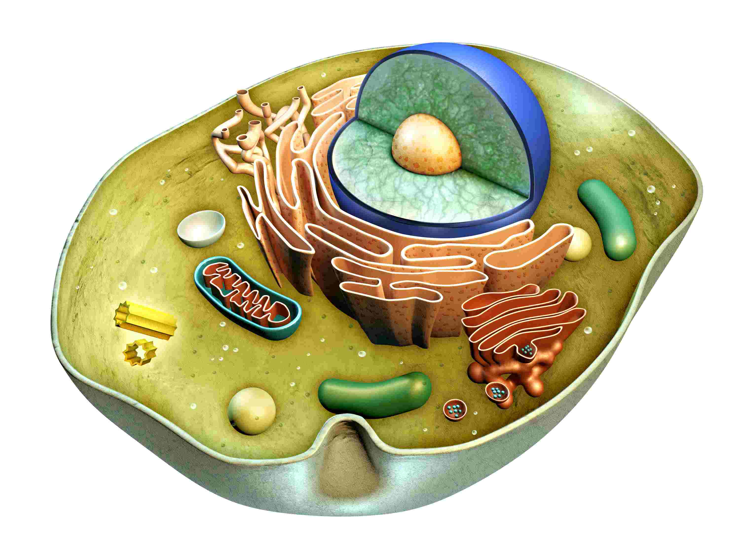

**KEVI HANDSWORTH WOOD GIRLS ACADEMY**



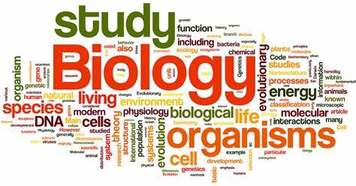

**PLEASE COMPLETE TASK DURING THE HOLIDAYS AND BRING BACK ON THE FIRST DAY BACK!**

**Section A**

**The tasks below will prepare you for A level Biology.**

**Use websites such as www.cellsalive.com and** [**www.biologymad.com**](http://www.biologymad.com)**. Libraries also have Advanced Biology books and guides that you could borrow.**

**Microscopy**

**Units of measurement**

1. Complete the diagram below to show: names of the units of measurement, unit symbols, and mathematical operations for converting between units.

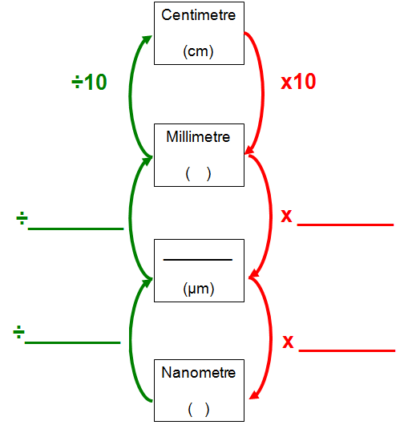

**Section B**

**Magnification, gas exchange and cell division**

1. Define the following terms:

Magnification:

Resolution:

**Calculating Cell Magnification from images**

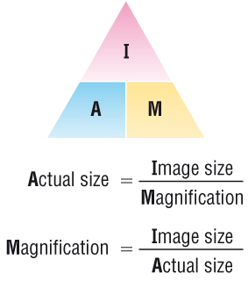

1. **Compare and contrast transmission electron microscopes with scanning electron microscopes. Make sure you include magnification, resolution, specimen preparation, type of image created/ observed and advantages and limitations of each type of microscope.**
2. **Explain why electron mcroscopes are better than light microscopes.**
3. **Describe and explain the role of mono clonal antibodies in pregnancy tests.**
4. **Compare and contrast mitosis and meiosis and their imprtance in living organisms. Decribe the different stages and explain what is happening to the genetcic material at each stage.**
5. **Apply your knowledge about surface area to volume ratio to explain why certain adaptations are needed for efficient gas echange in insects, fish and mammals.**
6. **Learn about the circulatory system and be able to apply this knowledge to how blood flows through the heart.**

8. The diagram below is a drawing of an organelle from a ciliated cell as seen with an electron microscope.



Calculate the actual length of the organelle as shown by the line AB in the diagram. Express your answer to the nearest micrometre (m).

Show your working.

Answer = ........................................... m

1. The diagram below is a drawing of an alveolus together with an associated blood capillary.



The line **AB** in the diagram represents an actual distance of 1.5 µm.

Calculate the magnification of the drawing. Show your working.

Answer = ×.................................................

1. The diagram below shows the general structure of an animal cell as seen under an electron microscope.

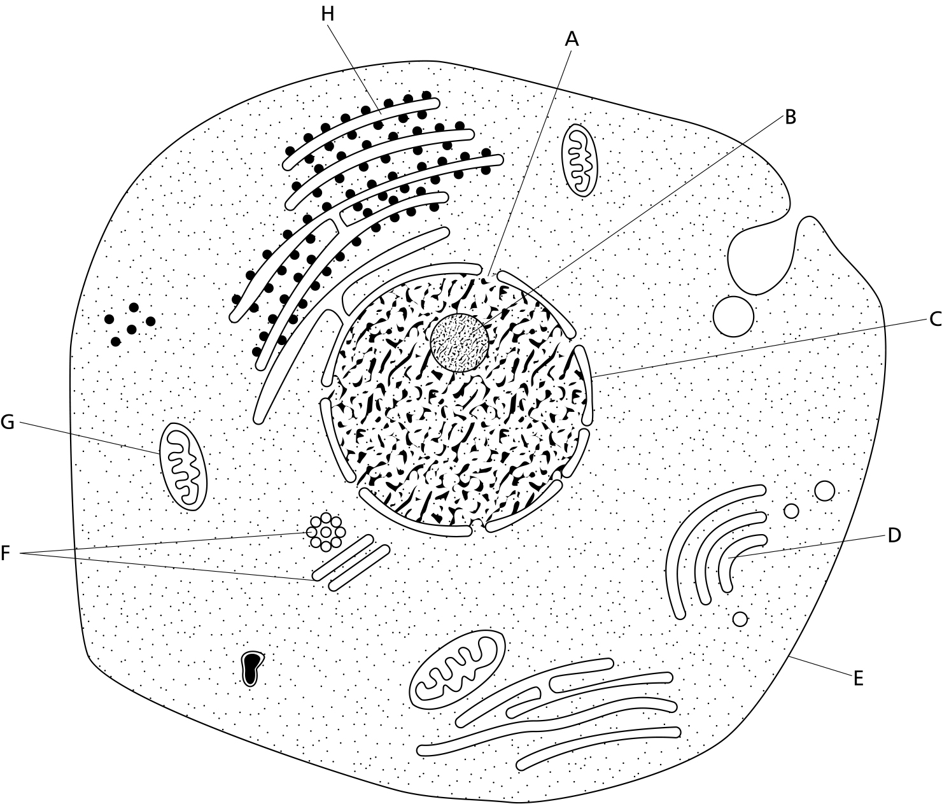

**_________**

5μm

1. Calculate the magnification factor of the diagram
2. Calculate the actual length of structure G
3. Calculate the diameter of the nucleolus (structure B)
4. Calculate the diameter of the nucleus
5. Calculate the diameter of the cell at its widest point

**Section C**

**Use websites such as cellsalive.com and biologymad.com as well as A level text books and revision guides to answer the following questions.**

**Cells ultrastructure and immunity**

1. Write down three differences between eukaryotic and prokaryotic cells.
2. Draw a HIV virus and label the different parts, desribe the fucntion of each part of the virus.
3. Discuss the consequences of antibiotic resistance and the role of natural selection in the development of superbugs such as MRSA.
4. Complete the table below with information on the structure and function of the following organelles.

|  |  |  |
| --- | --- | --- |
| **Organelle** | **Structure** | **Function** |
| Nucleolus |  |  |
| Granum and thylakoid in plant cells |  |  |
| Nuclear envelope |  |  |
| Golgi apparatus |  |  |
| Endoplasmic reticulum (RER and SER) |  |  |

**Section D**

**Biological molecules**

* **Draw and describe the structure of the following biological molecules:**

1. Amino acid- label the R group, amino group and the carboxyl group
2. Triglyceride and a phospholipid
3. Alpha glucose
4. Beta glucose
5. Ribose
6. Starch
7. Cellulose

* **Describe how different bonds are created to form polymers from monomers and include hydrolysis and condensation reactions where applicable.**
* **Food tests**

**Describe a method to test for the following foods** **and positive results for each food groups:**

1. Lipids
2. Reducing sugars
3. Non reducing sugars
4. Proteins

**Section E**

During the course you will be expected to read a variety of articles and use some of that information in your required practical write ups and synoptic essays. You will have to reference your work and learn to use Harvard Generator.

**“Please write a short essay 200 words on the properties of enzymes and their importance in living organsims.” Include the induced fit theory and refer to the 3D structure of enzymes as well as the factors that imapct enzyme actvity in organsims.**

Use a variety of sources and reference these sources using the **Harvard Generator Software** on the world wide web.

**Please bring this booklet and all the work completed on the first day back. These tasks will ensure a smooth transition into year 12.**

**You will be tested on the work above when you return to school in September.**